MA/CSSE 473 Day 13 Announcements and Summary
Announcements:
- HW6 (11 problems now) due Monday; No late days may be used for this one.
- Exam1 date: Tuesday Sept 30,
  - If you are allowed extra time for exams and plan to use that time, please talk with me soon about timing.
  - Exam 1 specification document is linked from Day 16 on the schedule page.
- In my office today: 12:45-2:30, 4:00-5:00.
Main ideas from today:
- We want to generate all permutations of the numbers 1, 2, …, n.
- Bottom-up algorithm. Alternate the insertion orders.
- Johnson-Trotter. Every element has an additional piece of info, its direction (right or left).
  - An element is mobile if the element it “points to” is smaller than itself.
  - Largest mobile element is swapped with the element it points to.
  - Then reverse the direction of all larger elements.

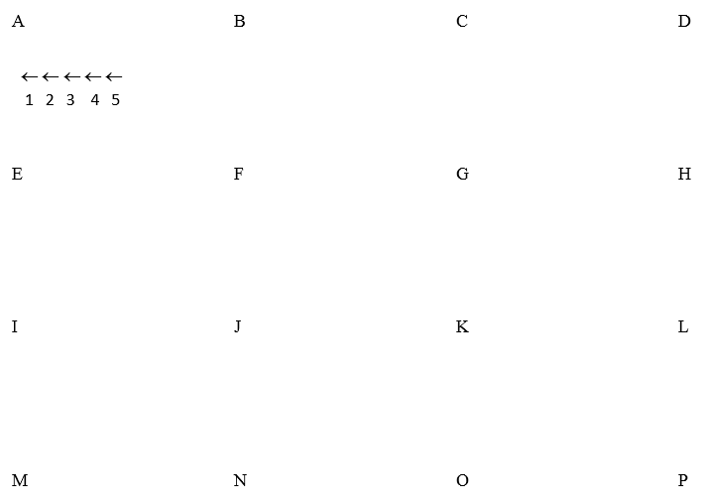

- Which permutation follows each of these in lexicographic order?

183647520 471638520
- Write an algorithm for generating the next permutation, with only N and the current permutation as input.

- If the lexicographic permutations of the numbers [0, 1, 2, 3, 4] are numbered starting with 0, what is the number of the permutation 14023? How do you get this?

- Write an algorithm which, given a permutation of the numbers 0..N-1, calculates its (zero-based) position in the lexicographic ordering of all of the permutations of 0..n-1.
- In the lexicographic ordering of permutations of [0, 1, 2, 3, 4, 5], which permutation is number 541? How do you get this?

