Name:___________________________________________________ Grade:_____/10
- XOR:
  - Can you separate XOR in the feature space using a hyperplane? ____ Explain.

  - Can you separate XOR in a higher dimension space using a hyperplane? ____ Explain.
- Name two common kernel functions used to map data to higher dimensions, and give the formula for each.
1.
2.
- The following graphs are taken from the svm demo done in class/videos: boxes are pos. examples (+1) and x’s are neg. (-1). The margin was calculated such that M=1.
  - Please mark on the picture the value of the SVM output on each line (0, +1, or -1) and the range of SVM output in each region ((-∞, -1), (-1, 0), (0, 1) or (1, ∞)).
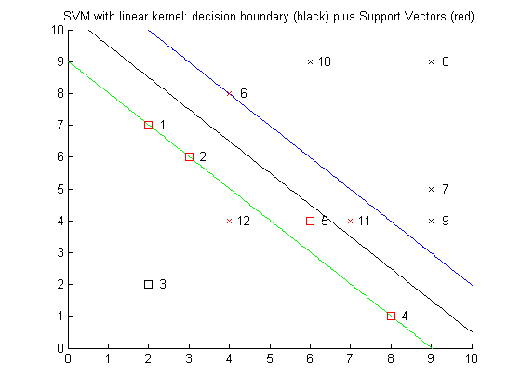
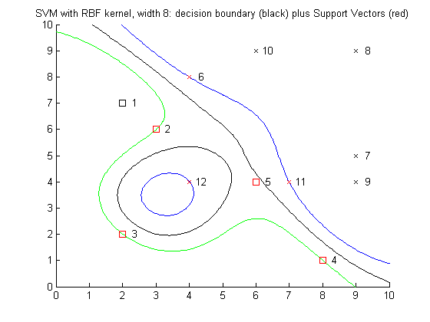

  - Hyperplanes are linear. We get a nonlinear decision boundary for the example to the right because we used a ______________________.

  - RBF kernels have another hyperparameter $σ$, which controls the ________ of the Gaussian. I choose $σ$ and get a high accuracy on the training set, but low accuracy on a different validation set. What is this called? _____________ Should $σ$ be made larger or smaller to increase accuracy on the validation set? ___________ Note that validation set accuracy is far more important than training set accuracy. We usually tune $σ$ and C to maximize validation accuracy at the same time.

- Points 4, 6, 11, and 12 have been removed to create the graph below.
- Draw the new margin if no kernel function were used.

- Which vectors would be the new support vectors? ______________

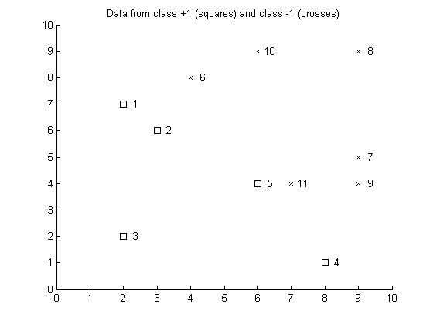

5. (Clear/muddy) If online, this question may have special instructions. (a) Clear: Write a detailed summary of the points that became clear during this lesson and that you don’t want to forget (if in class, you may have to do it after the quiz is returned). (b) Muddy: Then list anything from this session that you found confusing and will need to study more (if none, please write “None”).

