Name:_________________________________________CM: __________ Grade:_____/10
- List the two main steps in template matching.

- When using correlation as a match measure, what is the main danger?

- (3) Compute the un-normalized correlation between the template: [0 0 0; 0 4 4; 0 0 4] with these windows:
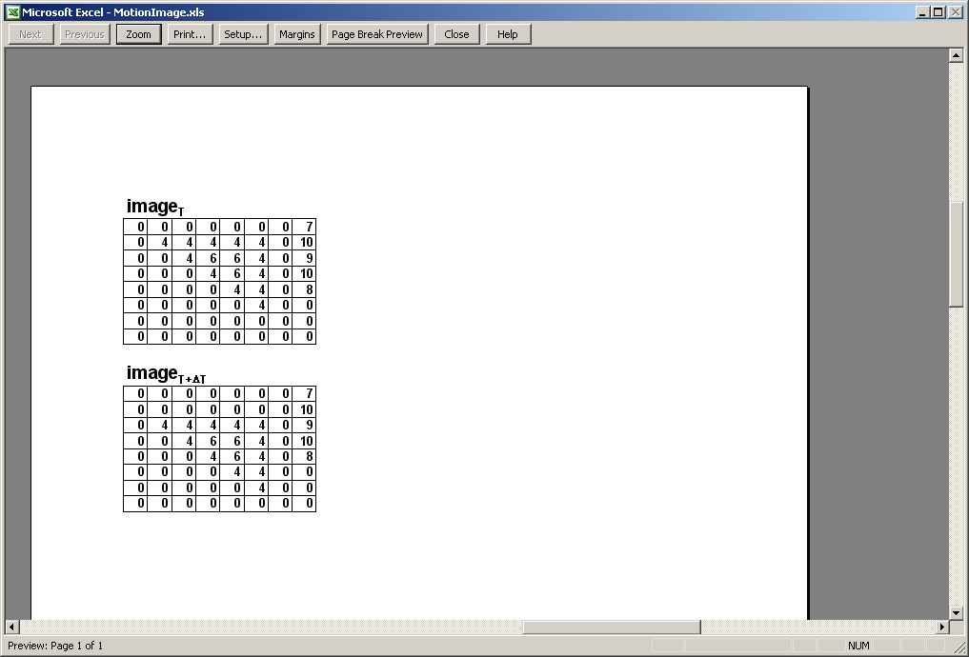
a. the window centered on (2,2)

b. the window centered on (6,2) (all 0’s)

c. the window centered on (3,5)

- (3) Repeat the previous question using normalized correlation. For the image means, use the mean of the pixels currently matched with the template. You may approximate the means to avoid fractions (so use 1 for the mean of the object).
a. the window centered on (2,2) (mean ~ 1)

b. the window centered on (6,2) (all 0’s)

c. the window centered on (3,5) (mean ~ 5)

- What does “HoG” stand for? _________________ of ________________ _________________.

- How do these features compare to others we have learned in the class?

- Name at least one application of template matching using HOG features:

- Tell your instructor about anything from today's session (or from the course so far) that you found confusing or still have a question about. If none, please write “None”.

