Name:___________________________________________________ Grade:_____/10
- (4 pts) The following graphs are taken from the svm demo done in class: boxes are pos. examples (+1) and x’s are neg. (-1). Please mark on the picture the value of the SVM output on each line (0, +1, or -1) and the range of SVM output in each region ((-∞, -1), (-1, 0), (0, 1) or (1, ∞)).
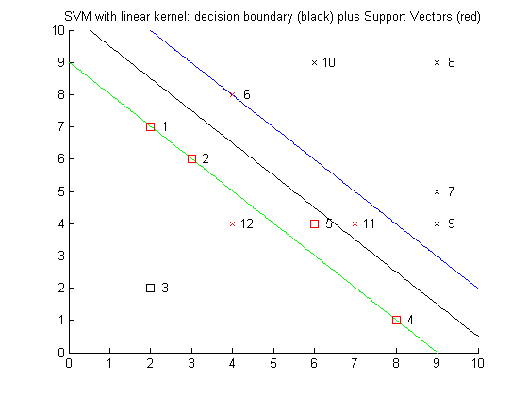
a.

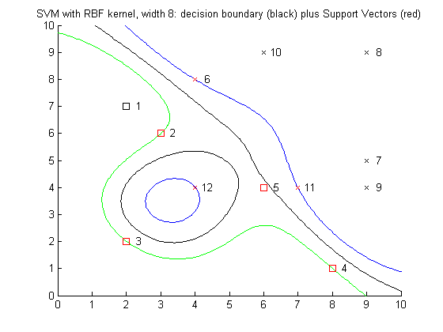
b.

- (3) Points 4, 6, 11, and 12 have been removed to create the graph below.
- Draw the new margin if no kernel function were used.

- Which vectors would be the new support vectors? ______________

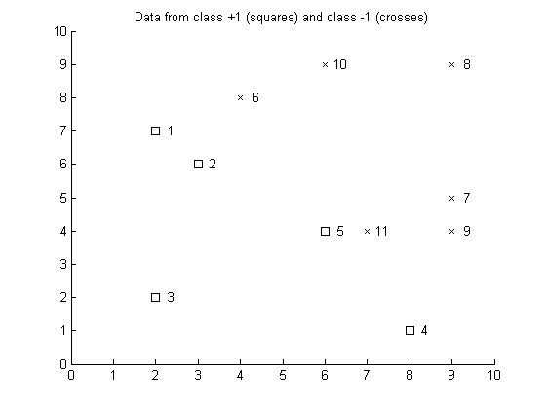

- (2) The complexity of classification using an SVM is O(sd),
where s is____________________________ and d is ____________________________

- (1) Tell your instructor about anything from today's session (or from the course so far) that you found confusing or still have a question about. If none, please write “None”. [You may always write comments to this effect, even if I don’t specifically ask for them!]

