- In class, we covered call/cc and looked at this specific example:
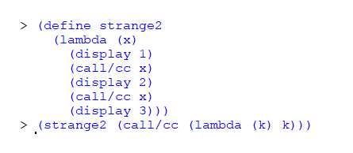
What type of “thing” is begin passed into strange2 in the second line of execution?
Continuation
- This weird function is created and executed
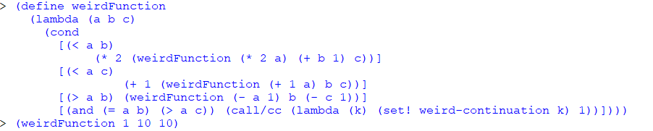
What is the expected output of the next line?
208
- Identity is defined below in Scheme:
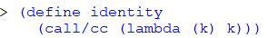

What is the output of these two lines?
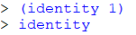
“Void” and 1 respectively
- How many times does 1 get displayed in this code?
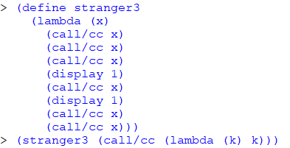

Twice

