Name: ___________________________ Section: ____
Name: ___________________________ Section: ____
Name: ___________________________ Section: ____
Practical 08
Read and perform the practical guide. Answer the questions after you have completed the practical. Be sure to keep the formatting of 1-2 questions per page.
Here is the pipelined datapath for your reference:
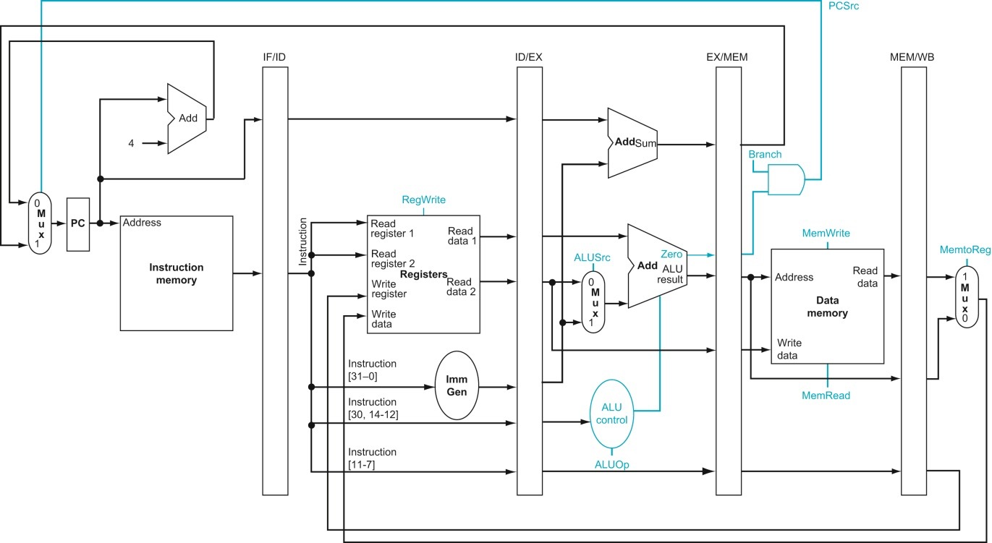

[4] (Need) What additional values need to be stored in the registers in each pipeline stage register (buffer) file to support branches? Fill out the table below. Fill this out before you implement Processor.v.
Buffer | Name | Bits | Use
IF/ID | PC | 32 | To calculate PC+imm in the decode stage
ID/EX
EX/MEM
MEM/WB

[4] (Iteration) What registers, if any, were missing from the table above after you implemented branches in Processor.v? Why are these additions necessary?

[4] (Need) What additional values need to be stored in the registers in each pipeline stage register (buffer) file to support jal and jalr? Fill out the table below. Fill this out before you implement Processor.v.
Buffer | Name | Bits | Use
IF/ID | PC | 32 | To calculate PC+imm in the decode stage
ID/EX
EX/MEM
MEM/WB

[4] (Iteration) What registers, if any, were missing from the table above after you implemented jumps in Processor.v? Why are these additions necessary?

[4] (Correctness/Iteration) Take a screenshot of the ModelSim running tb_Processor_Program for the test_gcd task. This should include the waveform with adequate signals grouped for organization as well as the transcript documenting the instructions you are running for the test.

Replace this textbox with your screenshot

[4] (Correctness/Iteration) What argument values did you call gcd with? Did you get the corrected expected result the first time you ran the test? If not, what did you have to change to get a correct gcd implementation?

[4] (Correctness/Iteration) Take a screenshot of the ModelSim running tb_Processor_Program for the test_relPrime task. This should include the waveform with adequate signals grouped for organization as well as the transcript documenting the instructions you are running for the test.

Replace this textbox with your screenshot

[4] (Correctness/Iteration) What argument value did you call relPrime with? Did you get the corrected expected result the first time you ran the test? If not, what did you have to change to get a correct relPrime implementation?

[4] (Need) The testbenches you examined for branches and jumps are likely designed different than the testbenches you wrote for Practical 6 (single-cycle processor). Is it necessary to write the testbenches this way or were the testbenches you designed in Practical 6 sufficient? Explain why or why not.

[4] (Need/Iteration) Was it necessary to plan out the contents of each buffer (as you did in the worksheet) before implementing the pipeline in Verilog? Did this planning process help with your implementation process, or was it a hindrance? Explain your reasoning as to why it did or did not help.

[4] (Performance) How many cycles does it take for your processor to run relPrime(360) (divide the execution time reported in ModelSim by the length of one cycle)? This can definitely be improved. Discuss what are the current inefficiencies in your relPrime assembly program and this will be improved in the future.

[4] (Performance/Iteration) Examine your implementation for relPrime in HW10. Are there any pairs of consecutive instructions that can be combined as a single new instruction to improve the performance? Identify at least two pairs and briefly discuss how feasible it would be to implement this as a new instruction.

[4] (Iteration) Why do you think the practicals have had you implement one instruction type into your processor at a time? Did you ever break this plan by attempting to implement multiple instruction types at once? Discuss the advantages and disadvantages you experienced with your approach.

[8] What was the biggest challenge in implementing and testing your new instruction? Explain in 100 words or less.

[10] What is the single biggest thing you learned from designing and implementing these instructions? Explain in 100 words or less.
[0] What is the git commit ID for your final commit of your code. This is required to pass the assignment. Check Practical 1 for instructions on how to get the correct commit ID.

