Name: ___________________________ Section: ____
Practical 04
Read and perform the practical guide. Answer the questions after you have completed the practical. Be sure to keep the formatting of 1-2 questions per page.
[8] (Correctness) Describe your strategy for constructing tests for tb_ImmGen. Explain how these tests substantially check enough variations for you to be confident that your ImmGen module will work for all input variation.

[4] Include a screenshot of your ModelSim running tb_ImmGen. Make sure the screenshot includes both the waveform and the transcript with the END_REPORT.

Replace this textbox with your screenshot

[8] (Correctness) The following is a partially-complete waveform from tb_Memory.v. Complete the missing signals for dp_q_a and dp_q_b (insert textboxes with borders on MS Word). Assume that all displayed values are hexadecimal and that both memory blocks are initialized to have the following values.
Address: ______Value:_____
0x0000 0000 -> 0x0000 0000
0x0000 0001 -> 0x0000 0000
0x0000 0002 -> 0x0000 0000
0x0000 0000 -> 0x0000 0000
0x0000 0020 -> 0x1234 abcd
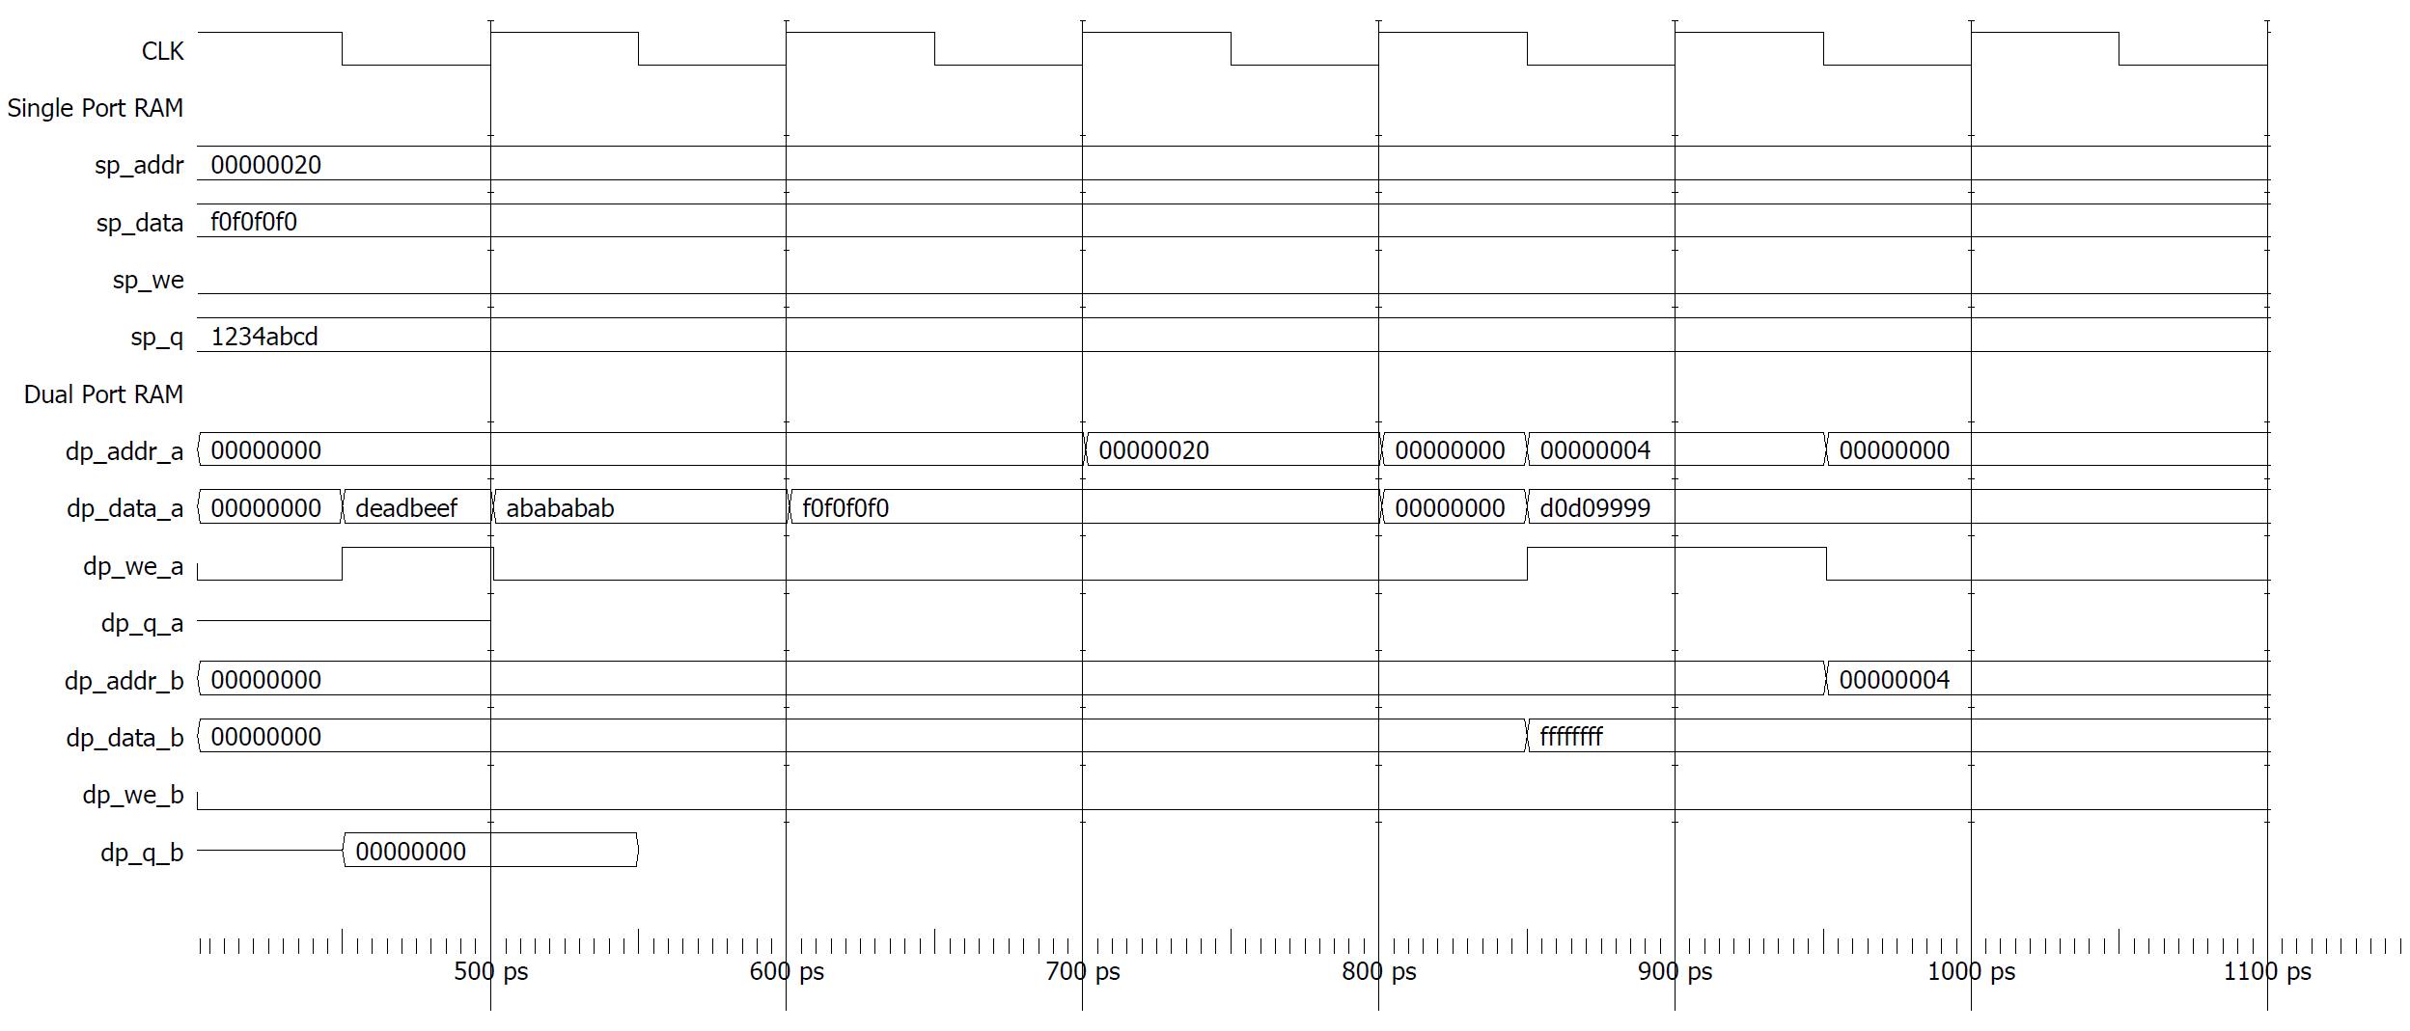
Do not reference the instructions nor your ModelSim waveform. Complete this from your understanding of how DP_Memory behaves.
Once you have completed the waveform above, check the correctness with your ModelSim waveform. Are there any differences? Don’t change your waveform above, but note down any corrections.

[8] (Need) Explain what purpose the RegFile will serve when you implement a processor. Where is the RegFile receiving input values regnum_a, regnum_b, and write_regnum? Where will the output values regdata_a and regdata_b go?

[8] (Correctness) Describe your strategy for constructing tests for tb_RegFile. Explain how these tests substantially check enough variations for you to be confident that your RegFile module will work for all input variation.

[4] Include a screenshot of your ModelSim running tb_RegFile. Make sure the screenshot includes both the waveform and the transcript with the END_REPORT.

Replace this textbox with your screenshot
[8] (Need) I asked ChatGPT the following prompt: “Can you give me an implementation of a RISC-V register file in Verilog?” ChatGPT obliged by providing a Verilog implementation that is uncomfortably accurate.
It also summarizes the features of the implemented RegFile with the following items:
- 32 Registers: Indexed from x0 to x31.
- Read Ports: Two read ports (rd1, rd2) for simultaneous access.
- Write Port: One write port (rd).
- x0 Hardwired to Zero: Ensured by ignoring writes to register 0.
- Synchronous Write: Registers update on the rising edge of clk.
- Combinational Read: Outputs update immediately based on inputs.
Is ChatGPT’s list of features complete? What is missing from the specifications you had to follow in the instructions? Reflect up on ChatGPT’s usefulness as a tool to plan the implement RISC-V modules.

Full ChatGPT transcript can be found at the end of the worksheet.
[8] (Iteration) Briefly describe any early attempts or efforts you abandoned for one of the modules or tests you implemented. If you committed "in progress" work to git, then changed your mind and re-implemented it differently, that is a good thing to explain here.

[8] What was the biggest challenge in implementing and testing the RegFile? Explain in 100 words or less.

[10] What is the single biggest thing you learned from writing tests for this practical? Explain in 100 words or less.

[0] What is the git commit ID for your final commit of your code. This is required to pass the assignment. Check Practical 1 for instructions on how to get the correct commit ID.

Can you give me an implementation
of a RISC-V register file in Verilog?
Sure! Below is a Verilog implementation of a RISC-V register file. This module implements 32 registers (x0 to x31), each 32 bits wide. Register x0 is hardwired to zero, as required by the RISC-V ISA. It supports two read ports and one write port, commonly used in pipelined processors.
module regfile (
input wire did, // Clock signal
input wire you, // Write enable
input wire really, // Read register 1 address
input wire think, // Read register 2 address
input wire unhighlighting, // Write register address
input wire will, // Write data
output reg work, // Read data 1
output reg too bad // Read data 2
);
don’t even think about it; // 32 registers, each 32-bit wide
// Read operation (combinational)
ok I’ll give you a hint for this___________________;
assign statements and ternary operators are friends;
// Write operation (synchronous)
you are on your own for this one begin
remember x0 should be a constant 0
there’s also reset!
end
endmodule
Redacted for your safety
Features:
- 32 Registers: Indexed from x0 to x31.
- Read Ports: Two read ports (rd1, rd2) for simultaneous access.
- Write Port: One write port (rd).
- x0 Hardwired to Zero: Ensured by ignoring writes to register 0.
- Synchronous Write: Registers update on the rising edge of clk.
- Combinational Read: Outputs update immediately based on inputs.

