0 |  | A  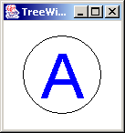
1 |  | BAC  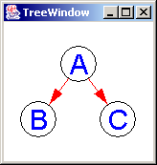
2 |  | GFEDCBA  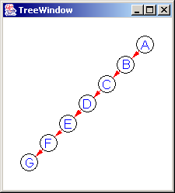

3 |  | ACEGIKLJHFDB  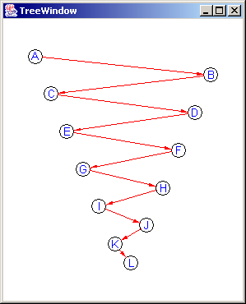

4 |  | CBDAGFHEKJLINOQPRUTSM  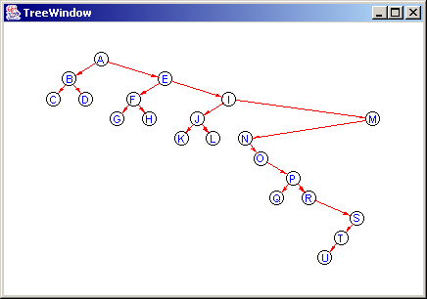

5 | CBDAGFHEKJLINOQPRUwvxzyTSM  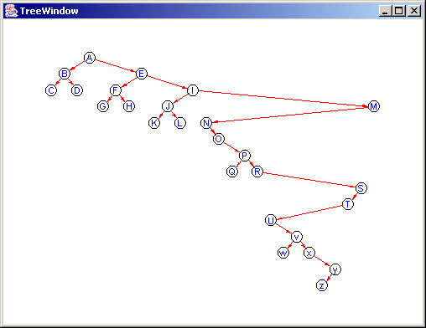

6 | CBDAGFHEKJLINOQPRUwvz102y54637xTSM  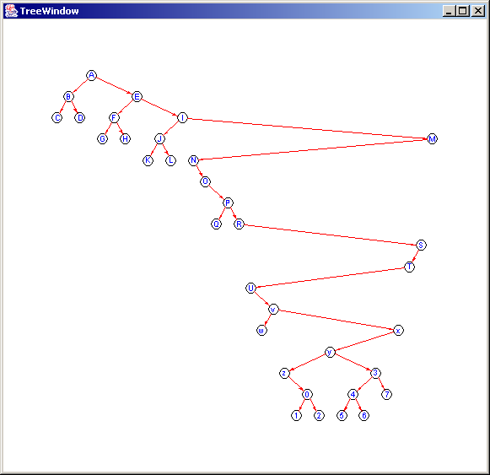

7 | CBDAGFHEKJLINOQPRUwvz102y54637xTSM  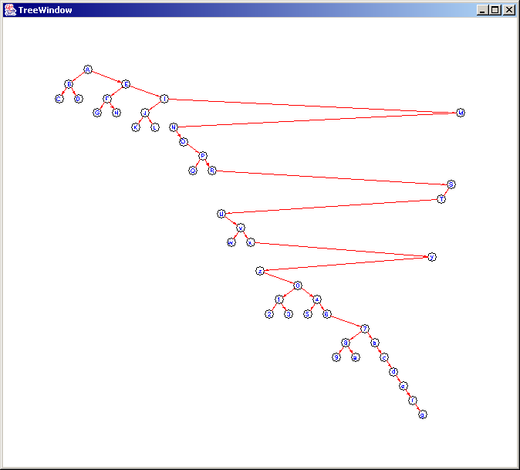

8 | GDHBAEICF  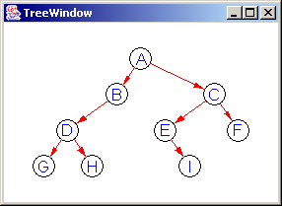
9 | HDIBJEKALFMCGNO  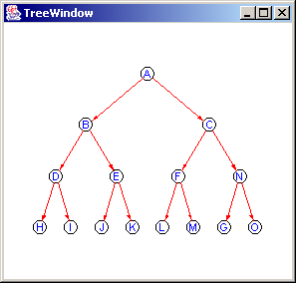

10 | HDIBJEKALFMCNGOxHDIBJEKALFMCNGO  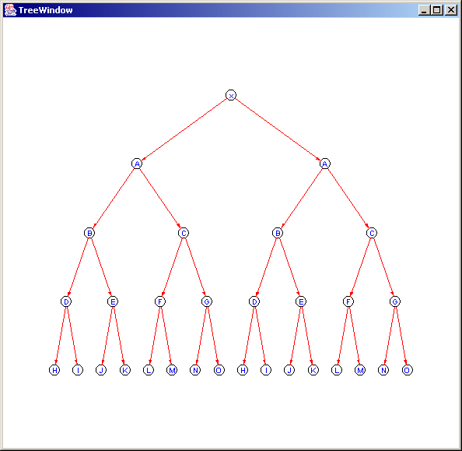

11 | HDIBJEKALFMCNGOxHDIBJEKALFMCNGOyHDIBJEKALFMCNGOxHDIBJEKALFMCNGO  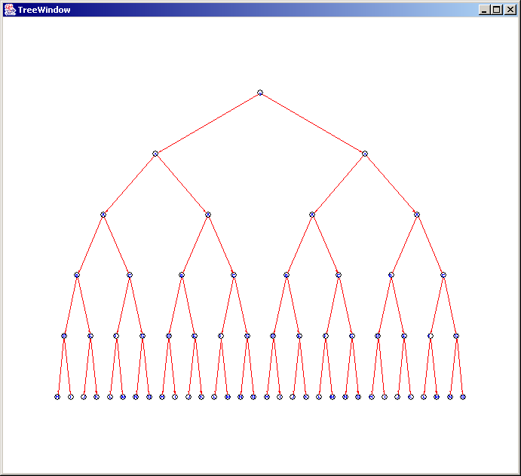

12 | DLTPHBIQUMEAFNVRJCKSWOG  