Enter a number to choose the tree to display [0 - 12 (blank line to exit) ]
12
Constructing tree - parameters
============
ABDHLPTEIMQUCFJNRVGKOSW
22RLRL0LRLR02RLRL0LRLR0

Tree 12 - inOrder(): DLTPHBIQUMEAFNVRJCKSWOG
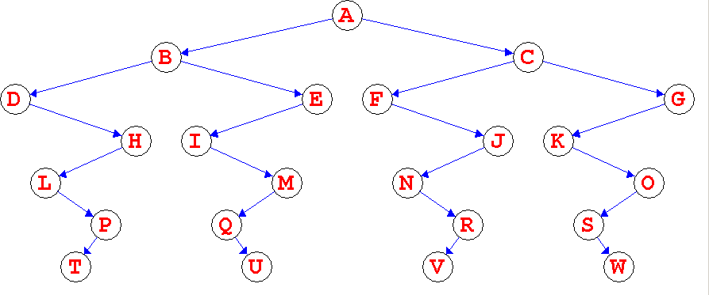

Enter a number to choose the tree to display [0 - 12 (blank line to exit) ]
11
Constructing tree - parameters
============
yxABDHIEJKCFLMGNOABDHIEJKCFLMGNOxABDHIEJKCFLMGNOABDHIEJKCFLMGNO
222220020022002002220020022002002222002002200200222002002200200

Tree 11 - inOrder(): HDIBJEKALFMCNGOxHDIBJEKALFMCNGOyHDIBJEKALFMCNGOxHDIBJEKA
CNGO

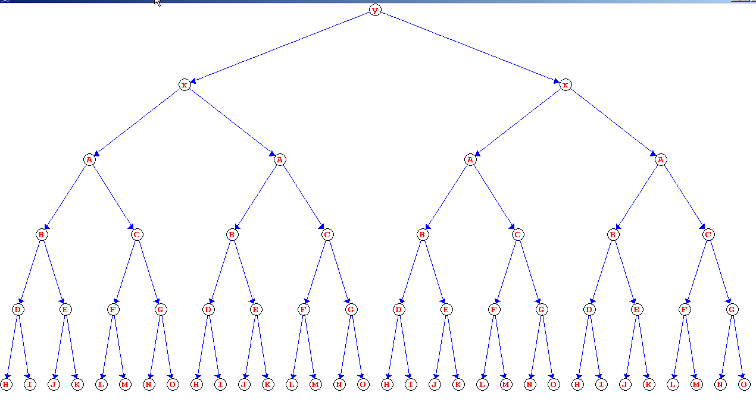
Enter a number to choose the tree to display [0 - 12 (blank line to exit) ]
10
Constructing tree - parameters
============
xABDHIEJKCFLMGNOABDHIEJKCFLMGNO
2222002002200200222002002200200

Tree 10 - inOrder(): HDIBJEKALFMCNGOxHDIBJEKALFMCNGO
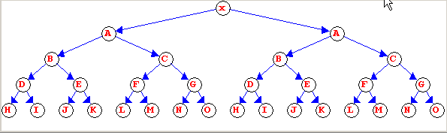

Enter a number to choose the tree to display [0 - 12 (blank line to exit) ]
9
Constructing tree - parameters
============
ABDHIEJKCFLMNGO
222002002200200

Tree 9 - inOrder(): HDIBJEKALFMCGNO
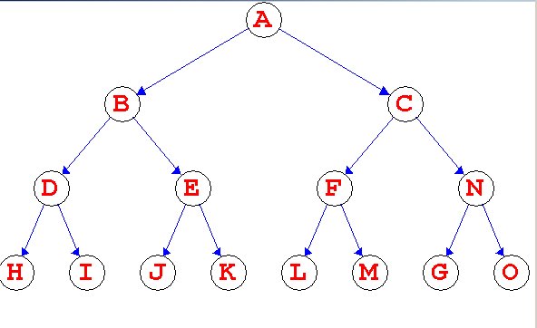

Enter a number to choose the tree to display [0 - 12 (blank line to exit) ]
8
Constructing tree - parameters
============
ABDGHCEIF
2L2002R00

Tree 8 - inOrder(): GDHBAEICF
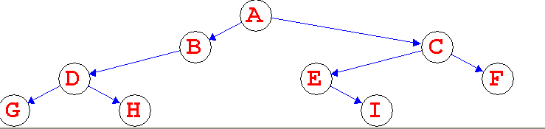

Enter a number to choose the tree to display [0 - 12 (blank line to exit) ]
7
Constructing tree - parameters
============
ABCDEFGHIJKLMNOPQRSTUvwxyz0123456789abcdefg
220022002200LRR20RLLR20RLR220020R2200RRRRR0

Tree 7 - inOrder(): CBDAGFHEKJLINOQPRUwvxz213054698a7bcdefgyTSM
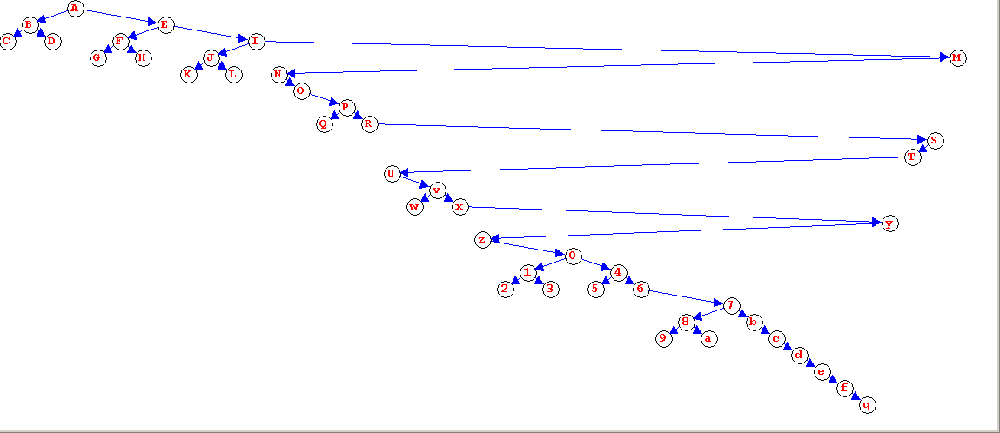

Enter a number to choose the tree to display [0 - 12 (blank line to exit) ]
6
Constructing tree - parameters
============
ABCDEFGHIJKLMNOPQRSTUvwxyz01234567
220022002200LRR20RLLR20L2R20022000

Tree 6 - inOrder(): CBDAGFHEKJLINOQPRUwvz102y54637xTSM
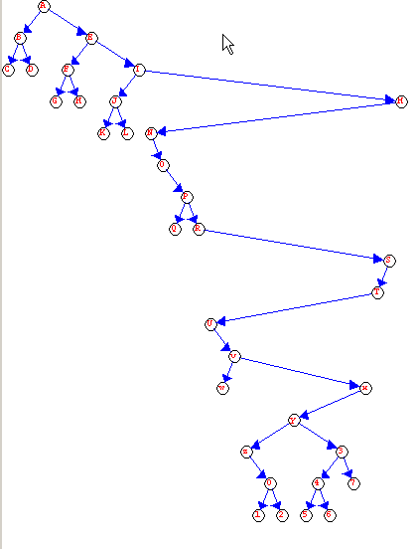
Enter a number to choose the tree to display [0 - 12 (blank line to exit) ]
5
Constructing tree - parameters
============
ABCDEFGHIJKLMNOPQRSTUvwxyz
220022002200LRR20RLLR20RL0

Tree 5 - inOrder(): CBDAGFHEKJLINOQPRUwvxzyTSM
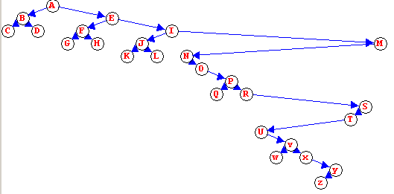

Enter a number to choose the tree to display [0 - 12 (blank line to exit) ]
4
Constructing tree - parameters
============
ABCDEFGHIJKLMNOPQRSTU
220022002200LRR20RLL0

Tree 4 - inOrder(): CBDAGFHEKJLINOQPRUTSM
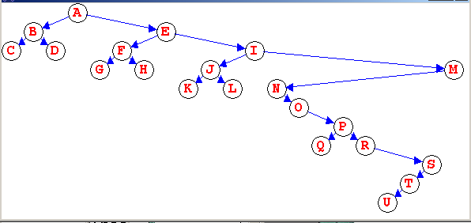

Enter a number to choose the tree to display [0 - 12 (blank line to exit) ]
3
Constructing tree - parameters
============
ABCDEFGHIJKL
RLRLRLRLRLR0

Tree 3 - inOrder(): ACEGIKLJHFDB
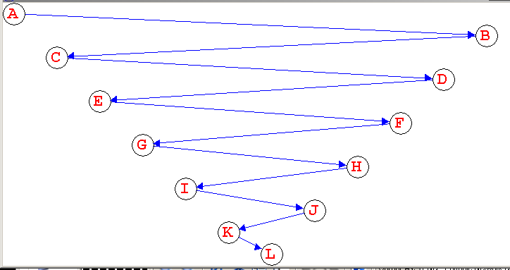

Enter a number to choose the tree to display [0 - 12 (blank line to exit) ]
2
Constructing tree - parameters
============
ABCDEFG
LLLLLL0

Tree 2 - inOrder(): GFEDCBA
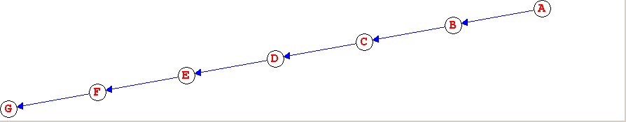

Enter a number to choose the tree to display [0 - 12 (blank line to exit) ]
1
Constructing tree - parameters
============
ABC
200

Tree 1 - inOrder(): BAC
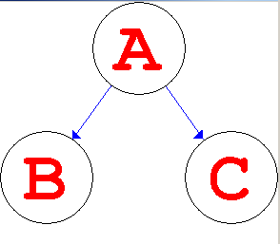

Enter a number to choose the tree to display [0 - 12 (blank line to exit) ]
0
Constructing tree - parameters
============
A
0

Tree 0 - inOrder(): A


Enter a number to choose the tree to display [0 - 12 (blank line to exit) ]

