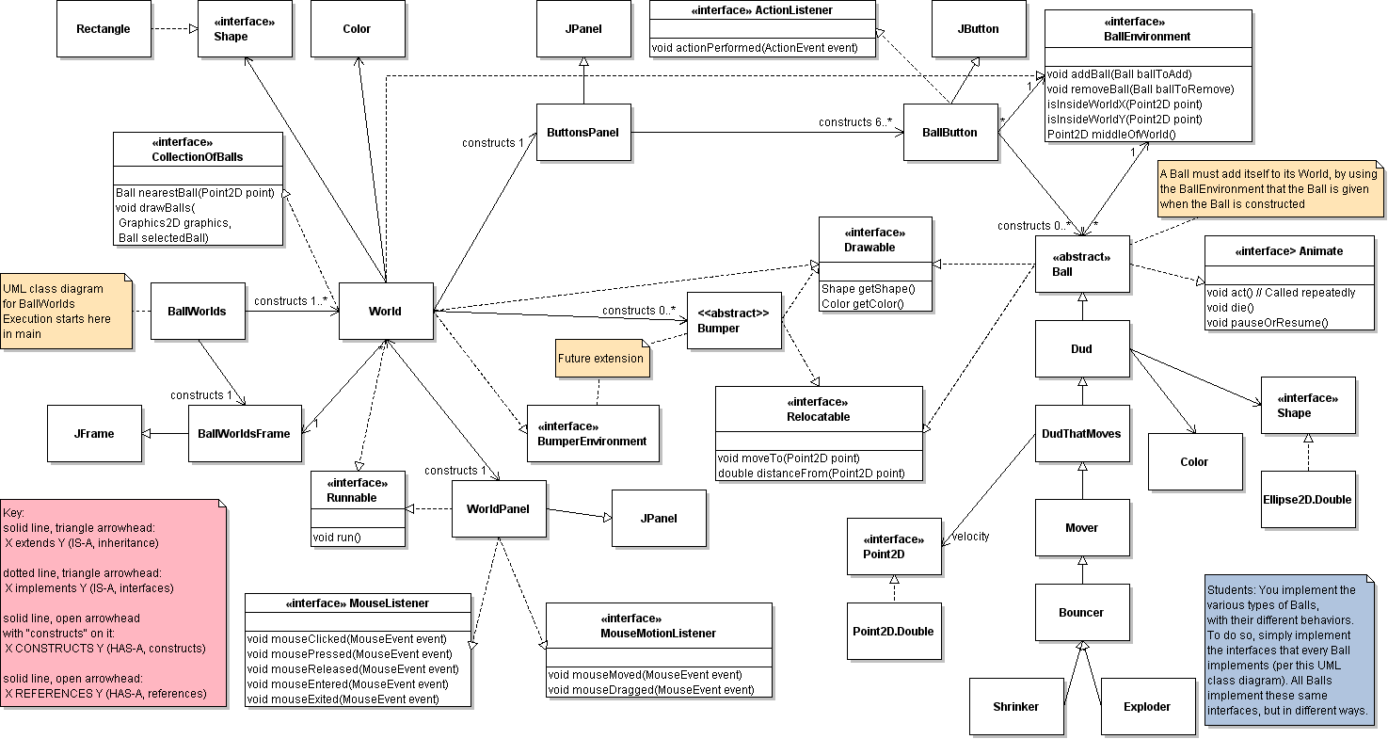
<abstract> Ball

Dud

DudThatMoves

Mover

Bouncer

Shrinker

Exploder

