MA/CSSE 473 HW 6A Problem statements/hints

Problems 1-2 are related to Dasgupta pages 30-34 and Weiss section 7.4 (both on Moodle)

Problems 1 and 2 (copied here from the assignment document):
- (15) (RSA decoding). If small primes are used, it is computationally easy to "crack" RSA codes.
Suppose my public key is N=703, e= 53. You intercept an encrypted message intended for me, and the encrypted message is 361. What was the original message? How did you get the answer?
- (6) Find and read about various ways of attacking the RSA cryptosystem.
Write about two attacks that interest you. Write a paragraph about each one to explain in your
own words how it works.

Problems 3 and 4 would have logically fit into HW 5, but were moved here to better balance out the length of the assignments. There are further clarifications on the HW6A assignment sheet

- (8) 3.4.6 [3.4.6]
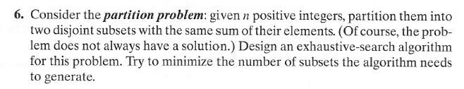
(partition problem) There is only so much a brute force algorithm can do to make this efficient.
Mainly, try to avoid checking duplicate subsets or subsets that cannot possibly be a solution.
- (6) 3.4.9 [not in 2nd edition ] (non-attacking queens) 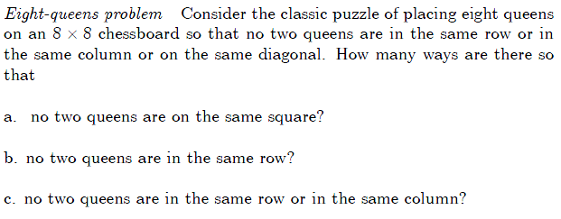
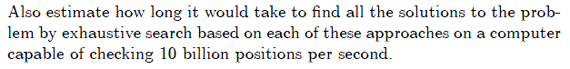
The real question in each case is “if we make only the given restrictions, then check each possibility to see if it is a solution, how many possibilities will we need to check?” If we made no restrictions at all (not even the restriction that multiple queens cannot occupy the same square), then there would be 64⁸ placements to check. How many for each of the given cases?

Problems 5-9 relate to material that should be review from CSSE 230. In addition to the
Levitin textbook, Weiss Chapter 8 should be good background for those.
- Problem 5: (3) 5.1.4 [4.1.4] (logarithm base in Master theorem)
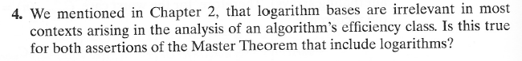
Problem 6: (6) 5.1.5 [4.1.5] (simple application of Master theorem)
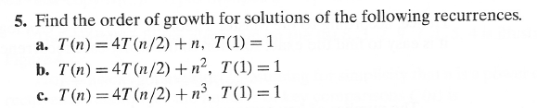
Author's hints for problems 5 and 6:
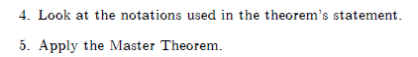
- Problem 7: (6) 5.2.2 [4.2.2] (Quicksort partition scan properties)
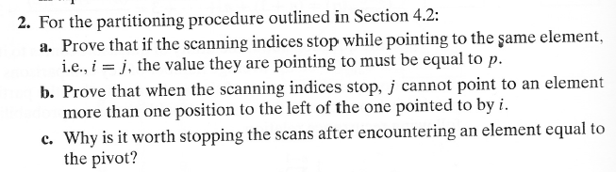
Author's hint for problem 7: Use the rules for stopping the scans.
Problem 8: (10) Not from the textbook.
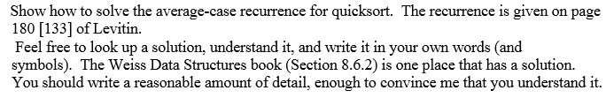

- Problem 7: (9) 5.2.11 [4.2.11] (Nuts and bolts). In addition to writing the algorithm,
write and solve a recurrence relation for average-case running time.

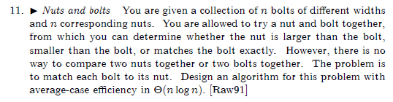
Author's Hints:
Use the partition idea that is part of QuickSort..

