CSSE 473 HW #3 Levitin problems (3rd edition)
The other problems that are not from the textbook are not listed in this document.
All of their details are in the HW3 assignment document, which also contains additional clarifications of the problems.
For these problems, assume that arithmetic operations are constant time.
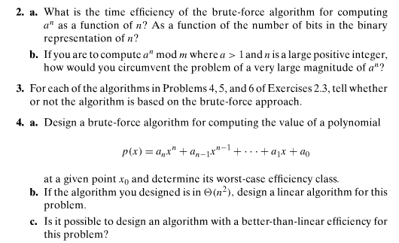
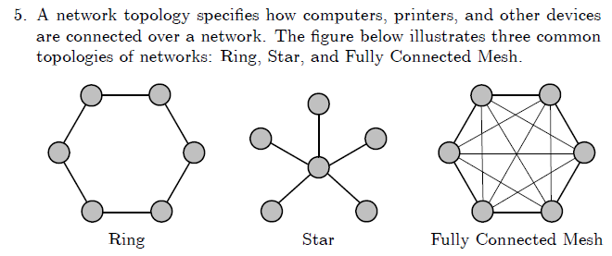
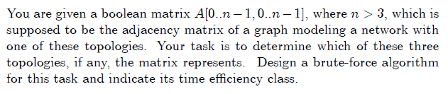

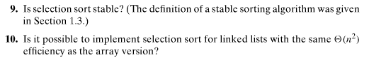
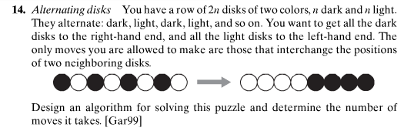

Author's hints for the above problems are on next page:

Author's hints: Section 3.1
