CSSE495 Image Recognition Lab 5: Support Vector Machines

Objective:
1. Learn how to use MATLAB’s Support Vector Machine (SVM) functions to prepare for the next mini-project.

Report Grading Rubric:
Score | Meaning | Description
10 | Exemplary | Report exceeded expectations. Complete, well-written and presented, and particularly insightful answers. Worth posting.
9 | Very Good | Complete, well-written and presented, and insightful.
8 | Satisfactory | Complete. Writing, presentation, and insights are reasonable.
7 | Ordinary | Minor detail missing, or writing weak.
6
5 | Deficient | Basically complete, but didn't demonstrate full understanding of the material.
4
3 | Unsatisfactory | Incomplete or last-minute attempt.
2
1
0 | Not submitted

Deliverables:

Writeup must include:
- All hyperparameters (kernel function and numbers (scale, box constraints)) used
- a table of the number of true positives, false neg., false pos., and true neg.
- the calculated TPR, FPR, and accuracy
- the graphs of the data and decision boundary (contour plot).
- An explanation of your results, including the number of support vectors.
- A short explanation of standardization / scaling.
- An appendix with your modifications to toyProblem.m (and any other functions you write), that
Train an SVM from the first set of data (xTrain, yTrain).
Evaluate and output the class of each point in the test data.
Determine the number of true positives, false negatives, true negatives, and false positives, then calculate TPR, FPR, and accuracy from this.

Summary:
You will use the demo function given with the SVM toolbox as an example of the commands for training SVMs from some examples and using them to classify other examples. You will then train an SVM to classify a new set of data, gaining the opportunity to experiment with different kernel functions and hyperparameters. All of this will be valuable background to the next mini-project, sunset detection.
Overall Directions:
- Copy and unzip the svm.zip package in the folder containing these instructions.

- Run the demsvm1.m script and read the MATLAB output – it’s a short tutorial. Ask questions about anything that you don’t understand.

- Open demsvm1.m, looking for where it trains the SVM and where it uses it to classify points. Note the usage of the two functions, fitcsvm and predict. Ask questions if you don’t understand something. Note also the two specific numbers passed for the class labels to fitcsvm (what are they? I discussed this in class, but this is really important to getting SVMs working correctly. You don’t need to submit this, but make sure you are clear.) You’ll be writing code that uses fitcsvm and predict below.

- Run the demo and ask questions of anything that is still muddy from lecture. When the demo finishes, open up the trained net object in MATLAB and see what properties it has. Specifically, how does it store which training points are support vectors and their corresponding values of alpha? Nothing to submit here – you’ll revisit this below.

Resources
At any point in this lab or in the sunset detector project, if you want more details, check out the MATLAB docs:
https://www.mathworks.com/help/stats/support-vector-machines-for-binary-classification.html (over-all how-to, tons of info here, including how to optimize hyper parameters)
https://www.mathworks.com/help/stats/fitcsvm.html (focus on training, lots here too)
https://www.mathworks.com/help/stats/classificationsvm-class.html (what’s in a trained SVM?)

Now you should be ready to experiment with creating another SVM to classify points from another data set.

For the rest of the lab, you will write code and add some detail to your report. Open the toyProblem.m script. It uses other functions I wrote to generate one data set for training and a similar one for testing. Please add to the script code to do the following, and update your report:

- Train an SVM on the first set of data (xTrain, yTrain). You may use any kernel function you like – even though the data set isn’t linearly separable, this is a good time to try out the baseline linear SVM (if you copy-and-paste from the demo).

Note: each x = (x₁, x₂) is a 2D feature vector, and y is the class (thus, they aren’t just x- and y-coordinates)!

- Use predict to output the classification of each point (+1 or -1) in the second set of data (xTest) using the script. By default, it uses 0 as a threshold.

- Using the predicted output and yTest (the true labels of xTest), calculate the accuracy on xTest, as we defined in class. If you find accuracy that is lower than 90%, take note of it and try a different kernel type and parameters (like polynomial kernels of various orders and RBF kernels with various scales). The documentation for fitcsvm will tell how to use each. Keep experimenting until you get 90% accuracy on the test set.

Hint: you should be able to calculate accuracy in 1 line of code without loops, comparing the list of predicted test labels with the list of true test labels to get a list of Booleans, then summing that list. Ask if this isn’t clear.

- Now that you have 90% accuracy on the test set, calculate the confusion matrix (numbers of true positives, false negatives, false positives, and true negatives) on the test set. You can fill in this table if you like:

True \ Detected | Positive | Negative
Positive
Negative

Also report the overall accuracy, the true positive rate (TPR, or recall), and the false positive rate (FPR). Refer back to your notes if you haven’t yet memorized how to find these. (Hint: these can all be found in 1 line of code.)

- Generate graphs of the training data and the testing data, each with the contour plot of the decision boundary and copy them to your report. (I included some commented-out code to help with this.)

- Use the graph to explain your experiments and results. Are they reasonable, given the data? Specifically, does your classifier achieve 100% accuracy on the test set? Why or why not? Point out 1 or more failure cases and explain why they failed. (Looking ahead, you’ll also do this on the sunset project, but it will be trickier since the “points” are 294-dimension color features, not 2-dimension (x,y) points.). Add to your explanation the fraction of your training points that are support vectors. (Open the trained net to remind yourself how it shows that.) This fraction alone isn’t evidence of overfitting unless you choose to do extension 3 below and make some comparisons.

- Write a short explanation of why standardization / data scaling was not needed here, but why it is typically used in data science and image recognition problems. (Please read and summarize the following paragraphs, adding in anything you like from your own experience.)

The data you are given has the same scale in the x1 and x2 directions: they each range from 0-100. This is a good thing. What’s more common is that they have different scales. (This could be because the features have different meanings. It could even be something as simple as measuring one length in centimeters and another in millimeters. For example, if we did that, our x1 would have a range of 0-100 and x2 would have a range of 0-1000. Since the RBF kernel uses distances between points, the x2 distances would be 10 times as big as the x2 distances and overwhelm them in the distance computations! This would look like Figure 1:
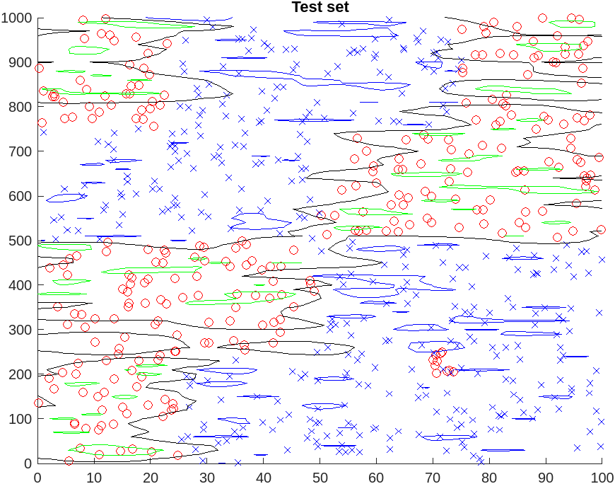
Figure 1: Decision boundary learned from unscaled data.

I’m sure your graphs look much nicer! SVMs allow you to handle this by giving you a built-in option to “standardize” the data. This simply means that each feature (in this case x1 and x2) is subtracted by its own mean and then divided by its standard deviation before training. We can look at the mean and std of x1 and x2. I got
mean(xTrain(:,1)) ~ 49.7 and std(xTrain(:,1)) ~ 28.5,
and
mean(xTrain(:,2)) ~ 505 and std(xTrain(:,2)) ~ 289.
X2 is approximately 10x as large, as expected.
Internally during training, the standardization does the scaling:
x1 = (x1 – 49.7)/28.5 and x2 = (x2-505)/289.
After this scaling, x1 and x2 both have mean = 0 and std = 1, so x1 and x2 each contributes equally in the distance formula. (For data that is normally distributed, recall this means that over 99% of the data will fall in the range [-3, +3] – thank you, stats class!)
Using the option, ‘Standardize’ true, and choosing a smaller kernel scale to match the tighter ranges gives the graph in Figure 2, which is much nicer!

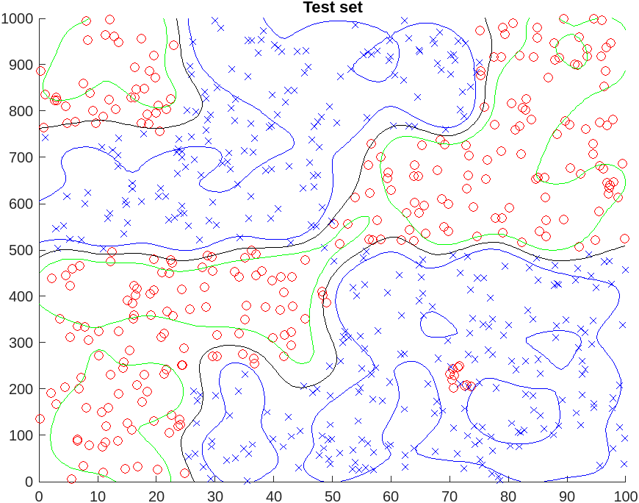
Figure 2: Decision boundary learned from scaled data.

Remember to use this for the miniproject, since the color features we’ll use there have different ranges. I’ll also ask you to write a little about it in the report. So ask now if it isn’t clear.

- Reminder on grading: If you are aiming to earn a 10, what will you do to impress me? I’ll give a few suggestions of extensions here, only because they are all things that you will need to do for the miniproject anyway. So … if you choose to do one of them now, that’s less you’ll need to do later.

- Read one of the first two MATLAB doc pages above and use one of the techniques there to try to optimize the hyperparameters (kernel scale and/or box constraint). A brute force search over hyperparameters or combinations of them is called a grid search in machine learning. (If this is new to you, look at the contour plot on this Wikipedia page. Note: this plot is different than others in this lab: the x and y values could be the kernel scale and box constraint and the contour height is the resulting accuracy on the test set. It is easy to brute-force loop over combinations of hyper-parameters using a loop or nested loop.)
Present evidence in a graph or table that your value(s) are optimal (or close to it) for accuracy on the test set. An example of a table is here, although that table was generated not with a grid search but with an automatic method built in to fitcsvm. (I included more detail in the sunset miniproject specs here, part 1, item 6, if you want to look ahead.)

- The svm predict function gives both the class (+1, -1) and the real-valued distance from the boundary for each example. The default threshold between classes is 0, but if you vary that threshold in small increments, each threshold gives you a point on an ROC curve. (I included more detail and code to create an ROC curve in the sunset miniproject specs here, part 1, item 7, if you want to look ahead).

- Change your kernel parameters so that you get 3 different examples: one in which the classifier overfit the training set, one in which it underfit the set, and one in which it fit the training set reasonably well. (I’m not giving you a definition of any of these, but your intuition is probably correct – this article and its figure here also give the intuition pretty well.) For each, show the contour plot and report what percentage of your training set became support vectors.

