Name:__________________________________ CM: _______ Grade:_____/10

- (1, review) Give formulas to calculate the centroid of a region.

- (6) Perform the requested calculations on the following regions using the formulas described in class. Use 8-connected perimeters and assume 1-based subscripts for the centroids. Give bounding boxes in the form: (r_{min}, r_{max}, c_{min}, c_{max}) For circularity, use 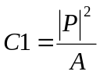 You need not show work for simple calculations.

(7x7 diamond)
0 0 0 0 0 0 0 0 0 0
0 0 0 0 0 1 0 0 0 0
0 0 0 0 1 1 1 0 0 0
0 0 0 1 1 1 1 1 0 0
0 0 1 1 1 1 1 1 1 0
0 0 0 1 1 1 1 1 0 0
0 0 0 0 1 1 1 0 0 0
0 0 0 0 0 1 0 0 0 0
0 0 0 0 0 0 0 0 0 0
(5x5 rectangle, with one pixel missing)
0 0 0 0 0 0 0
0 0 0 0 0 0 0
0 1 1 1 1 0 0
0 1 1 1 1 1 0
0 1 1 1 1 1 0
0 1 1 1 1 1 0
0 1 1 1 1 1 0
0 0 0 0 0 0 0

a) Area: _____ Area: _____
b) Centroid: ___________ Centroid: ___________
c) B. Box : ____________________ B. Box : ____________________
d) Extent : ____________________ Extent : ______________
e) Circle each perimeter pixel (P₈): in each figure
f) |P₈|: ____________ |P₈|: ____________
g) Circularity: _____________ Circularity: _____________

- (1) Why is |P₈| ≤ |P₄|?

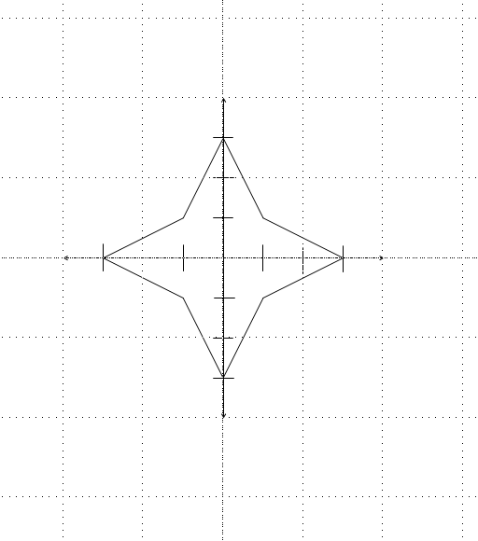
- (2) Draw the radial representation of this shape. You must label your axes and draw it approximately to scale. Each tick mark is 1 unit:

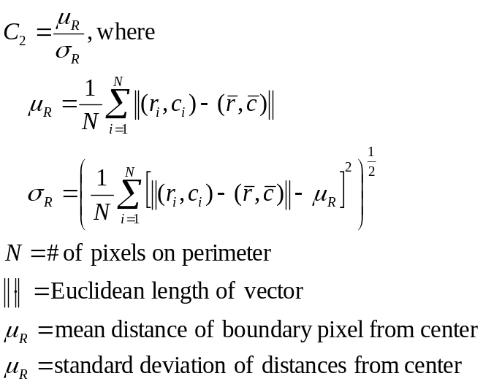

- (0) Tell your instructor about anything from today's session (or from the course so far) that you found confusing or still have a question about. If none, please write “None”.

