CSSE375 Sec 2 & 3
Individual Homework 1
UI Error Handling
Purpose: For you to wrestle with realistic demands on verifying and controlling user inputs.
Due date: 11:55 pm, Thursday, May 1.
To Do: Write a Java Eclipse program which implements the GUI prototype shown below. Recommended that you use SWING. If you use anything else, it should be runnable by clicking RUN in Eclipse, without having to add new libraries. Your program should meet the following specs:
- It should allow user inputs in all the 5 fields shown in Figure 1 as data entry locations.
- Actually, the user will enter data into any 4 of these, and the program will calculate the 5th value. The user can choose which 4 to enter, in any order.
- The 5th value is calculated by the program, so that the top 4 add up to the bottom number. E.g., if the user enters 1, 2, 3, and 4 for the top 4, then 10 shows as the total. If the user enters 1, 2, 3, and then skips down to enter 11 as the total, the program provides 5 as the missing 4th entry to get that total.
- The entries can be completed by hitting “Enter,” as a sign to tell the program to check them.
- All entries must be positive integers. If anything else is entered, the program should show an error message to the right of the error entry, as shown in Fig 1.
- As soon as there are 4 entries, the program will show the correct 5th entry that goes with these.
- The top 4 numbers must be in increasing order, like in the examples shown in point 3, above. If this is incorrect, the program should show an error in the appropriate place till the problem is fixed.
- All entries, including the total, should be in the range 0 to 1000.
- Note that the result of an error entry could mean that a different entry is fixed!
- The program finishes by “X”-ing its window. There is no “Done” button required. The actual goal is to let the user “fix” their experimental data so that it fits these requirements!
Your program will be graded partly on “elegance” – as in, how easily can it be understood and how easily, in the grader’s opinion, could it be changed.
Clearly, this program should be covered with unit test cases, to follow Feathers’ advice. We may do that as a follow-up, but there’s no need to do it now.
Do not do this as all one class. Make it MVC, and have the Model detect errors in the data, and report these back to the Controller. The Controller should look like a “use case” to get this data and verify it through the Model. The View should provide the display and alert the Controller when a new entry has been completed.
Your design should, therefore, pass error information among the MVC classes. It should do this primarily via throw/catch mechanisms. If you have to provide validity data using some other means, like the value in a “return” statement, be sure to document why you had to resort to that!
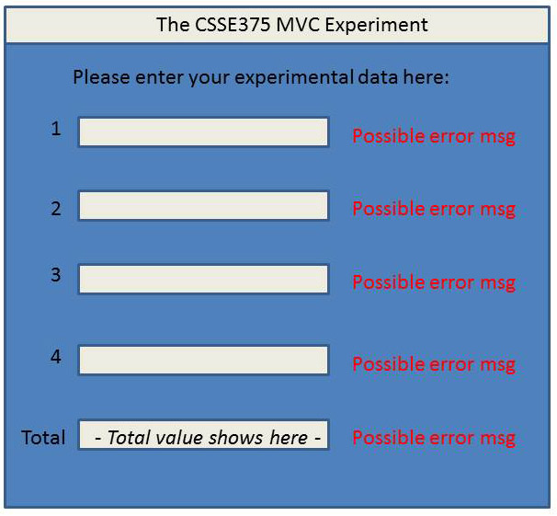
Figure 1 – The GUI prototype.

