CSSE 374 – Software Design

Quiz 28
- Label the parts on the UML activity diagram below. (If you are doing this electronically, you should be able to use text fields to do this.)
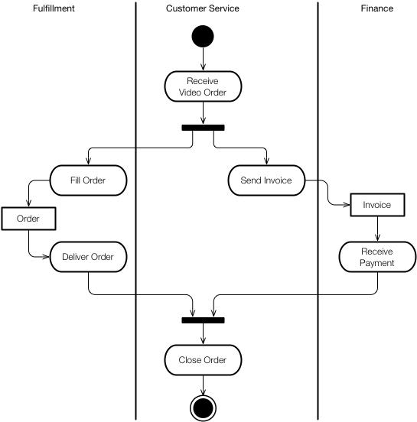
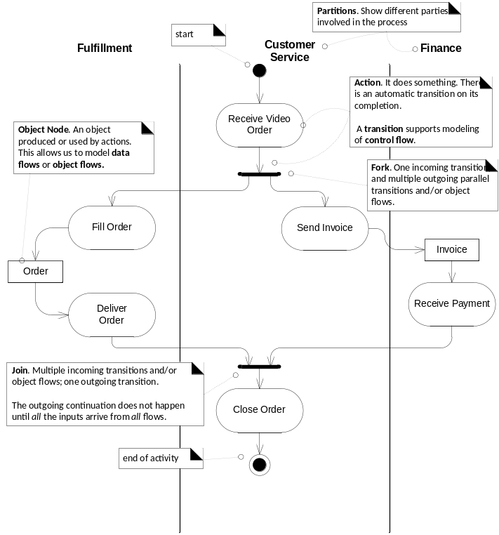

- In a UML activity diagram, what does this symbol, , represent?

- What is the difference in meaning between the following two symbols:
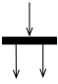, and 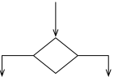.

- Sketch (and bring to class) an activity diagram for creating an account, with username and password, on a website. Be sure to include swim lanes for the User, the System, and an external CAPTCHA Service. Your diagram should include
  - a check that the password is valid,
  - a check that the username has not already been used, and
  - a check that the user entered the CAPTCHA text correctly.
The last two checks should be done in parallel, the first by the System and the second by the CAPTCHA Service.

- List something (if anything) that became clear to you as a result of studying for today's class. Write None or N/A otherwise, so we know you gave it some thought. (Completely blank answers to feedback questions like this will receive 0 credit!)

- Note anything from today's material (or from the course so far) that you still have a question about. If you think about it and there's really nothing, then write None or N/A so we know you gave it some thought!

Here’s an example of a CAPTCHA, or Completely Automated Public Turing test to tell Computers and Humans Apart: 