CSSE 374 – Software Design

Quiz 10
- Interaction diagrams are used for static/dynamic (circle, or write below, one of these) object modeling.
- The two most common interaction diagrams are ________________ diagrams and _________________ diagrams.
- Draw a lifeline box representing a named instance of a class Store.

- Label the parts of the sequence diagram below (if you are doing this electronically, you can write your answers in the spaces under the figure):
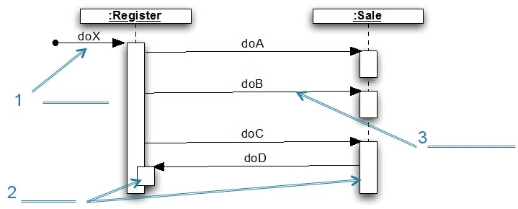
(1)

(2)

(3)
- What interaction frame operator is used to represent an if-then-else control flow?

- What two interaction frame operators are used to show that one sequence diagram uses another?
_______ and _________

- Sketch your own version of a sequence diagram for the Rent Video Example that we’ll do in class (see Slides 23+, and also, in the Session05 slides, the use case on slides 15-16).

- Label the parts of the communication diagram below:
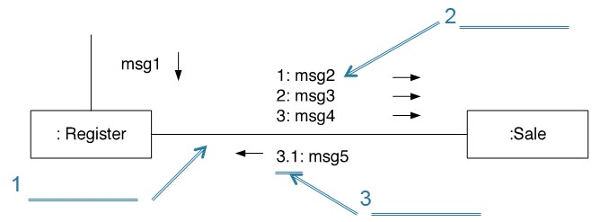
(1)

(2)

(3)

- What do we write after the sequence number to show…
… conditional execution: ________________
… iteration: ______________
- Sketch your own version of a Communications diagram for the Rent Video Example on Slides 23+ (See also, in the Session05 slides, the use case on slides 15-16).

- List something (if anything) that became clear to you as a result of studying for today’s class. Write None or N/A otherwise, so I know you gave it some thought.
(Completely blank answers to feedback questions like this will receive 0 credit!)

- Note anything from the reading and quiz (or from the course so far) that you still have a question about. If you think about it and there's really nothing, then write None or N/A so I know you gave it some thought.

