If you couldn’t complete the Moodle version of this survey, please do this one and email to me. Thanks.

Your Section of 374 ________
(Position:1)
() Your name (last, first)

(Position:2)
() Daytime phone number


(Position:3)
() What you're doing next summer (very briefly)

(Position:4)
() Your first major, second major

(Position:5)
() Your aggregate GPA in CSSE, EE, and CPE courses (we will not look at this answer till after the course):

(Position:6)
() Beyond the fact this is a required course, what would you like to get out of 374?
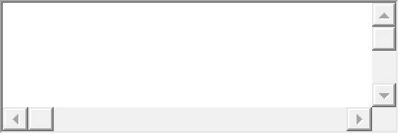

(Position:7)
For the following, indicate your familiarity with these methods and practices, on a scale of 1 to 5:
1 -> Little or no exposure
2 -> Have read about it
3 -> Have used it, but very little
4 -> Somewhat proficient with it
5 -> Proficient / expert with it

(Position:8)
() Using agile methods to develop a product for a real customer. (1 - 5)


(Position:9)
() Delivering a completed software product as part of a large team. (1 - 5)

(Position:10)
() Negotiating with clients about the scope of upcoming features. (1 - 5)

(Position:11)
() Using UML diagrams like class diagrams and interaction diagrams to document a design. (1 - 5)

(Position:12)
() Applying Gang of Four patterns like Observer, Adapter, and Abstract Factory to standardize a design. (1 - 5)

(Position:13)
() Using SOLID principles like dependency inversion to generalize code. (1 - 5)

(Position:14)
() Reviewing design documents to decide the feasibility and soundness of a design. (1 - 5)

(Position:15)
() Using design tricks to improve the cohesion and coupling of a design. (1 - 5)

