Name: ______________________________________ Section: 1 2 3 4 5

PRINT this document and handwrite your answers on it. Bring your solution to class.
Throughout these problems:
- Use the boxes we supplied; just add labels and arrows for variables and data for non-container objects.
- Assume the existence of a Point class with just two instance variables
(x and y).
- Assume the existence of a Circle class with just two instance variables (center and radius, where center is a Point object).
As a reminder, here are the four rules for drawing box-and-pointer diagrams, followed by an example from the video.
Rule 1: Draw a NON-container object by putting its value inside a box.
Rule 2: Draw a variable using a box labeled with the variable’s name and with arrows from the box to the object to which the variable currently refers.
Rule 3: Draw a CONTAINER object by making a box for it, and then creating sub-boxes that are drawn as if they were variables, but with names for the instance variables of an object and indices for items of a sequence.
Rule 4: When code RE-assigns a variable, as in x = blah:
- Evaluate the expression on the right-hand-side. If it is a new object, draw a box for it.
- Cross through the existing arrow from the variable.
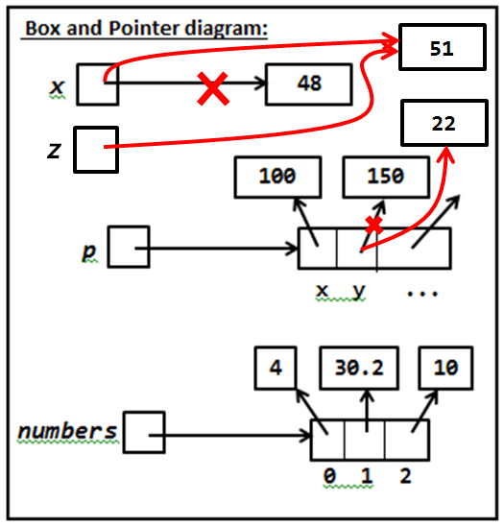
- Draw a NEW arrow from the variable to the object to which the right-hand-side evaluated.
Arrows ALWAYS go FROM a variable’s box TO an object’s box.
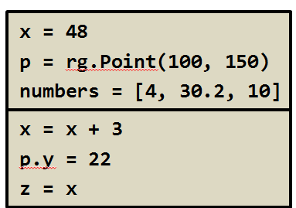
Arrows NEVER go from a variable’s box to another variable’s box.
- Draw a Box-and-Pointer diagram that shows what happens when the following statements execute. Also indicate what output is printed.
Output:
x: __________
r: __________
p.x: ___________
p.y: ___________
c.center.x: _________
c.center.y: _________
c.radius: _________
Box and Pointer diagram:

x = 33
r = 20
p = Point(80, 50)
c = Circle(p, r)

print('x:', x)
print('r:', r)
print('p.x:', p.x)
print('p.y:', p.y)
print('c.center.x:', c.center.x)
print('c.center.y:', c.center.y)
print('c.radius:', c.radius)
- This problem continues the previous one. We have drawn a SOLUTION to the previous problem below. Use it to check your answer to the previous problem. Then augment the box-and-pointer diagram below to include the new statements in the code below. Also indicate what output is printed by the print statements that follow that new code.
Previous problem printed these numbers.
33
20
80
50
80
50
20
Output from 2nd set of print statements:
x: __________
r: __________
p.x: ___________
p.y: ___________
c.center.x: _________
c.center.y: _________
c.radius: _________
x = 33
r = 20
p = Point(80, 50)
c = Circle(p, r)
<same print statements as in problem 1>

r = 77
p.x = 44

<same print statements as in problem 1, repeated here>
Box and Pointer diagram:

33
20
80
50

x
r
c
p
x
y
center
radius
New code is here

Your next problems will involve function calls.
A function call creates a new namespace in which the function will run. The parameters are variables in that namespace, as are all variables assigned values with assignment in that function.
def main():
x = 44
y = 33
foo(100, x)

def foo(a, b):
...
x = ...
So for example, in the code snippet to the right, when function foo is called, the box-and-pointer diagram will gain 3 new variables labeled a, b and x, respectively. These are in addition to any variables by the same name that are in main’s namespace. That is, after foo is called in the snippet to the right, the box-and-diagram will look like the one shown below on the LEFT, in part.
Furthermore, when a function is called, each parameter is assigned the value of the corresponding actual argument.
For example, in the code snippet above, when foo(100, x) executes, the parameter a is assigned the value 100, just as if the statement a = 100 were executed, and the parameter b is assigned the value of the variable x, just as if the statement b = x were executed. The diagram on the RIGHT shows the effects of those assignments. Study that picture carefully!
Box and Pointer diagram:
In main’s namespace:

In foo’s namespace:

x

y

b

a

x
44
33
100
Box and Pointer diagram:
In main’s namespace:

In foo’s namespace:

x

y

b

a

x
44
33
100
- Draw a Box-and-Pointer diagram that shows what happens when main executes. Also indicate what output is printed, assuming appropriate print statements.
Box and Pointer diagram:
In main’s namespace: In foo’s namespace:

def main():
a = 44
b = 33
z = 22
p1 = Point(100, 200)

foo(a, b, z, p1)

<print statements here>

def foo(x, y, z, p):
x = 10 * x
y = 88
p.x = 1
p = Point(300, 400)
p.y = 2
Output:
a: __________
b: __________
z: __________
p1.x: ___________
p1.y: ___________

We have already drawn all the boxes that you need
Just draw arrows (and eventually X’s).

x
y
400
300
2
1

p
440
88
10

z
y
x

200
100
22
33
44

y

x

z

b

p1

a

There is an exception to this regarding global variable, but we won’t be using global variables, as their use is a practice that does NOT scale up to real-sized programs.

