CSSE 120 – Introduction to Software Development
Concept: Namespaces and variables’ Scope
Today’s programs might have millions of variables. If we had to think of a different name for each one, we would be in trouble! For that reason, variables are local to the functions or class instances in which they are defined. That is, each function call has its own namespace, which means:
With functions:
- When a function is called, a namespace for its variables is created. The function’s parameters and any variables defined inside the function are placed into the function call’s namespace.
- Variables in one namespace have NOTHING to do with variables of the same name in another namespace. The namespaces are completely independent.
- When a function returns to its caller, its namespace (and all the variables defined in it) is “forgotten” and no longer available.
With instances of a class:
- When a class is instantiated, a namespace for the variables of the class instance is created. The class methods and any variables given to the instance are placed into the class instance’s namespace.
- Variables in one class instance have NOTHING to do with variables of the same name in another class instance because they are in different namespaces. Variables in one namespace have NOTHING to do with variables of the same name in another namespace. The namespaces are completely independent.
The next page shows the creation of namespaces, from a textbook by Ljubomir Perkovic. The pages after that present a concrete example using functions. You will see similar effects with different instances of a class in the future when we use classes more.

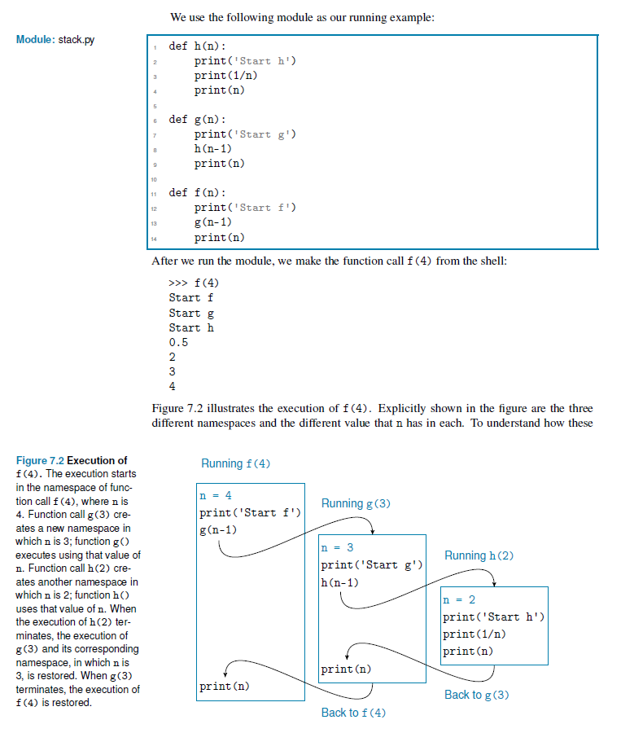

Here is a concrete example to show that variables are local to their function.
In the code shown to the right:
def main():
x = 10
y = foo(x)
x = 'hello'

y = foo(y)

def foo(m):
x = 89
return (m * x)
- The three x’s in main have nothing to do with the x in foo – changing the x in foo does not affect the x’s in main, and vice versa.
- The three x’s in main refer to the same place in memory – changing any of them changes the others.
- The two y’s in main refer the same place in memory -- changing either of them changes the other.
- The x and y in main have nothing to do with the m (or any other variable) in foo – these three variables each have their own space in memory.
However:
  - Because a function call assigns values to the parameter of the function, there is a relationship:
    - When foo(x) in main runs, the variable m in foo is assigned the value of x in main at that point. (That value is 10 in this example.)
    - When foo(y) in main runs, the variable m in foo is assigned the value of y in main at that point. (That value is 890 in this example).
  - Also, recall that a return sends a value back to the caller. So when the statement
y = foo(x)
in main runs:
    - First, the right-hand-side is computed. That is, foo(x) is evaluated. This means that the m in foo is set to the value of x in main (which is 10 at this point). Then the code in foo runs and then the return statement in foo executes, sending (10 * 89), which is 890, back to main.
    - Second, the left-hand-side of the y = foo(x) statement is executed, so y in main is set to 890.

Try tracing the execution of the code (starting in main) by hand. That is, write down line-by-line what variable(s) are changed to what values, being sure to distinguish variables in one function from variables by the same name in the other function.
The answer is shown on the next page, but try it yourself first!

Here is a “trace” of the execution of the code (starting in main). The code is repeated to the right for your convenience.
def main():
x = 10
y = foo(x)
x = 'hello'

y = foo(y)

def foo(m):
x = 89
return (m * x)
- x in main is set to 10.
- foo(x) is called, which means:
  - m in foo is set to 10.
  - x in foo is set to 89.
  - (m * x) is computed to be 890, and 890 is returned to the caller.
- The rest of y = foo(x) in main runs, so y in main is set to 890.
- x in main is changed to 'hello'.
- foo(y) is called, which means:
  - m in foo is set to 890.
  - x in foo is set to 89.
  - (m * x) is computed to be 890 * 89, which is 79,210, and 79,210 is returned to the caller.
- The rest of y = foo(y) in main runs, so y in main is changed to 79,210.

