CSSE 120 – Introduction to Software Development
Getting started in Python – Numbers, Arithmetic Operators, Expressions, Objects, Types, Variables, Assignment, Calling Functions, Input and Output (whew! )
Instructions:
- If you have not already done so, do the PyDev Console by Pictures exercise, per the handout by that name.
  - It shows you what a PyDev Console is, how to open it, and how to work inside it.
- Open a PyDev Console in Eclipse to do the following exercises. But note:
  - Don’t just type – make sure you understand what is happening.
  - If you are doing this in class, ask questions – the exercise is crafted to generate questions as much as answers!
  - If you are doing this outside class, either post to the Piazza web site (see the Resources on the course home page) or bring your questions to class.
You will find much of this exercise straightforward. But you will probably find some of it quite mysterious. That’s OK if you ask questions until you understand the concepts shown in this exercise.

  - The instruction “evaluate the following” means: Type the item at the prompt in the PyDev console, press Enter, examine what the computer spits back, and make sure you understand why that expression yields that result.
For example, the first exercise below says to evaluate:
      - + 8
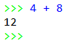
So, you type that in the PyDev Console (after the >>> prompt). You will see that the computer spits back 12. (Duh!) Assuming that you see why it spit back 12, you continue to the next step of the exercise.
If you don’t understand these instructions, ask your instructor for help NOW.

Numbers and arithmetic. Operators and expressions. Parentheses and precedence.
- You can do the usual arithmetic operations with numbers. Try evaluating the following:
4 + 8
7 * 10
1.53 + 8
- Do some subtraction and division using examples that you choose.
Yes, do it now!
- We call things like + operators. It is a binary operator because it needs TWO things, one on its left and one on its right. (Binary means “two”.)
We call things like 7 * 10 and 4 + 8 and (4 + 2) * 3 expressions.
You can use parentheses to make sense of expressions with more than one operator. Try these:
(4 + 2) * 3
4 + (2 * 3)
4 + 2 * 3
Parentheses matter! Use them, especially at first, so that you don’t have to remember all the so-called precedence rules.
- The exponentiation (raising to a power) operator is **
Try it:
2 ** 10
10 ** 2
2 ** 0.5
- Do more examples until you are sure you understand exponentiation in Python.
Yes, do it now!

Exceptions, run-time errors.
- You would expect bad things to happen from bad arithmetic. Try:
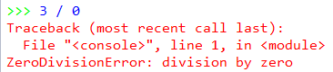
3 / 0
You should see a red error-message like the one to the right. Read it. If it makes no sense to you, ask someone to clarify.
Errors like these are called exceptions, or sometimes run-time errors.
- You would expect bad things to happen from other bad expressions. Try:
3 / hello
You should see a red error-message. Read it. If it makes no sense to you, ask someone to clarify.
- Write another couple of expressions that cause error messages. Be creative! Be sure you understand the error messages.
Yes, do it now!

(This exercise continues on the next page.)

Objects and Types. Int, float, string.
- In Python, every “thing” (that is, every item of data) is called an object.
An object has a type and a value. Let’s learn some types, like this:
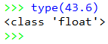
The type function tells you what the type of an object is, as shown in the PyDev Console snippet to the right. Note that types are sometimes called classes; two ways to say the same thing, in this context.
Use the type function to determine the type of each of the following objects.
482
Those are double-quote characters (SHIFT-single-quote on your keyboard), NOT two single quotes in a row!
48.203
"blah blah blah"
'yada yada'
[4, 2, 9]
min
min(4, 6, 2, 12, 10)
min(4, 6, 2.0)
Do you see why the types of the last three expressions are different? If not, ask someone!
- Objects of type int and float can do the usual arithmetic operations:
  - Type an expression that involves addition, subtraction and multiplication (but NOT division, yet), using whole numbers (which are of type int).
  - Repeat the above, but making just a single one of the numbers in your expression a float, by appending a decimal point to it, like this: instead of 2 (which is an int) write 2.0 (which is a float).
  - Now try division:
4.2 / 2.0
4.2 / 2
4 / 2
3 / 2
What do you notice about the type that results from division, even if both arguments are int’s?
Numbers can also do other operations that we’ll learn about later.
- Objects of type string can do a sort of arithmetic. Try expressions like this (feel free to use your own strings and numbers):
'hello' + 'goodbye girl'
Those are double-quote characters (shift-single-quote on your keyboard), NOT two single quotes in a row!
'big' * 20
('hello' + 'goodbye girl') * 8
'single quotes' + "double quotes"
- In Python, both single and double quotes can denote strings. Use both to figure out how to write a string that has a single-quote as part of the string (for example, the contraction isn’t ). Ask for help if you don’t see how to do this!
Yes, do it now!
To summarize: An object has a type and a value. For example:
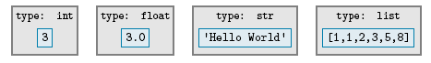
The type of an object determines:
- The kind of thing the object is
- What kind of thing the object knows (we call those fields) and what kind of thing the object can do (operations, like you have just seen, and more generally what’s called methods).

What does an object know and what can an object do?
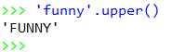
- The type of an object determines what an object knows and what it can do. For example, strings know their characters and can return an upper-case version of them, like this:
'funny'.upper()
Try it!
We will see LOTS more of this
“who DOT does-what PARENTHESIS with-what PARENTHESIS”
notation starting in Session 3.

(This exercise continues on the next page.)

Variables and Assignment.
greeting

- A variable is a name that refers to an object.
For example, the variable greeting might refer to the object shown above.
The value of a variable is the object to which the variable refers. A variable gets its value through an assignment. One way to do assignment is by using the = (read it as “gets”) operator. For example, to make greeting refer to the object above, we would write:
greeting = 'Hello World'
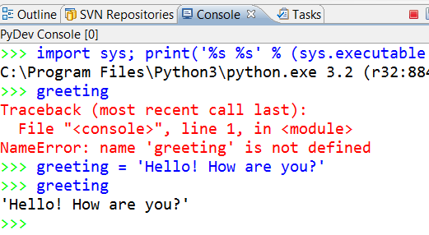
Until you assign a variable a value, it has no value; we say that it is not defined. For example, if you typed greeting in a PyDev Console before typing an assignment statement like the above, you get an error message, as shown to the right.
Note that variables are sometimes (as in the error message to the right) called ‘names’; two ways to say the same thing.

As you have just read, the assignment operator = gives a value to a variable.
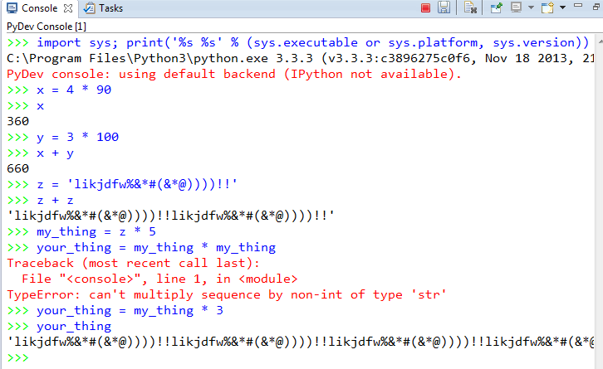
Practice assignment by giving variables values of type int, float and string, and then using those variables in expressions to define new variables, as suggested in the picture to the right (but use your own variables and expressions, and note that I purposefully made an error in my example).

Yes, do it now!

Dynamically typed versus statically typed.
- In Python, variables don’t themselves have types. If you ask for the type of a variable, what you are really asking for is the type of the object that the variable refers to. Languages in which variables don’t themselves have types (but the objects to which they refer do) are called dynamically typed languages – Python is one such language. Statically typed languages that you might have heard about include C, C++ and Java.
Try these (one at a time, in this order), and use type(x) between each to determine the (current) type of the variable x.
x = 45
Remember, do type(x) between each of these to see the current type of the variable.
x = -5.32
x = x + 10
x = 'hello' * 20
What do you notice about the type of the variable x – does it stay the same throughout or change?
Also, after you have changed x from 45 to something else, can you “get back” the 45?
(Answer: No, not in this context.)
Throughout these examples I will use short, silly names – in real programs the variables would have meaning and hence you would use a meaningful name for them.

- See if you can make sense of this:
x = 5
x = x + 1 (and then enter x to see what x evaluates to now)
If you understand why the latter is perfectly sensible computer science (but lousy mathematics), then you understand the assignment operator. Ask questions as needed about this KEY IDEA!

The assignment operator is not symmetric.
- When an assignment statement blah = such-and-such executes:
- First, the right-hand-side is evaluated (computed), thus yielding an object.
- Then, the variable (name) on the left-hand-side is made to refer to the object on the right-hand-side.
There is a big difference between the two sides of an assignment! Try the following (some of which yield error messages):
a = 45
45 = a

b = 10
c = b + 20
b = c
(and then enter b to see what b evaluates to now,
and likewise enter c to see what c evaluates to now)
Make sure that you understand the non-symmetric aspect of the assignment operator = now. Ask questions as needed!
Calling functions.
- Next, let’s see how you call functions, where a function is just like in mathematics (in this context).
Functions are defined in modules (Python’s word for a file that contains Python code – sometimes we also call a collection of one or more modules a library). Many of the mathematics functions are in the math module. The notation for using such functions goes like this:
  - First, you need to import the relevant module (i.e., library).
import math
You need to do that only once per PyDev session – it “sucks in” the definitions of all the math functions, for you to use in the rest of the session.
  - Then, you precede the function name by the module name and a dot, like this:
math.sin(3.14)
x = math.pi
math.cos(x)
Try the above (don’t forget to do the import math first).
Yes, do it now!
- PyDev does a wonderful thing to help you learn the names of the functions in a library – after you type the DOT after math, if you pause at that point, PyDev pops up all the functions (and other things) in the math library, like this:
This is what I typed. Note the DOT after math

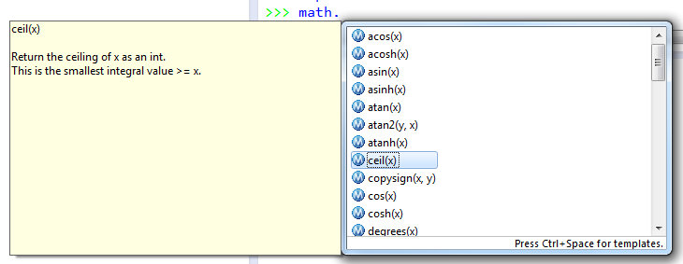
This part pops up when you select one of the items in the list. The quality of the documentation varies, but for the math library it is pretty good.

This part pops up first. You can scroll to see ALL the functions (and other things) in the math library!

Using this “dot trick”, try some other functions from the math library until you feel comfortable with them.
Yes, do it now!

- The functions (and other things) in the builtins module are well, “built in”. So you don’t have to type the builtins-dot in front of them (and would not ordinarily do so). Try:

builtins.abs(-445)
Everyone uses the second, shorter, form. But you should see that even the builtins are from a library, just like the math functions. There are many thousands of Python libraries.
abs(-45)
min(55, 3, 20, 4)

Input and strings. The float and int functions.
- Most of the functions you have explored so far are like the math.sqrt function – it takes a number and returns a number (namely, the square root of the given number). So if you type:
z = math.sqrt(9)
then z’s value will be a number (about 3.0). Let’s look at some functions that operate on strings instead of numbers.
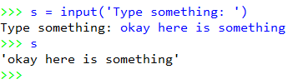
One of the builtins functions is the input function. It takes a string as an argument and displays that string as a “prompt” to the user to type some input. It then waits for the user to type something and press the Enter key. It returns whatever the user typed, as a string.
For example, consider the snippet in the box to the right. I typed the blue stuff, the computer typed the rest.

Try it yourself – do some input statements like the one shown, but with your own prompts (inside the parentheses), your own variables (to the left of the = sign) and your own input (whatever you type after the prompt appears).

Yes, do some input statements now!
Make sure that you see how what you (the human) type after the prompt gets stored in the variable that you (the programmer) chose.

Try to understand the important, but perhaps subtle, distinction between:
  - the string that you give to the input function as an argument (i.e., the string that you, the programmer, put inside the parentheses), and
  - the string that the input function returns (that comes from the human being using your program)
The former ( 'Type something' in the example in the box above) is information that is “sent” to the input function, and the latter ( 'okay here is something' in the example in the box above) is information that is “sent” from the human being typing in the PyDev console. While “sending” is involved in both of these, they are completely different concepts. The distinction will become more clear when you see input statements in the context of an entire program (not just in the PyDev console), but feel free to ask questions about input even at this stage.
- Let’s look at what happens when the human user provides input that is intended to be a number.
First, predict what the computer will print after I pressed Enter at the end of this snippet:

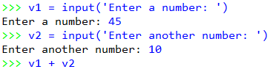

Yes, make your prediction now!

Then, type in the same thing that I did (you can use your own prompts if you like) and see if your prediction was accurate.

Yes, type in the stuff and compare the result against your prediction!

- You should see from the preceding problem that the computer did NOT “add” 45 and 10 and thus display 55. To make that happen, we need to tell the computer to consider the inputs as the numbers that the strings represent.
The int and float functions are what we need. Try the following in your PyDev console to understand what the int function does:
Type a whole number (aka integer) when the prompt appears. For example, you might type 45
v = input('Enter a whole number: ')
v
int(v)
Then repeat the above, but using the float function (and enter a number with a decimal point in it, like 43.7).
Do you understand what the int and float functions do? If not, ask someone!
- Now combine what you just learned about float with what you previously learned about input to solve the following problem:
Type:
v1 = input('number: ')
v2 = input('number: ')
Now write the expression that really adds v1 and v2
(producing 55 – and not 4510 – if the human enters 45 and 10 as the respective inputs).

Output and the print function.
- Input takes information from the human user and sends it to the computer. (You can input from lots of other things too, like files and the internet, but we are focusing on the Console here.) Output does the reverse – it takes information from the computer and displays it for the human user.
The input function does input. (Duh!) The print function does output.
Here are a few examples:
x = 88
y = 101
print(78 + math.sqrt(x) + (y ** 3))
print(x, y, x + y)
print('Here is a big number', y ** x)
It is hard to appreciate the print function when you are typing expressions in the PyDev Console. It will make more sense when you see it in a full-fledged program.

Indeed, that is where we are headed next – to full-fledged programs!
- Use the PyDev console to explore single-line statements like you have in this exercise.
- Use Eclipse’s editor to write, run and debug full-fledged programs, as you will see in an exercise coming very soon!

