CSSE 120 – Introduction to Software Development
Getting started in Python:

Open a Python Console as described in a previous document. Throughout these exercises, type within your Python Console to “evaluate” things as directed, which means:
- Type the item at the prompt in the Python Console.
- Press Enter.
- Examine what the computer spits back, and
- Make sure you understand why that expression yields that result.
For example, the first exercise below says to evaluate:
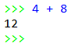
      - + 8
So, you type that in the Python Console (after the >>> prompt). You will see that the computer spits back 12. (Duh!) Assuming that you see why it spit back 12, you continue to the next step of the exercise.

As you work through these exercises, do the associated Moodle quiz. Answer the questions in the Moodle quiz WITHOUT typing those questions into the Python Console, as best you can; that way, you can self-assess how well you are understanding the concepts in this exercise.
- Don’t just type – make sure you understand what is happening.
- BRING YOUR QUESTIONS TO CLASS.
You will find many of these exercise straightforward. But you may find some of them quite mysterious. That’s OK – just ask questions in class until you understand the concepts shown in these exercises.

Part 1: Numbers, Arithmetic, and Precedence
- You can do the usual arithmetic operations with numbers. Try evaluating the following in the Python Console:
4 + 8
7 * 10
1.53 + 8
- Do some subtraction and division using examples that you choose.
Yes, do it now in your Python Console!
- We call things like + operators. It is a binary operator because it needs TWO things, one on its left and one on its right. (Binary means “two”.) We call things like 7 * 10 and 4 + 8 and (4 + 2) * 3 expressions.
You can use parentheses to make sense of expressions with more than one operator. Try these:
(4 + 2) * 3
4 + (2 * 3)
4 + 2 * 3
Parentheses matter! Use them, especially at first, so that you don’t have to remember all the so-called precedence rules.
- The exponentiation (raising to a power) operator is the ** symbol. Try it:
2 ** 10
10 ** 2
2 ** 0.5
- Do more examples until you are sure you understand exponentiation in Python. Yes, do it now!
If you have not already done so, do Part 1 of the Moodle quiz (on Numbers, Arithmetic, and Precedence).
Part 2: Syntax and Run-Time Errors; Exceptions
- Python programs have a notation, or syntax, that is required for the Python interpreter to execute (run) the program. Violations of the required notation are called syntax errors.
PyCharm notes such errors even before you run the program. If you run a program that executes a statement that has a syntax error, you get a run-time message like in this example:
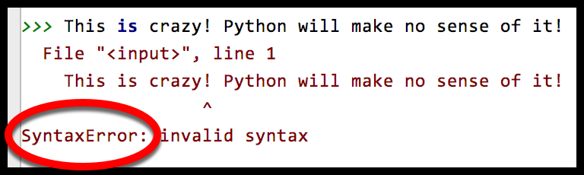
Try typing and then evaluating some short, silly thing that you think might include syntax errors, like the above. (Reminder: You should be typing things in your Python Console, as directed in these exercises.)
- You would also expect bad things to happen from bad arithmetic. Try:
3 / 0
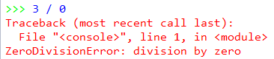
You should see a red error-message like the one to the right.
Always read the last line of the error message – it summarizes the error. If the message makes no sense to you, ask someone to clarify.
Errors like these are called run-time errors, aka exceptions.
- You would expect bad things to happen from other bad expressions. Try:
3 / hello
and read the last line of the error message. If that message makes no sense to you, ask someone to clarify.
- Write another couple of expressions that cause error messages. Be creative! Be sure you understand the error messages.
Yes, do it now!
If you have not already done so, do Part 2 of the Moodle quiz (on Syntax and Run-Time Errors; Exceptions).

Part 3: Objects, Types, and Values
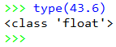
- In Python, every “thing” (that is, every item of data) is called an object.
An object has a type and a value. Let’s learn some types:
The type function tells you what the type of an object is, as shown in the Python Console snippet above. Types are sometimes called classes; two ways to say the same thing, in this context.
Use the type function per the example above to determine the type of each of the following objects.
482
Those are double-quote characters (SHIFT-single-quote on your keyboard), NOT two single quotes in a row!
48.203
"blah blah blah"
'yada yada'
[4, 2, 9]
Do you see why the types of the last three expressions are different? If not, ask someone!

min
min(4, 6, 2, 12, 10)
min(4, 6, 2.0)
- Objects of type int and float can do the usual arithmetic operations:
  - Type an expression that involves addition, subtraction and multiplication (but NOT division, yet), using whole numbers (which are of type int).
  - Repeat the above, but making just a single one of the numbers in your expression a float, by appending a decimal point to it, like this: instead of 2 (which is an int) write 2.0 (which is a float).
  - Now try division:
4.2 / 2.0
4.2 / 2
4 / 2
3 / 2
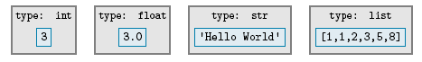
What do you notice about the type that results from division, even if both arguments are int objects?
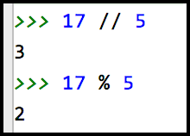
- You can do integer division using the // operator and you can get the remainder when you do integer division by using the % operator. For example, 5 goes into 17 three whole times with a remainder of 2, per the example to the right.
Try out the // and % operators on some more integers until you understand what they do.
- Objects of type string can do a sort of arithmetic. Try expressions like this (feel free to use your own strings and numbers):
"hello" + "goodbye girl"
"big" * 20
("hello" + "goodbye girl") * 8
'single quotes' + "double quotes"
- In Python, both single and double quotes can denote strings. Use both to figure out how to write a string that has a single-quote as part of the string (for example, the contraction isn’t ). Ask for help if you don’t see how to do this!
Yes, do it now!
- The type of an object determines what an object knows and what it can do. For example, strings know their characters and can return an upper-case version of them, like this:
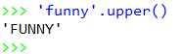
'funny'.upper()
Try it, using your own string!
We will talk more about this “dot” notation later in these exercises.

To summarize: An object has a type and a value. For example:
The type of an object determines:
- The kind of thing the object is
- What sort of thing the object knows (stored in what we call instance variables) and what the object can do (operations, like you have just seen, and more generally what’s called methods).
Lots more on this shortly! Don’t worry if it does yet make total sense!
If you have not already done so, do Part 3 of the Moodle quiz (on Objects, Types, and Values).

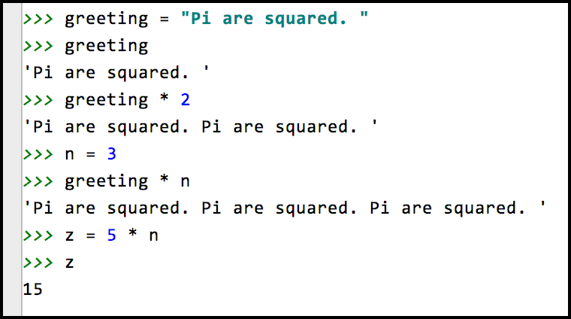
Part 4: Names, Variables, and Assignment
- We use names to refer to objects. We often use the word “variable” instead of “name” since the value of the object to which the name refers can vary over time.
For example, the name greeting might refer to the object per the diagram below:
greeting

The value of a name is the object to which the name refers. A name gets its value through assignment. One way to do assignment is by using the = (read it as “gets”) operator. For example, to make greeting refer to the object above, we would write:
greeting = 'Hello World'
Until you assign a variable a value, it has no value; we say that it is not defined. For example, if you typed greeting in a Python Console before typing an assignment statement like the above, you get an error message, as shown below.
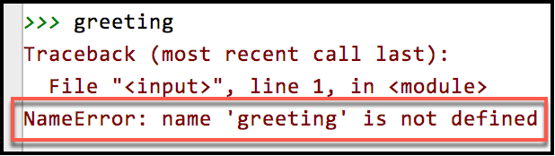

Once you have assigned a name a value, it evaluates to that value in all subsequent uses in the Python Console. Here is an extended example (in the next column):

Practice assignment as suggested by the above example, that is: Choose your own names, given them values by using the assignment (=) operator, and define new names by using expressions that include names that you defined previously.
Yes, do it now!
- Assignments can result in run-time errors (discussed previously), as in these examples:
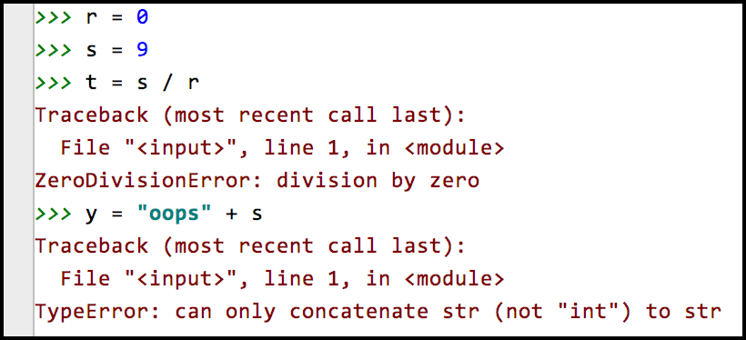
As always, read the last line of the error message and try to make sense of it. If the message makes no sense to you, ask someone to clarify. (For example, do you understand the error message in the 2nd example above?)
Try some assignments that yield run-time errors. Yes, do it now!
- The assignment operator is not symmetric! That is, when an assignment statement blah = such-and-such executes:
- First, the right-hand-side is evaluated (computed), thus yielding an object.
- Then, the name (variable) on the left-hand-side is made to refer to the object on the right-hand-side.
There is a big difference between the two sides of an assignment! Try the following (some of which yield error messages):
Throughout these examples I will use short, silly names – in real programs the names (variables) would have meaning and hence you would choose meaningful names for them.
a = 45
45 = a
b = 10
c = b + 20
b = c
(and then enter b to see what b evaluates to now,
and likewise enter c to see what c evaluates to now)
Make sure that you understand the non-symmetric aspect of the assignment operator = now. Ask questions as needed!
- Finally, see if you can make sense of this:
x = 5
x = x + 1
(and then enter x to see what x evaluates to now)
If you understand why x = x + 1 is perfectly sensible computer science (but lousy mathematics), then you understand the assignment operator. Ask questions as needed about this KEY IDEA!
If you have not already done so, do Part 4 of the Moodle quiz (on Names, Variables, and Assignment).
Part 4: Calling functions
- One last concept: let’s see how you call functions, where a function is just like in mathematics (in this context).
Functions are defined in modules (Python’s word for a file that contains Python code – sometimes we also call a collection of one or more modules a library). Many of the mathematics functions are in the math module. The notation for using such functions goes like this:
- First, you import the relevant module (i.e., library), e.g.:
import math
Doing that once per Python Console run is enough – the above import statement “sucks in” the definitions of all the math functions, for you to use in the rest of the run.
  - Then, you precede the function name by the module name and a dot (aka period, full stop), like this:
math.sin(3.14)
x = math.pi
math.cos(x)
Try the above (don’t forget to do the import math first).
Yes, do it now!

- PyCharm does a wonderful thing to help you learn the names of the functions in a library – after you type the DOT after math, if you pause at that point, PyCharm pops up all the functions (and other things) in the math library, as shown on the next page:
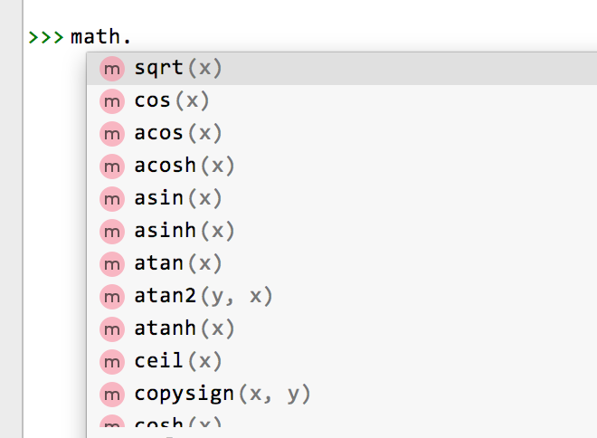
This is what I typed. Note the DOT after math

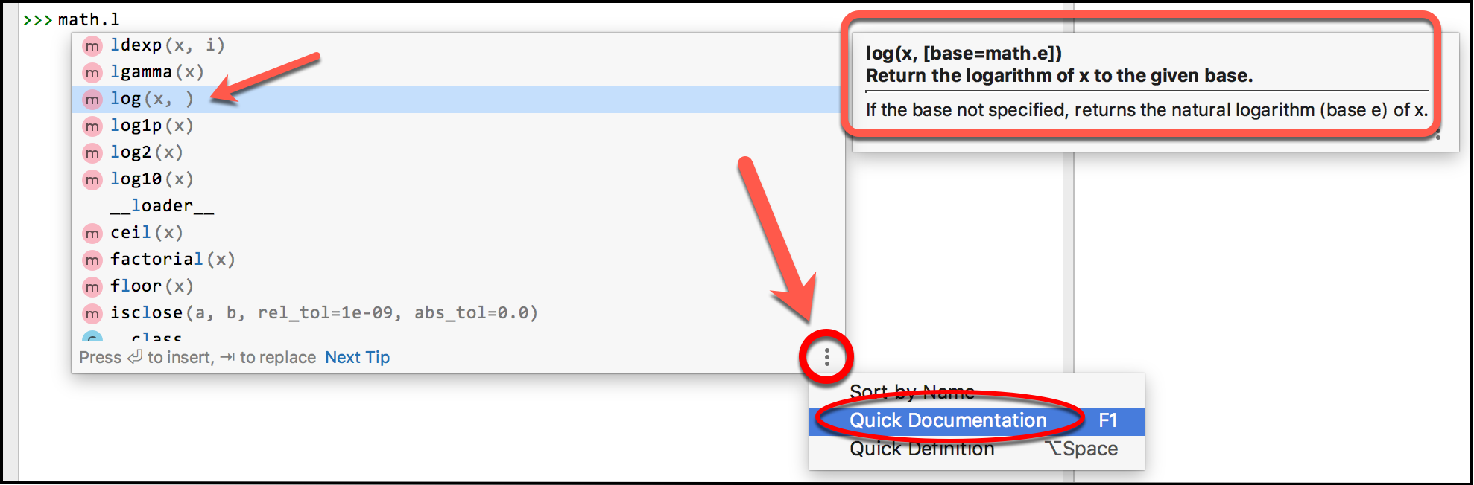

You can scroll through the list that appears or you can type one or more characters after pausing at the DOT, like this example that shows me all the math functions that begin with “s”:
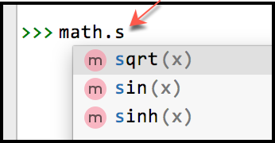
Using this “dot trick”, try some other functions from the math library until you feel comfortable with them. For example:
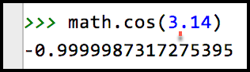
Yes, do it now!

- Assign a name the value math.pi and then compute the cosine of the value of that name. Do the trigonometric functions seem to use radians or degrees?
- You can even get documentation on the functions when using the DOT trick, by bringing up the DOT selection (i.e., pausing after typing the DOT) and then (per the picture below):
  - Select the three dots on the bottom-right, then
  - Select Quick Documentation, then
  - Select the function whose documentation you want.
- The functions (and other things) in the builtins module are well, “built in”. So you don’t have to type the builtins-dot in front of them (and would not ordinarily do so). Try:
import builtins
Everyone uses the shorter form. But even the builtins are from a library, just like the math functions. There are many thousands of Python libraries.
builtins.abs(-45)
abs(-45)
min(55, 3, 20, 4)
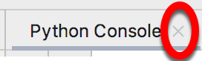
If you have not already done so, do Part 5 of the Moodle quiz (on Calling Functions). Then exit your Python Console by clicking on the little X beside the words “Python Console” at the top of the Python Console.

