CSSE 120 – Introduction to Software Development
The Python Console
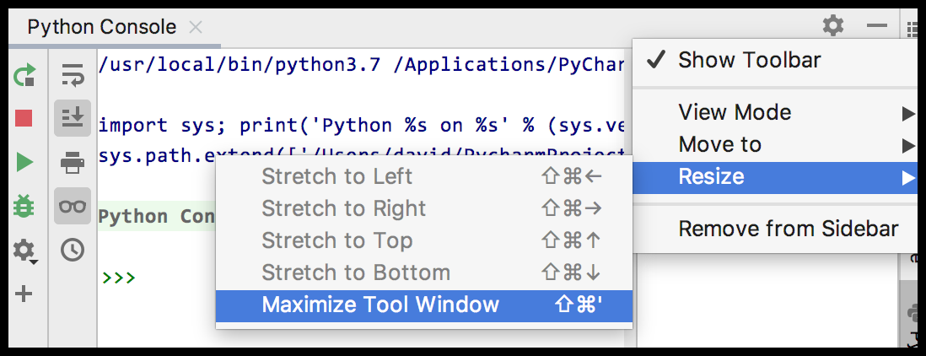
The .Python Console is a window available inside PyCharm in which you can type single Python expressions and evaluate them (that is, have the Python Interpreter run them). This document shows you how to open a Python Console; subsequent documents will lead you through exercises using one.
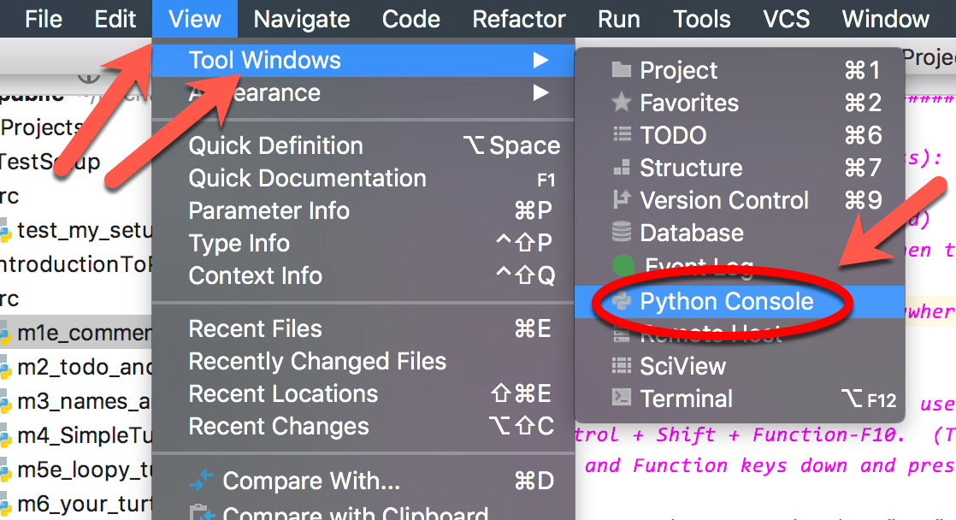
To open a Python Console in PyCharm, select the View menu at the top of PyCharm, then Tool Windows, then Python Console, as shown in the picture below.
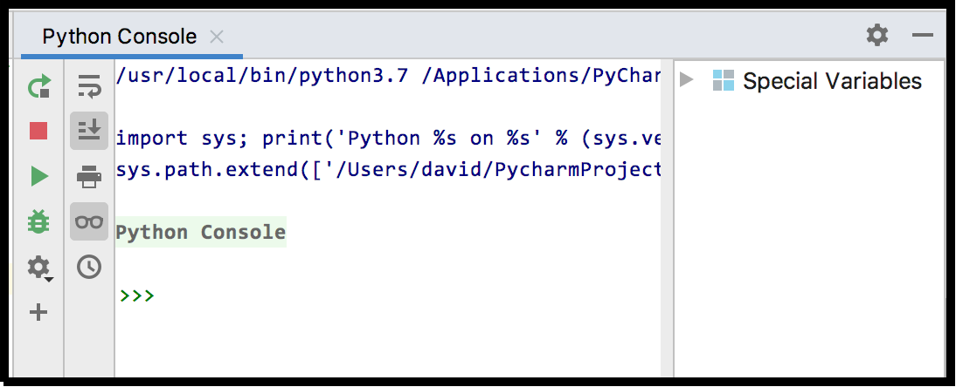
A window opens that looks like the one shown to the right.

Double-click on the bar at the top of the window, or select the “gear” symbol at the top-right and then choose Resize, then Maximize Tool Window to make the window big, as shown below.
Then try typing 2 + 2 at the >>> prompt, and then press the Enter key. You will see the result of the evaluation (i.e., 4) show up, as shown below.
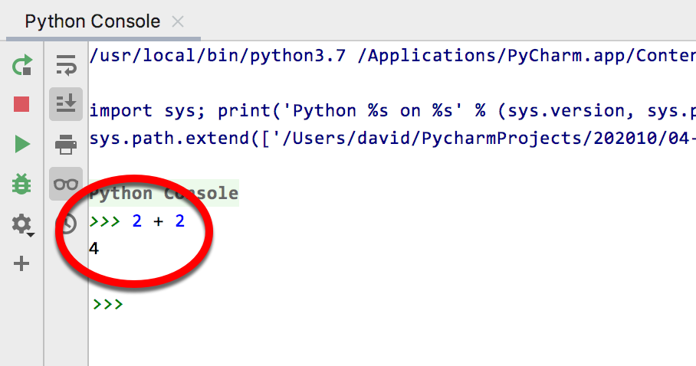
You will NOT use this Python Console to write programs; rather, it is simply a tool that you will use in subsequent exercises to begin your exploration of Python.
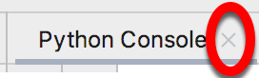
To exit a Python Console, click on the little X beside the words “Python Console” at the top of the Python Console.

