Using Piazza
We will use a tool called Piazza for you to ask and answer questions outside of class. It is a great tool. Here is what you need to do to get started:
- Check your Rose-Hulman email for a message from Piazza whose subject is:
David Mutchler welcomes you to CSSE 120, Rose-Hulman Institute of Technology
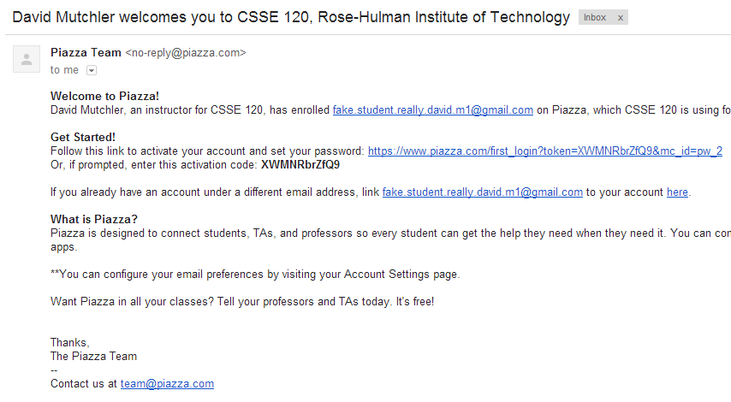
The email will look something like this:
The above email from Piazza should arrive not long after the email with these instructions.
If you do NOT get an email like the above from Piazza within a few hours of receiving this email, check whether your spam filter quarantined it. If not, contact me (David Mutchler).

- Follow the “Get Started!” link in that email to enter Piazza.
It will ask you for your full name – write your name however you want us to address you, in the American style of NameToCallYouBy FamilyName.
For example, Gabrielle Mysterious might enter her name as:
Gabby Mysterious
since she wants us to call her “Gabby”.

It will also ask for a password and some other information. You might (or might not) want to UN-check the box for Piazza Careers. Your choice!
- After you are in Piazza, confirm that you see the Q & A page that looks something like this (the screenshot shows only the upper-left of the window):
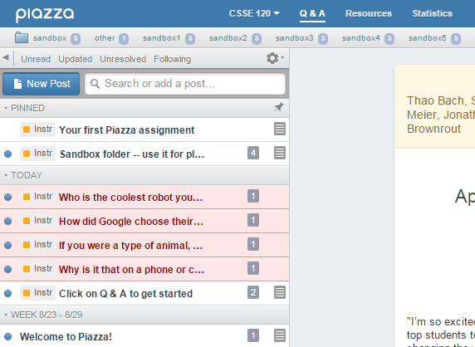

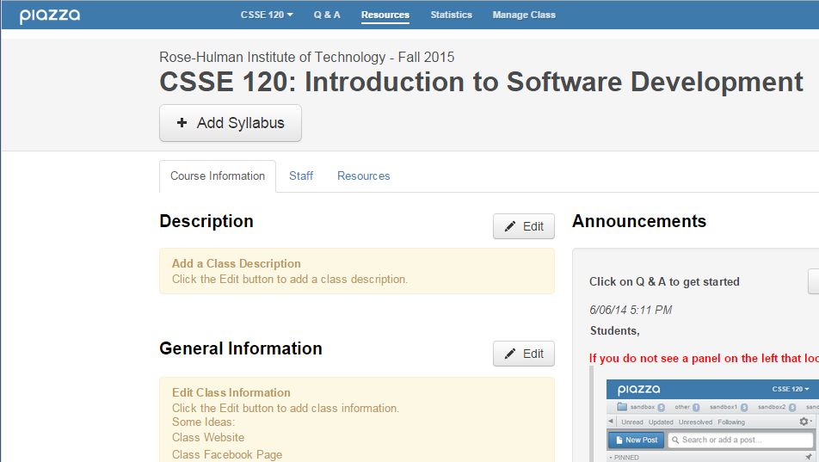
If instead you see the “Course Page” that looks something like the picture to the right, click on the Q & A button to get to the page that looks like the above picture.

(

These instructions continue on the next page.

- Once you see the Q&A page, click on the note labeled:
Your first Piazza assignment

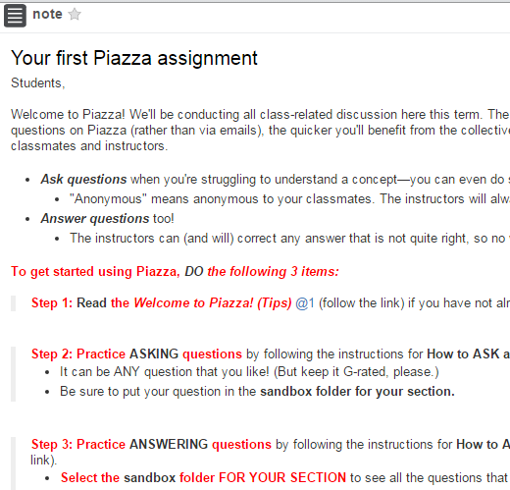
- You should now see a Piazza “note” that looks something like this (the screenshot shows only the top part of the page, since the page scrolls).

- The note says to DO 3 things:
    - Read …
    - Practice ASKING questions by …
    - Practice ANSWERING questions by …
The note gives instructions for how to do those 3 things.
*** FOLLOW THE INSTRUCTIONS IN THE NOTE. ***
The instructions in the note are ALSO attached to this email as a screen shot.
But you CANNOT do the instructions until you log into Piazza!

