Your first SVN session in Eclipse, by Pictures
Here’s a pictorial introduction to a part of your version control system, SVN (Subversion, implemented by Subclipse within Eclipse). It assumes that you are in Eclipse with the PyDev120 perspective. If not, your mileage may vary.
Follow the pictures (and associated instructions), one by one. Turn to a neighbor or an assistant quickly whenever you get a bit lost – most of this is much easier to show than to explain.
These pictures show the setup that you do only the first time you use SVN in Eclipse. See the different handout on SVN checkout, commit and update for what you do at each session thereafter.
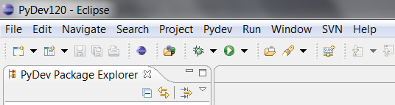
- Select the SVN icon on the toolbar at the top of Eclipse.
- If you don’t have an SVN icon, ask for help now.
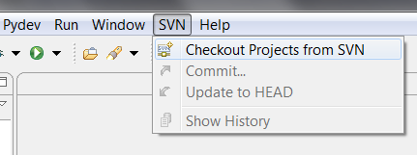
- Initially, the only option is to
Checkout Projects from SVN

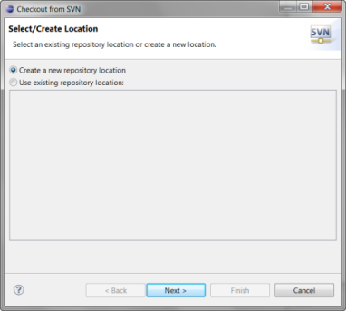
- Choose Create a new repository location.

- In the next dialog box that opens, carefully type the URL of your personal repository for this class (we created it for you):
http://svn.csse.rose-hulman.edu/repos/csse120-201310-yourUsername

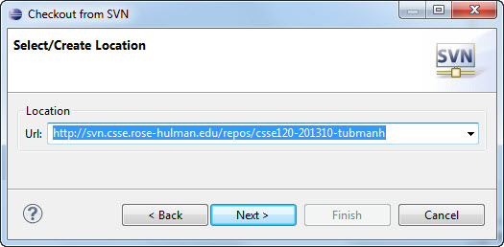
where you replace yourUsername with your Kerberos username. (The example to the right shows how one particular famous person would do it.)
Eclipse will remember this repository, so you won’t have to type it again once you get it right. After this session, you will use the personal repository you create today, but may use other repositories (created later) for team projects.
If you get an error message after pressing
Next, try again, typing carefully, and get help as needed.
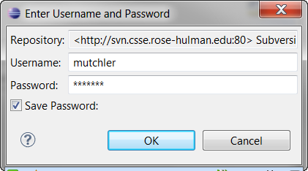
- The first time you use SVN in Eclipse, it will ask you to enter a username and password.
This should be YOUR username
Check the box to Save Password and enter either your default SVN password (hello) or the SVN password that you set in class.
Then press OK.
If it repeats this dialog box, try again (type carefully!), be sure you checked the Save Password box, and get help as needed.
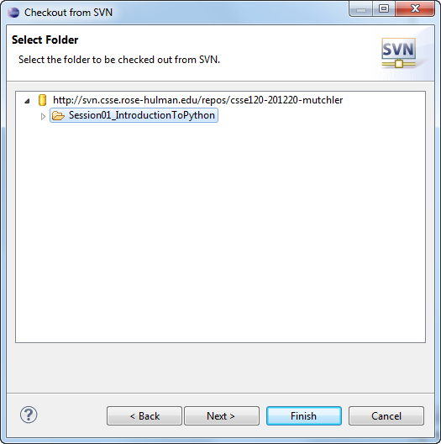
- Select the folder (project) that you want to check out.
- Caution: Select the project (as shown), NOT the http line and NOT anything that would appear if you were to expand the project.

From here you would ordinarily select Finish. But this first time, choose Next to confirm that all is well.

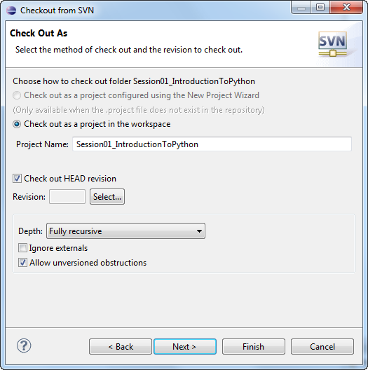
- Confirm that the next dialog selects Check out as a project in the workspace – if not, something has probably gone wrong.

Then Next to get the picture shown below – confirm that you are using the default workspace location and that that location is your
C:/EclipseWorkspaces/csse120
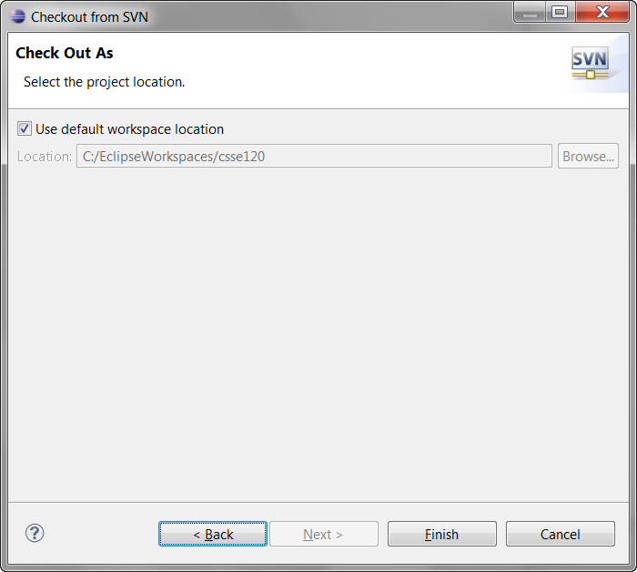
folder.

If all is well, press Finish.

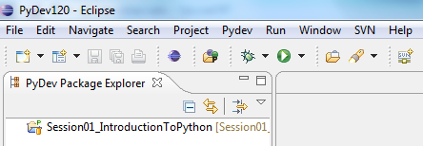
- If you see the project in the
PyDev Package Explorer window, all is well!

- Finally, expand the project until you see the .py files within it, as shown below.

Then double-click on the .py files to bring them to the editor window (in the middle). Now you are ready to work on the programs!

If you haven’t already done so, maximize Eclipse; you will want lots of screen real estate!

Try the green arrow (circled below) to run the program. Select Python Run if it gives you a choice for how to run it.
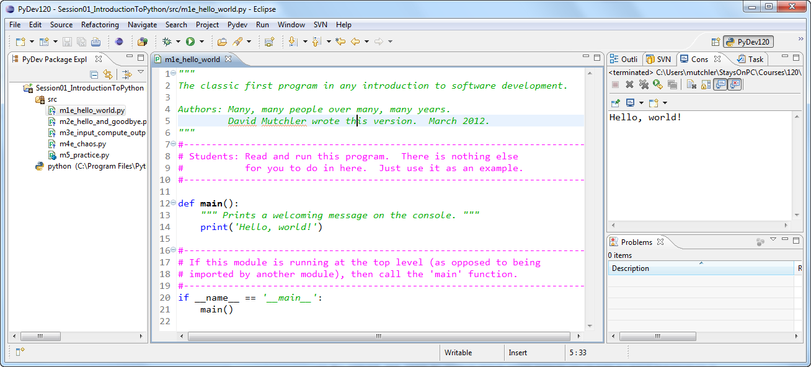
The m1e_hello_world.py module shown above prints (displays) its output in the Console window (on the right). Other modules (like the m3e_input_compute_output.py module) expect you to type inputs in that window as well.

