Your first Eclipse session, by Pictures
Here’s an introduction to your first Eclipse session, by pictures. It assumes that your Eclipse and related items are set up correctly. If not, your mileage will vary.
Follow the pictures (and associated instructions), one by one. Turn to a neighbor or an assistant quickly whenever you get a bit lost – most of this is much easier to show than to explain.

- Confirm that you have a folder: C:\EclipseWorkspaces\csse120
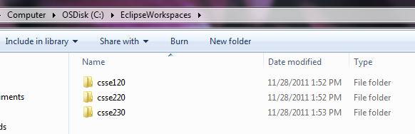
It is important that there be no spaces in the path, so please use exactly the above.
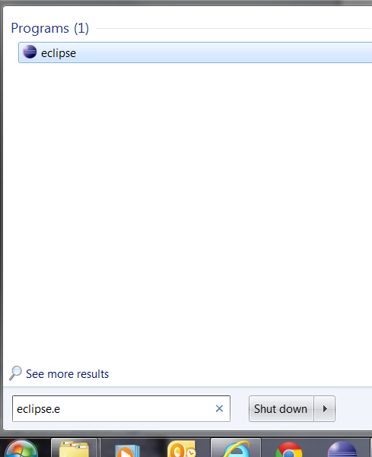
If you are retaking this course, you should probably rename your existing folder and make a new, empty one for this term. Ask your instructor for how to switch back and forth between them.

- Find Eclipse via the Start Menu and open (run) it.

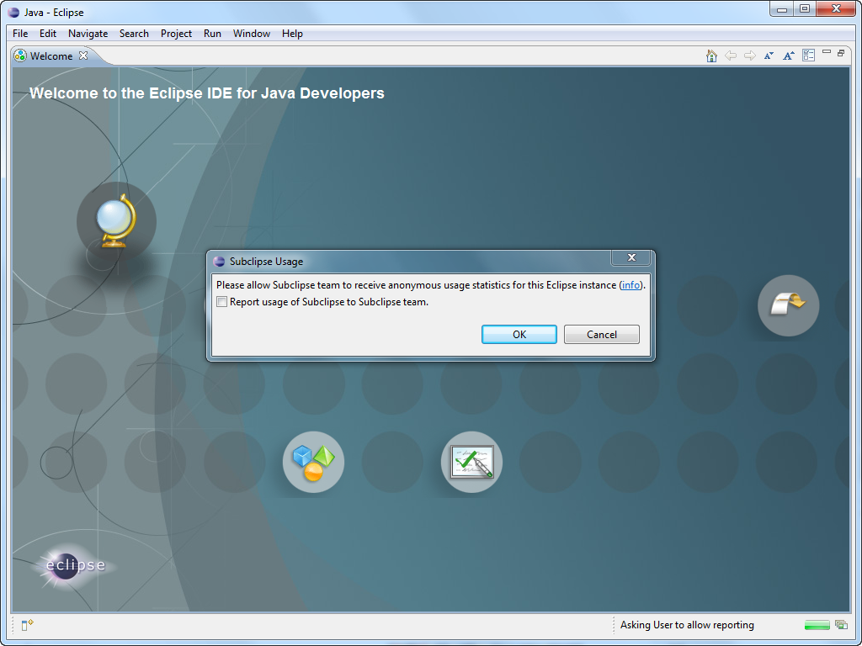
- You may see this Welcome screen (but you probably won’t) and you may see the pop-up on it.
  - If you see the pop-up, UN-check the box, then press OK.
  - Then select the ribbon-like arrow on the far right to continue.

If you do not see this screen, no problem, just continue to the next page of these instructions.

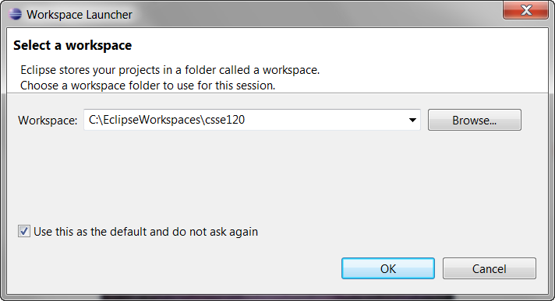
- You should see this window when Eclipse starts up the first time.
  - If you don’t see this window, see the footnote below.
  - Check the box!!!!!!!!
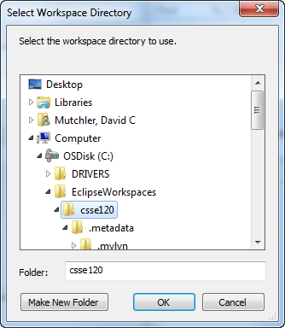
  - Be sure that the Workspace
is exactly as in the picture.
    - If it isn’t, Browse to select the correct folder.
  - Then press OK.

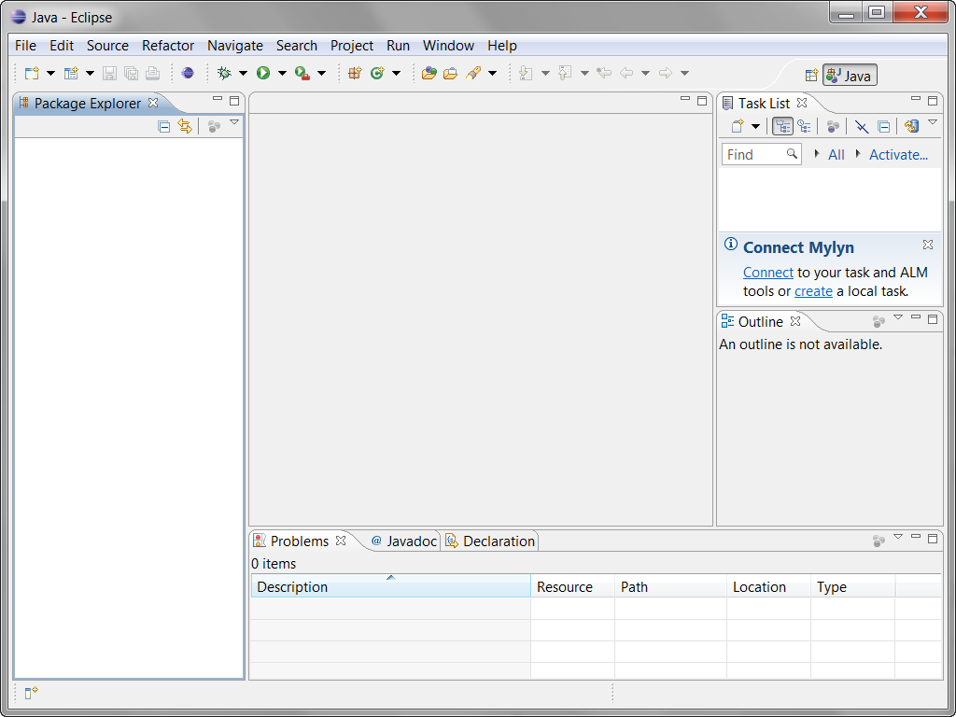

- This is probably next.
- This is the Java perspective.
- Our next step will make the PyDev120 perspective the default hereafter.

(continues on next page)

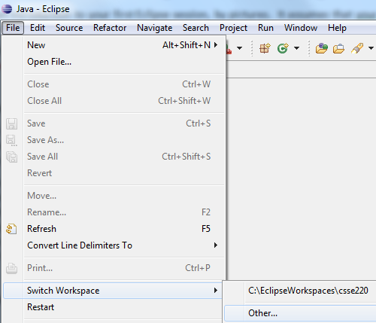
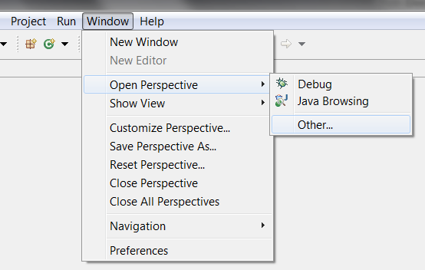
- Choose
Window
~ Open Perspective
~ Other
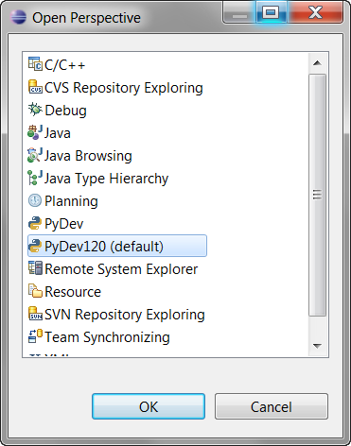
to open the PyDev120 perspective as shown in this and the next picture.

- Continuing the previous step, select
PyDev120 (default)
and then OK to complete opening the PyDev120 perspective.

If PyDev120 is NOT one of your options, ask for the PyDev120 handout.

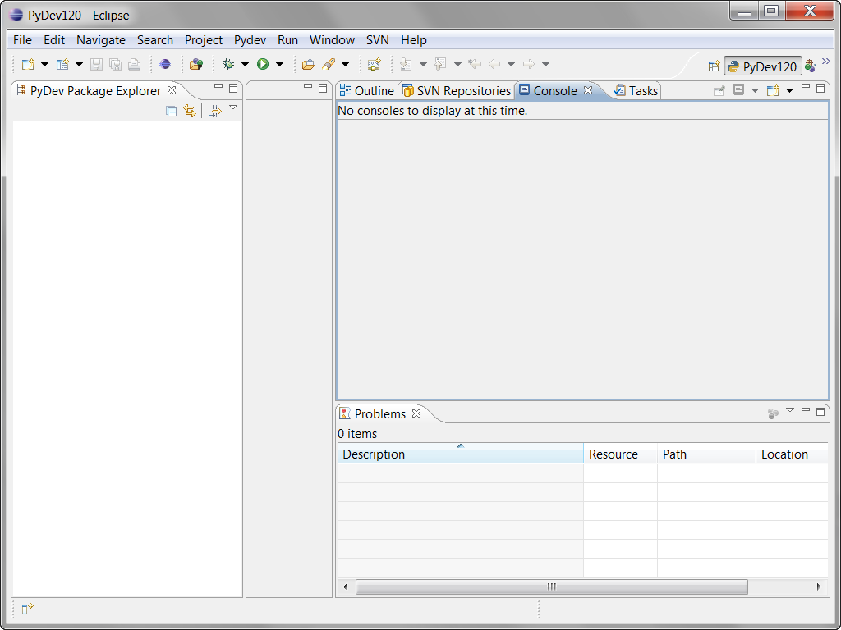
- You’ll see something like this – the exact window sizes will vary.
  - Do all your Python work in the PyDev120 perspective. Always make sure that you see PyDev120 as circled.
  - Maximize your window (make it big).

Congratulations! You have successfully entered Eclipse, ready to work in Python!
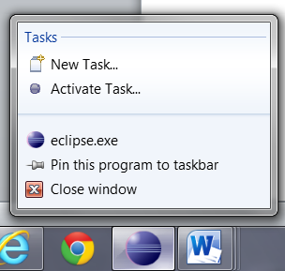
The next time that you start Eclipse, it will ordinarily start right where you left off (in the PyDev120 perspective).

- One more step: Way down on the taskbar (bottom of your screen), right-click on the Eclipse icon to
Pin the Eclipse icon to the taskbar
so that you can open it easily in the future.

If you are ever in doubt about whether you are in the right workspace, for example if Eclipse does not ask you for a workspace the first time you open it, choose File ~ Switch Workspace, then Other, then browse (per the picture above) for the C:\EclipseWorkspaces\csse120 folder. Eclipse will then shut down and re-open in the right workspace. If Step 4 above worked for you, you can ignore this footnote.

