A workaround for an error
in our installation of Eclipse
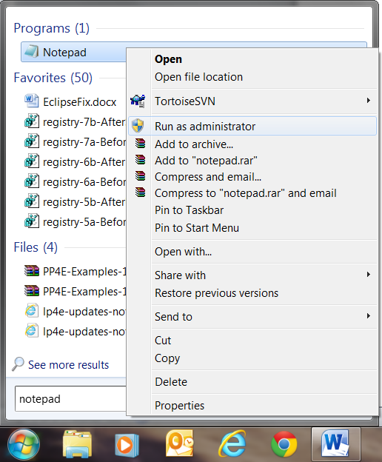
- Find Notepad from the Start Menu.

- Right-click on it and select Run as Administrator.

- If asked to do so, enter your localmgr username (.\localmgr) and password.
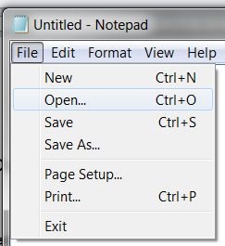

- In Notepad, select File ~ Open

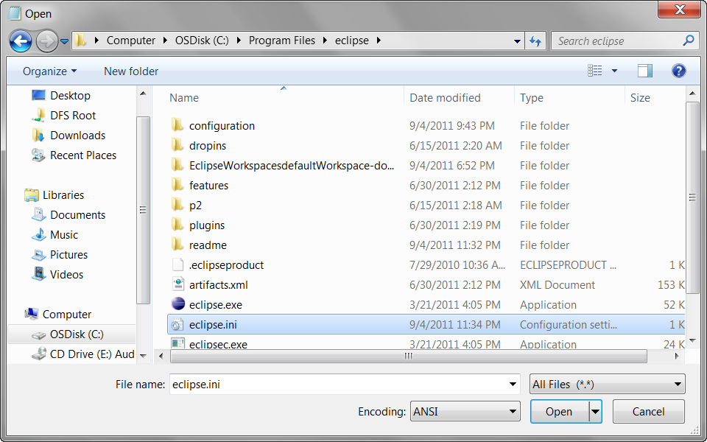
- Browse for the file:
C:/Program Files/eclipse/eclipse.ini
You will need to change from Text Documents to All Files in the lower-right of the dialog box to make this .ini file visible.

- Select Open.

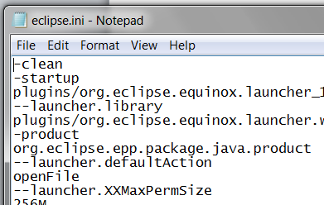
- Put -clean as the first line of that file (leaving the other lines unchanged). The file should then look like the picture to the right (just check that the first two lines are as shown).

- Select File ~ Save and then exit Notepad.

