474 HW 09 problems (highlighted problems are the ones to turn in)
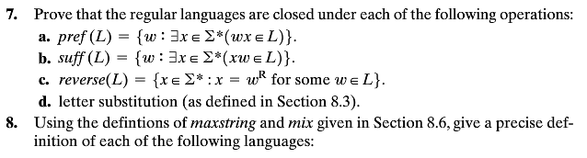
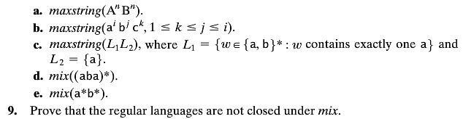
8.8(#1)
8.8 d, e
(#2)( 3, 6)

8.9
(#3) (9)

8.10a
(#4) (9)

8.16a
(#5) (6)

8.16b
(#6)
8.21
(#7)

8.21n
(#8) (12)

8.21o
(#9) (3)

8.10-a I.e., given a DFSM M = (K, Σ, δ, s, A) such that L(M)=L, construct a DFSM
M*=(K*, Σ, Δ*, s*, A*) such that L(M*)=maxstring(L).

Definitions of maxstring and mix: Examples 8.22 and 8.23.
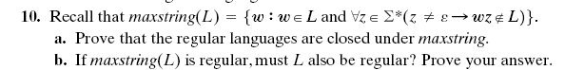

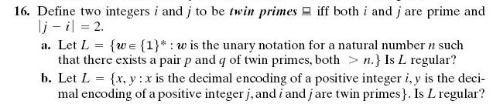
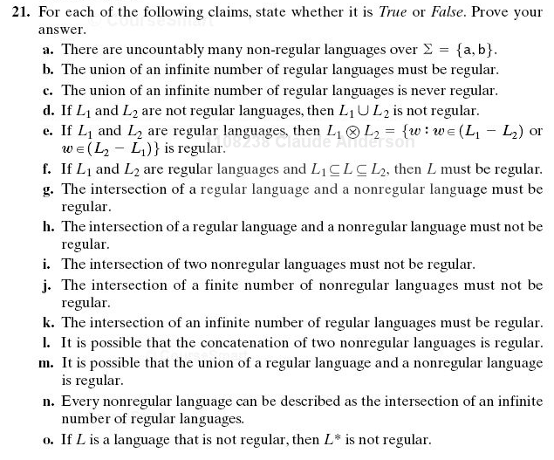
9.1g:
There is a small error in the statement of the problem. a* should be {a}*

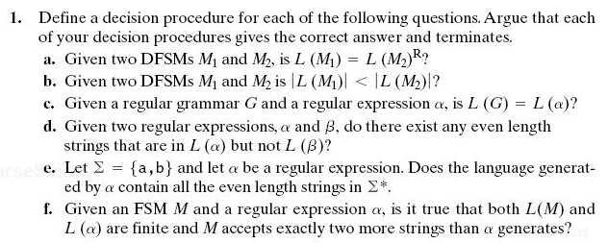
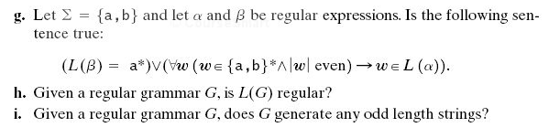

9.1 (#10)
9.1b
(#11) (6)

9.1d
(#12) (6)

9.1g
See note below
(#13) (6)

9.1i
(#14) (6)

9.1g:
There is a small error in the statement of the problem. a* should be {a}*
9.1b:
Note that |L(M)| means “the number of elements in the language accepted by the machine M. Note that for some machines M, the language is countably infinite.

