474 HW 16 problems (highlighted problems are the ones to turn in)

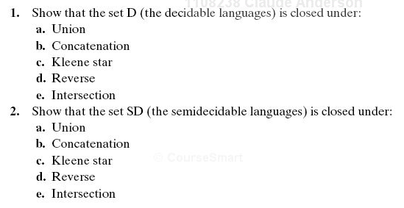
20.1
(#3)
20.2
(#4)

20.3
(#3) 9
20.4
(#4) 6
20.5
(#7)
20.6
(#8)
20.7
(#7) 6
20.8
(#8) 9

20.11
(#9) 9

10.12
(#10) 6

20.13
(#11) 9
