474 HW 15 problems (highlighted problems are the ones to turn in)

18.1a
(#1) 9

18.1b
(#2) 9

19.1
(#4) 6

19.2
(#5) 12

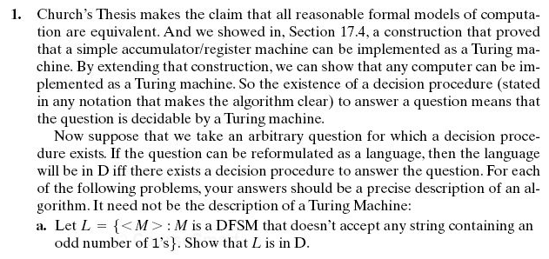

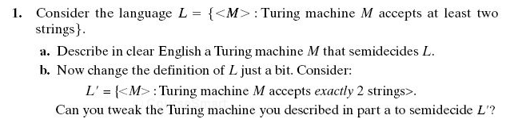
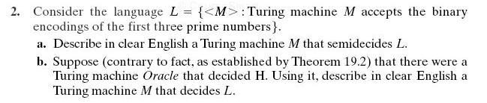
Problem #3 A TM M has tape alphabet { , a, b} (this is the order used in the encoding <M>).
<M> = (q00,a00,q00,a00, →), (q00,a10,q01,a10,→), (q00,a01,y10,a10, ←), (q01,a01,q00,a10,→), (q01,a10,n11,a01, ←)
- (6) Provide a transition diagram or a transition table for the TM M.
- (3) For each of the following outcomes of running M, provide a short string of a's and b's that is
accepted by M,
rejected by M,
neither.

