MA/CSSE 474 HW 14 problems (highlighted problems are the ones to turn in)
Be sure to read the numerous questions and answers in the main assignment document
17.1a
(#1) 6
17.1b
(#2)

17.3a
(#3) 9

17.3b-d
(#4)

17.4
(#5) 9

17.6
(#6) 3

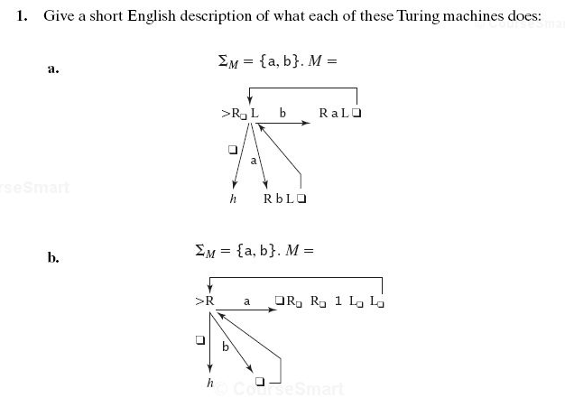

17.1a Don't just describe in English the individual steps the machine makes. Your answer should be a global one: in particular, describe how the final tape content is different from the original tape content.

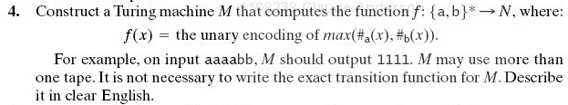
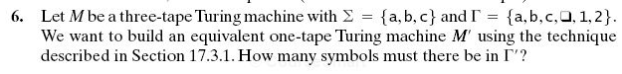
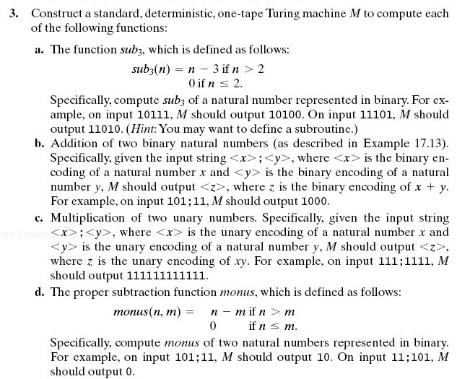

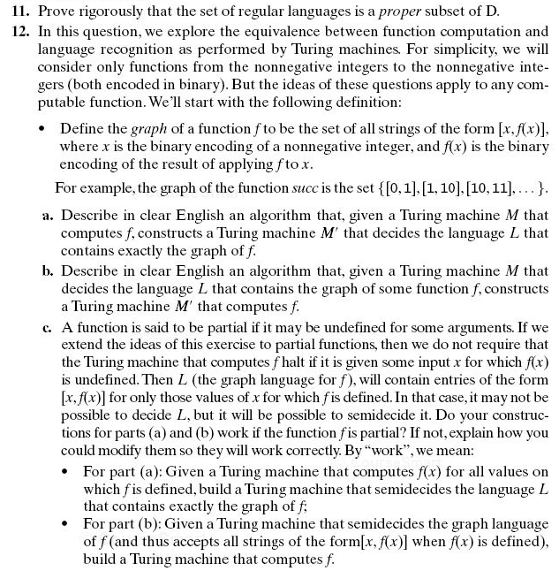
17.11
(#7) 6-3
17.12
(#8) 6-6-6-6

17.13
(#9) 3

Note on 17.12a:
L = { [<x>, <f(x)>], x∈ℕ}, where <x> means "the binary encoding of x" and <f(x)> means "the binary encoding of f(x)"
17.12b,c: Do these constructions for a general function-computing TM, not specifically for the successor function.
(c) You might find the concept of "dovetailing" helpful for this problem. If you have not seen that technique before, this reference will probably help:

http://lambda-the-ultimate.org/node/322

