474 HW 13 problems (highlighted problems are the ones to turn in)

13.1f
(#1) 9
13.1g
(#2)
13.1h
(#3)
13.1i
(#4) 9
13.1k
(#5)
13.1l
(#6) 9
13.1p
(#7)
13.1q
(#8)
13.1w
(#9) 9

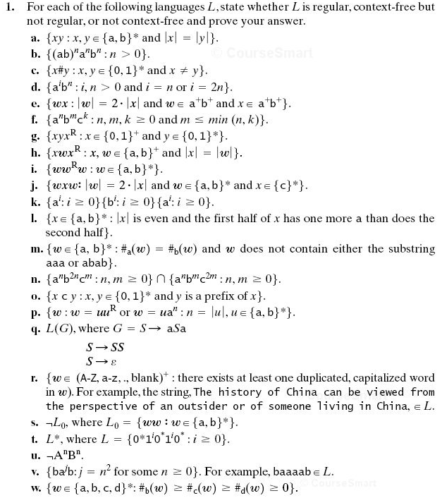
Recall: When we use the pumping theorem to show a language is not context-free, we do not get to choose the k, we choose the w whose length is at least k. We do not get to choose how w is broken up into uvxyz (although the breakup has to meet the length constraints of the theorem), but we do get to choose how to pump the v and y (I.e. we can choose the q in uv^{q}xy^{q}z).

13.3
(#10) 9

13.4
(#11)

13.8
(#12)

13.9
(#13) 6

13.12
(#14)
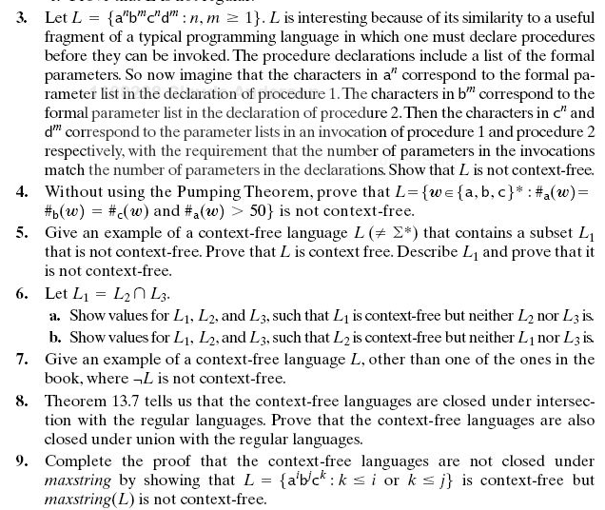
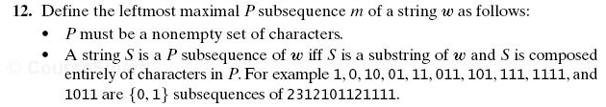
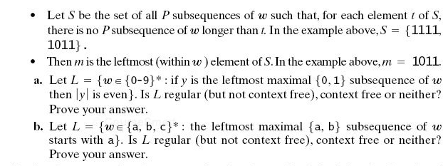
Note on 13.12. What the author meant to ask and what she actually asked are quite different. Both parts should have said: "Is L context-Free (but not regular), regular, or neither? Prove your answer.

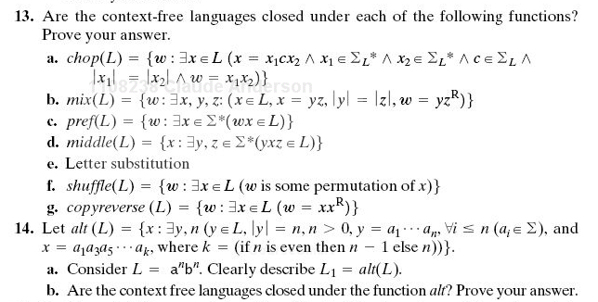
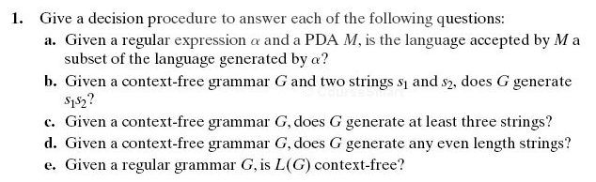

13.13d
(#15) 6
13.14
(#16) 6,9

14.1a
(#17) 6
14.1c
(#18) 9
14.1d
(#19)
14.1e
(#20)

13.14 Examples:
If L is the language denoted by r.e. (ab)*, then alt(L) is denoted by r.e. a*.
If L is the language denoted by r.e. (abcdefg)*, then alt(L) is denoted by r.e. (aceg)* .
If L is the language denoted by r.e. a or the language denoted by r.e. a*, then alt(L) is L.

