474 HW 12 problems (highlighted problems are the ones to turn in)

12.1j
(#1)

12.3
(#2) 6+6+6

12.4
(#3) 3 for each part

12.5a
(#4) 9

12.6
(#5) 6

13.1a
(#6) 6
13.1b
(#7) 6
13.1c
(#8) 12
13.1d
(#9) 6

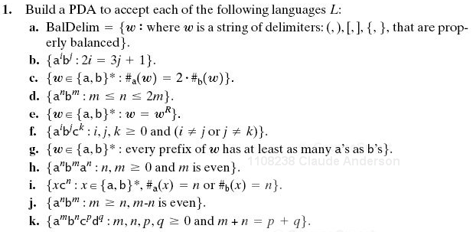
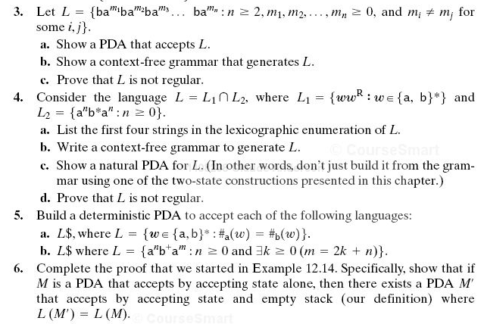
See hint below
12.5a Hint: In order to be deterministic, the first thing your PDA should do, before it adds any input, is to push a special "bottom of stack" marker

12.3 Clarification: It may help you to understand the language better if you replace “for some i, j” by “at least one pair i, j” .
Hints (a) Have states and transitions to handle the "don't care" sections where we aren't worried about the number of b's. (b) One nonterminal for when the m_{i}>m_{j}, and one for when m_{i}<m_{j}. (c) Pumping theorem alone probably won't do it; also use closure property.
Warning: Last time I taught the course, several students indicated that this was the most difficult problem in the assignment, and a few thought it was one of the hardest problems of the term.

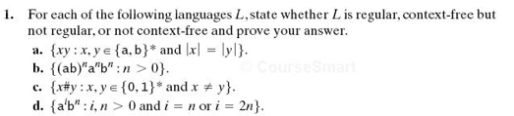
Recall: When we use the pumping theorem to show a language is not context-free, we do not get to choose the k, we choose the w whose length is at least k. We do not get to choose how w is broken up into uvxyz (although the breakup has to meet the length constraints of the theorem), but we do get to choose how to pump the v and y (I.e. we can choose the q in uv^{q}xy^{q}z).

