474 HW 08 problems (highlighted problems are the ones to turn in)

8.1acegklptuz
(#1)

8.1 e (#2)
8.1f
8.1g
8.1h
8.1k
8.1m
(#2 - #7)
3 pts. each

8.7a
(#8) 9

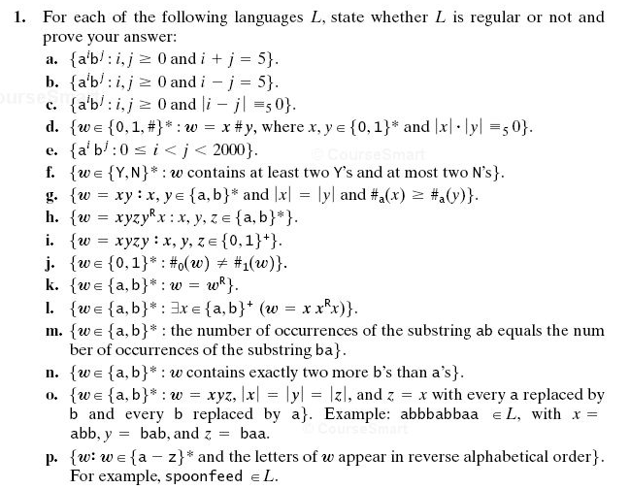

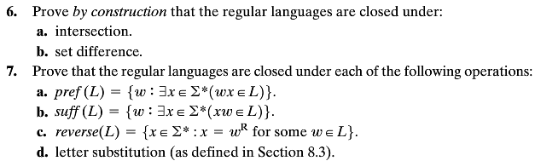
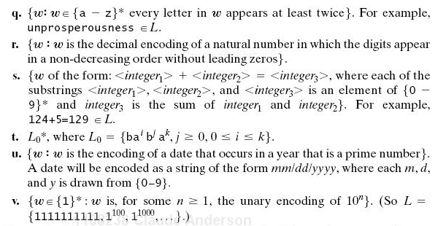
8.7a Do this by construction, i.e., produce an algorithm that takes as input a DFSM
M = (K, Σ, δ, s, A) that accepts L, and produces a DFSM M′ = (K′, Σ′, δ′, s′, A′) that accepts pref(L). Describe how to get from M to M'
Hint: M’ will have a lot of its elements in common with M, but it takes a somewhat complex calculation (based on M) to determine exactly what has to be changed.
On the main HW8 assignment document, I posted the author’s solutions to the other three parts of problem 8.7, so that you will have more examples.

8.2ac
(#9)

8.3
(#10)
8.4a
(#11) 6
8.4b
(#12)
8.7
(#13)

6.18
(#14) 9

6.20
(#15)
Good practice problems for exams (no proof necessary)

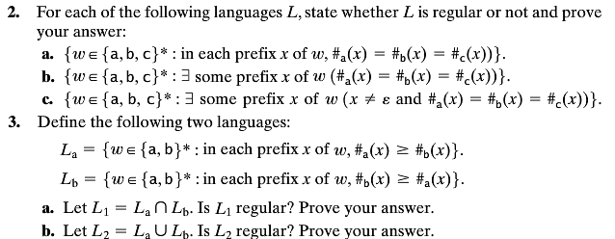
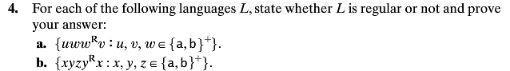
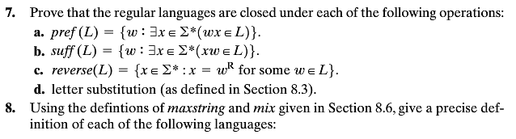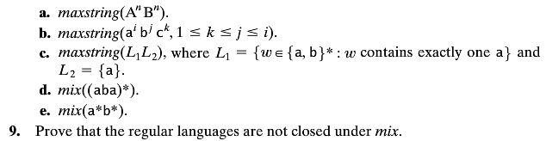
18. Let Σ = {a, b}. Let L = {ε, a, b}. Let R be a relation defined on Σ* as follows: ∀xy (xRy iff y = xb). Let R′ be the reflexive, transitive closure of R. Let L′ = {x : ∃y ∈ L (yR′x)}. Write a regular expression for L′.
Note on 6.18 Transitive and reflexive closures are introduced in Section A.5 Closures under various operations are also mentioned on pages 17, 57, and 72.

