474 HW 7 problems (highlighted problems are the ones to turn in)

6.7a
1 (9)

6.8 (#2)

DFSM to Reg expression problem
3 (18)

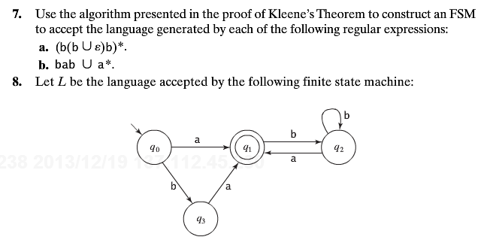

- (t-18) Consider the DFSM M below. Use the algorithm from class/video to find a regular expression r such that L(r) = L(M). You should calculate all of the r_{ijk} for k=0 and k=1. For k>1, you are only required to calculate as many of the r_{ijk} as needed to do the recursive steps that the algorithm actually needs to get the answer. Be explicit about the ones that you do calculate. [The proof of the “video” algorithm and a complete example are given in the proof of Theorem 3.4 on the bottom of p33 and on pages 34-35 from this document, taken from “introduction to Automata Theory, Languages, and Computation by Hopcroft and Ullman (Addison-Wesley, 1979). ]
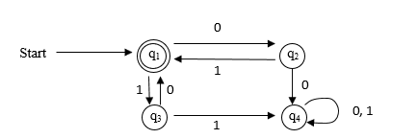

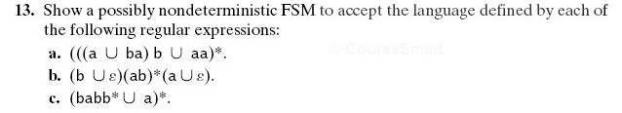
6.13d
(#4)

6.15
(#5)

6.18
7 (9)

6.20
(#14)
Good practice problems for exams (no proof necessary)

8.2ac

8.3
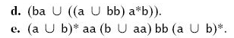
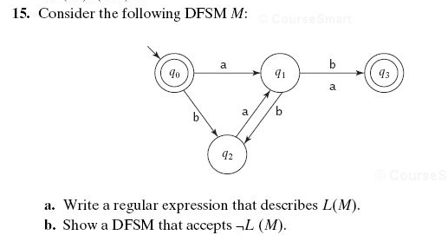
There is an error in this diagram in the book. The b-transition from q₁ to q₃ should not be there. Remove it before doing the problem.
18. Let Σ = {a, b}. Let L = {ε, a, b}. Let R be a relation defined on Σ* as follows: ∀xy (xRy iff y = xb). Let R′ be the reflexive, transitive closure of R. Let L′ = {x : ∃y ∈ L (yR′x)}. Write a regular expression for L′.
Note on 6.18 Transitive and reflexive closures are introduced in Section A.5 Closures under various operations are also mentioned on pages 17, 57, and 72.

