474 HW 6 problems (highlighted problems are the ones to turn in)
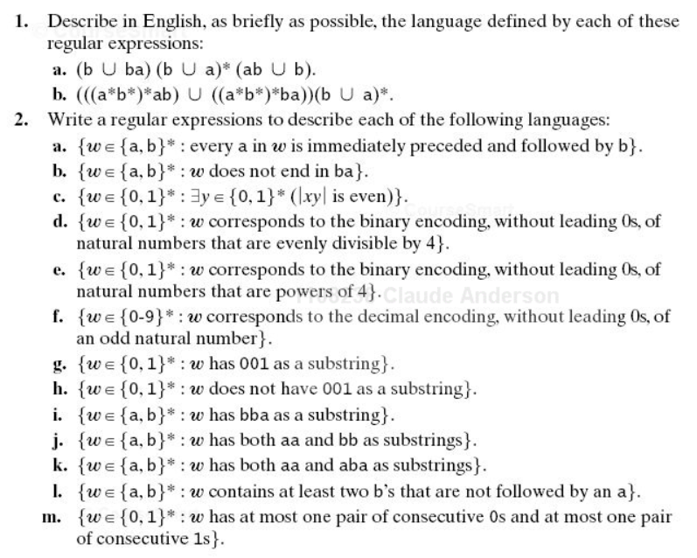

Some problems were moved to HW5

6.2e
1 (3)

6.2h
2(3)

6.2l (el)
3 (3)

6.3bcd
8 (3-3-3)

6.2: For the "to-turn-in" parts of 6.2, aim for as simple a regular expression as you can come up with. Some of the credit may be for simplicity. If your expression is very complicated, some annotation may help the grader to know whether it is correct. The "burden of correctness" is on you. I did not require some of the more complex parts of this problem due to difficulties with grading, but you should try some of them.
Note for part c: The x is a typo, should be w.
|wy| means "the length of string wy"

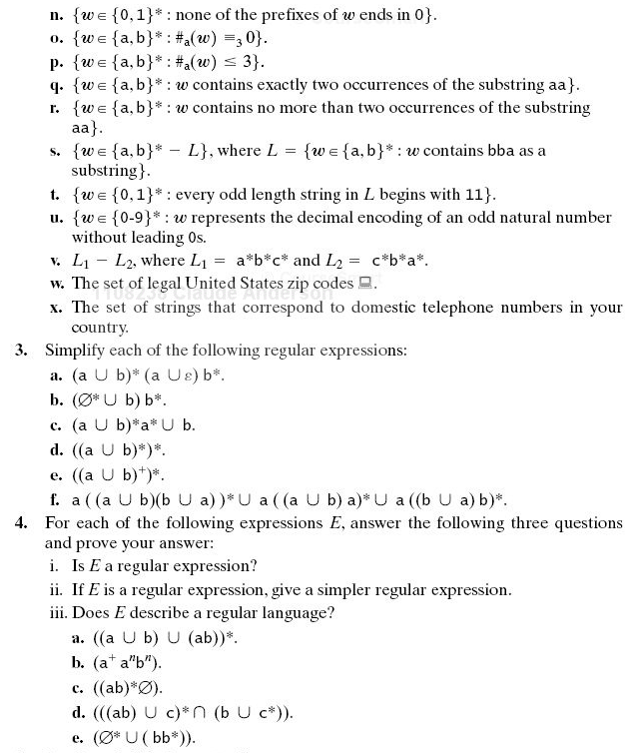
Continued on next page

6.6
5 (3-3)

6.7a
6 (9)

6.8
Not to turn in.

Rijk problem
8 (18)

