474 HW 4 problems (highlighted problems are the ones to turn in)
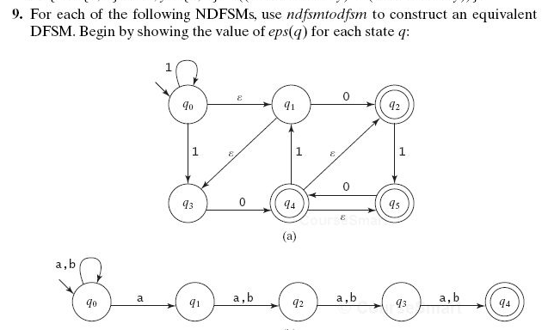
5.9a

5.9c

5.10

5.11 a,
5.11d

5.11 (b) (e)

5.12

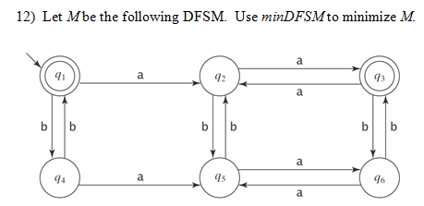
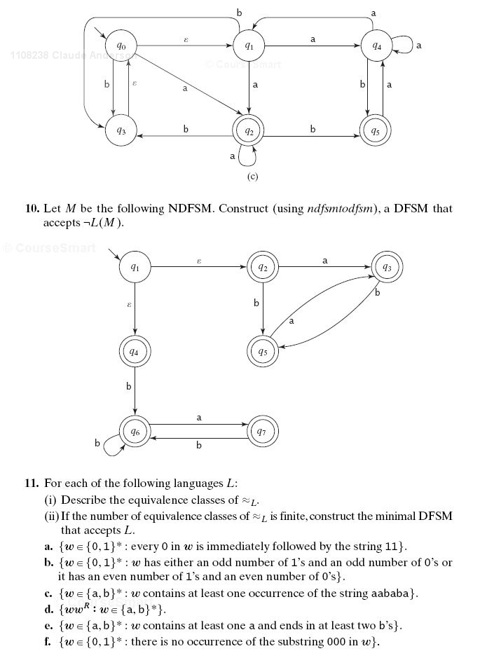
The last problem from this assignment is not from the textbook, so I did not include it on this page. It is on the HW4 assignment page. Before summer 2020, it was problem 1 from assignment 5.
It involves finding the canonical form of a DFSM.

