474 HW 3 problems (highlighted problems are the ones to turn in)
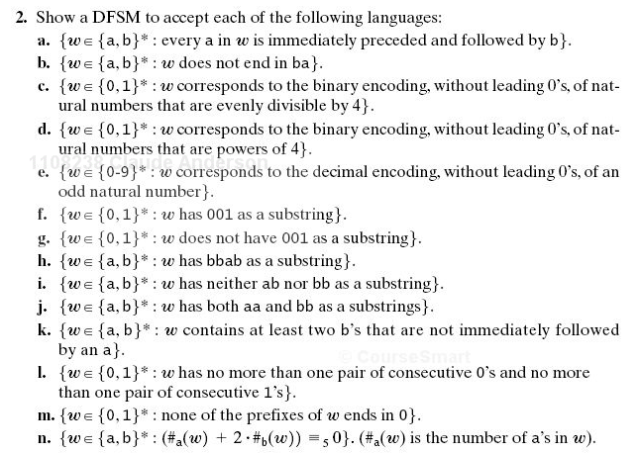
5.2

5.2j

5.2l
5.3

5.4
Problem 5 (On the assignment sheet, not from textbook. DFSM for "divisible by 3")

5.5

If you need simpler practice problems, do some other parts of 5.2 first.

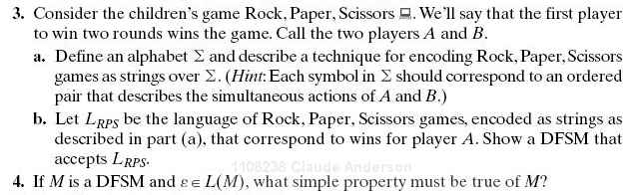

The answer is simple and straightforward, so don't look for anything complicated or tricky.
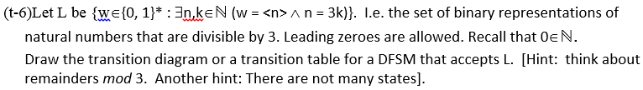
5.

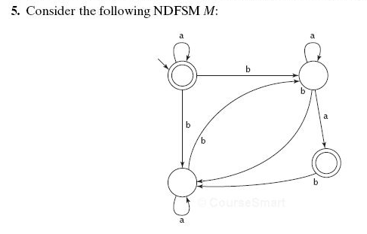

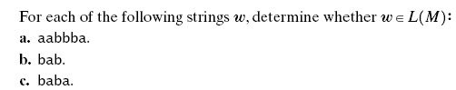

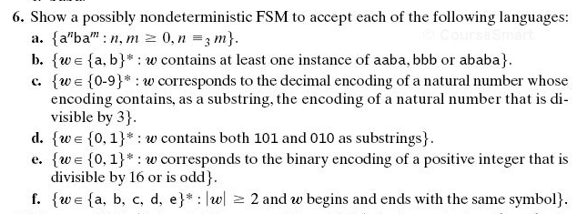
5.6a

5.6c

5.7

5.6(c)
Note that this one is decimal, while problem 1 is binary. Also notice the “contains a substring” part.

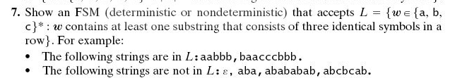

Problem 10 is not from the textbook, so it is not shown on this page., only on the assignment page. It is a challenging problem for many students.

