Former 474 HW 1 problems, now optional HW0
(highlighted problems were the ones to turn in)
Note on problem A.5:
In line 3, it says, “Define the following predicates over those sets.”
A clearer statement would be “Assume that the following predicates over those sets have been defined.”
That part of the problem is not asking you to do anything; instead it is giving you the building blocks to use for what you are supposed to do, which is parts a and b.

A.1 A.2 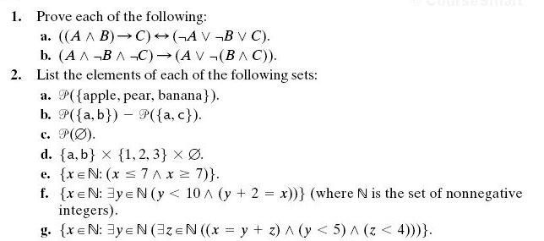
A.4, A.5 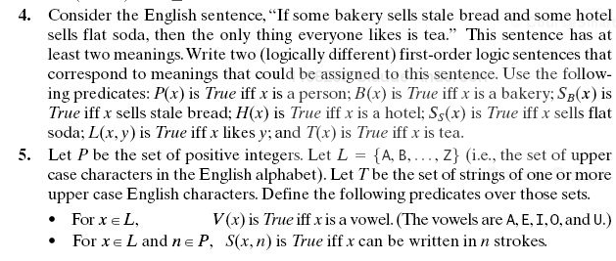
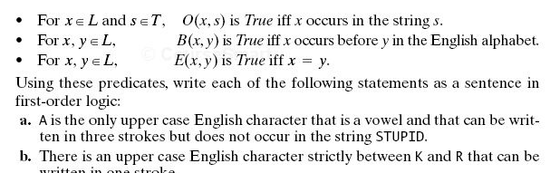

A.6-A.9 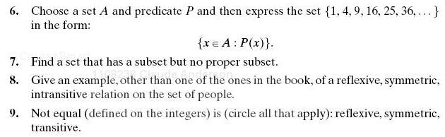
A.11 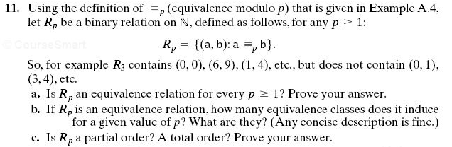
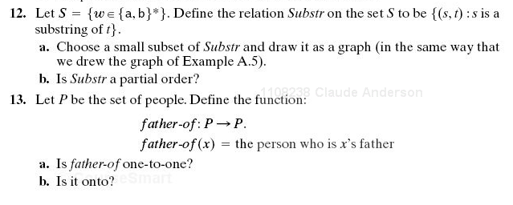
A 12-13

A 14.
Part d for turnin

A 15

A17

A18, A19
A19c for turnin
A 20

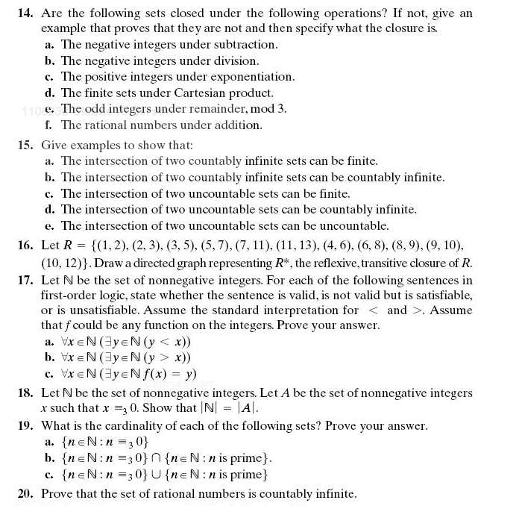
A14d: She should have said “the set of finite sets under …” I.e., is the Cartesian product of two finite sets always a finite set?

