MA/CSSE 474 Exam 3 Notation and Formulas page Name ________________ (turn this in with your exam)
Unless specified otherwise, r,s,t,u,v,w,x,y,z are strings over alphabet Σ; while a, b, c, d are individual alphabet symbols.
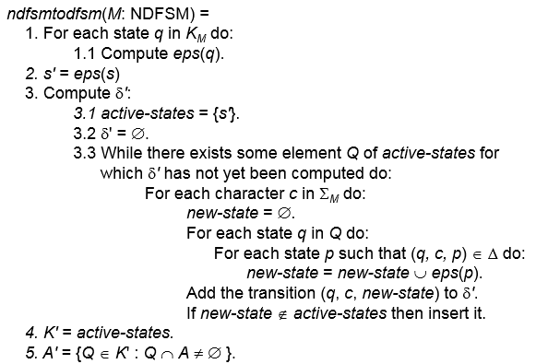
DFSM notation: M= (K, Σ, δ, s, A), where:
K is a finite set of states, Σ is a finite alphabet
s ∈ K is start state, A ⊆ K is set of accepting states
δ: (K × Σ) → K is the transition function
Extend δ's definition to δ: (K × Σ*) → K by the recursive definition δ(q, ε)=q,
δ(q, xa) = δ(δ(q, x), a)
M accepts w iff δ(s, w) ∈ A. L(M) = {w ∊ Σ* : δ(s, w) ∊ A}
Alternate notation:
(q, w) is a configuration of M. (current state, remaining input)
The yields-in-one-step relation: |-_{M} :
(q, w) |-_{M} (q', w') iff w = a w' for some symbol a ∈ Σ, and δ (q, a) = q'
The yields-in-zero-or-more-steps relation: |-_{M}* is the reflexive, transitive closure of |-_{M} .
A computation by M is a finite sequence of configurations C₀, C₁, …, C_{n} for some n ≥ 0 such that:
• C₀ is an initial configuration,
• C_{n} is of the form (q, ε), for some state q ∈ K_{M},
Reg. exp. operator precedence (High to Low):
parenthesized expressions, * and ⁺, concatenation, union
• ∀i∈{0, 1, …, n-1} (C_{i} |-_{M} C_{i+1})
M accepts w iff the state that is part of the last step in w is in A.
A language L is regular if L=L(M) for some DFSM M.
In an NDFSM, the function δ is replaced by the relation Δ: Δ ⊆ (K × (Σ ∪ {ε})) × K
Equivalent strings relative to a language: Given a language L, two strings w and x in Σ_{L}* are indistinguishable with respect to L, written w≈_{L}x, iff ∀z ∈ Σ* (xz ∈ L iff yz ∈ L).
[x] is a notation for "the equivalence class that contains the string x".
The construction of a minimal-state DSFM based on ≈_{L}:
M = (K, Σ, δ, s, A), where K contains n states, one for each equivalence class of ≈_{L}.
s = [ε], the equivalence class containing ε under ≈_{L},
A = {[x] : x ∈ L},
δ([x], a) = [xa].
Enumerator (generator) for a language: when it is asked, enumerator gives us the next element of the language. Any given element of the language will appear within a finite amount of time. It is allowed that some may appear multiple times.
Recognizer: Given a string s, recognizer halts and accepts s if s is in the language. If not, recognizer either halts and rejects s or keeps running forever. This is a semidecision procedure. If recognizer is guaranteed to always halt and
(accept or reject) no matter what string it is given as input, it is a decision procedure.
The regular expressions over an alphabet Σ are the strings that can be obtained as follows:
1. ∅ is a regular expression.
Functions on languages:
firstchars(L) = {w : ∃y∈L (y = cx, c ∈ Σ_{L}, x ∈ Σ_{L}*, and w ∈ c*)}
chop(L) = {w : ∃x∈L (x = x₁cx₂, x₁ ∈ Σ_{L}*, x₂ ∈ Σ_{L}*, c ∈ Σ_{L} |x₁| = |x₂|, and w = x₁x₂)}
maxstring(L) = {w: w ∈ L, ∀z ∈Σ* (z ≠ ε → wz ∉ L)}
mix(L) = {w: ∃x, y, z (x ∈ L, x = yz, |y| = |z|, w = yz^{R})}
middle(L) = {x: ∃y, z ∈ Σ* (yxz ∈ L)}
alt(L) = {x: ∃y,n (y ∈ L , |y| = n, n > 0, y = a₁…a_{n},∀i ≤ n (a_{i} ∈ Σ), and
x = a₁a₃a₅…a_{k}, where k = (if n is even then n-1 else n))}

2. ε is a regular expression.
3. Every element of Σ is a regular expression.
4. If α , β are regular expressions, then so is αβ.
5. If α , β are regular expressions, then so is α∪β.
6. If α is a regular expression, then so is α*.
7. α is a regular expression, then so is α⁺.
8. If α is a regular expression, then so is (α).

Recursive formula for constructing a regular expression from a DFSM: r_{ijk} is r_{ij(k-1)} ∪ r_{ik(k-1)}(r_{kk(k-1)})*r_{kj(k-1)}
The set of regular languages is closed under complement, intersection, union, set difference, concatenation, Kleene * and +, reverse

Pumping Theorem and its contrapositive:
The contrapositive form:
(∀k ≥ 1
(∃ a string w ∈ L
(|w| ≥ k and
(∀ x, y, z
( (w = xyz ∧ |xy| ≤ k ∧ y ≠ ε) →
∃q ≥ 0 (xy^{q}z is not in L)
) ) ) ))
→ L is not regular

Formally, if L is regular, then
∃k ≥ 1 such that
(∀ strings w ∈ L, (|w| ≥ k →
(∃ x, y, z (w = xyz, |xy| ≤ k, y ≠ ε, and
∀q ≥ 0 (xy^{q}z is in L)))))

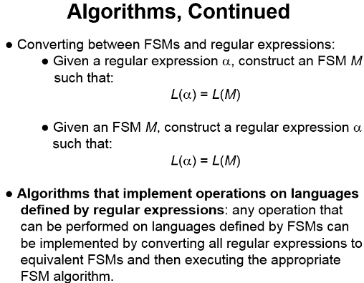
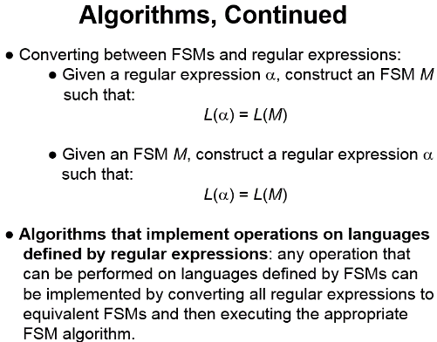
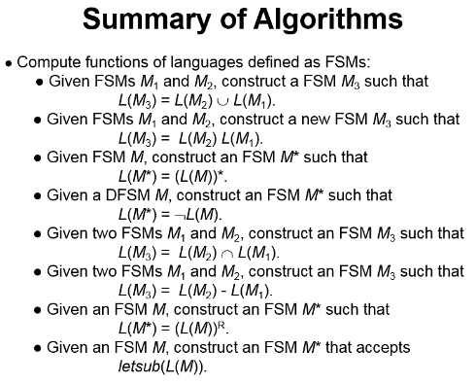
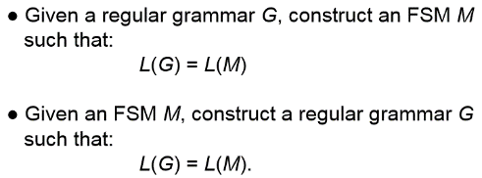
CFG definition: G = (V, Σ, R, S)
(vocabulary, terminals, rules, start symbol)
Derivation and language definition
One derivation step: x ⇒_{G} y iff ∃α,β,γ∈V*, A∈N ((x = αAβ) ∧ (A → γ ∈ R) ∧ (y = α γ β))
⇒_{G}* is the reflexive, transitive closure of ⇒_{G}
The language defined by a grammar: L(G) = {w ∈ Σ* : S ⇒_{G}* w}
L is context-free if there is a context-free grammar G such that L = L(G).
A parse tree, derived from a grammar G = (V, Σ, R, S), is a rooted, ordered tree in which:
Every leaf node is labeled with an element of Σ ∪ {ε},
The root node is labeled S,
Every other node is labeled with an element of N, and
If m is a non-leaf node labeled X and the (ordered) children of m are labeled x₁, x₂, …, x_{n},
then R contains the rule X → x₁ x₂, … x_{n}.
Chomsky Normal Form, in which all rules are of one of the following two forms:
X → a, where a ∈ Σ, or X → BC, where B and C are elements of V - Σ.
Greibach Normal Form, in which all rules are of the form X → a β, where a ∈ Σ and β ∈ N*.
A grammar is ambiguous if some string it generates has two different parse trees
Equivalently, two different leftmost derivations, or two different rightmost derivations
A CFL is inherently ambiguous if every CFG that generates it is ambiguous.
PDA definition: M = (K, Σ, Γ, Δ, s, A),
states, input alphabet, tape alphabet, transition relation, start state, accepting states
(q₁, cw, γ₁γ) |-_{M} (q₂, w, γ₂γ) iff ((q₁, c, γ₁), (q₂, γ₂)) ∈ Δ.
accepting computation of M: (s, w, ε) |-_{M}* (q, ε, ε), and q ∈ A
Top-down PDA from grammar: Production A → XYZ becomes (q, ε, A) → (q, XYZ)
(s, ε, ε) → (q, S) [s is the start state of M). A ={q} . For each terminal, (q, a, a) → (q, ε)
Bottom-up PDA from grammar: The shift transitions: ((p, c, ε), (p, c)), for each c ∈ Σ.
The reduce transitions: ((p, ε, (s₁s₂…s_{n}.)^{R}), (p, X)), for each rule X → s₁s₂…s_{n}. in G. .
The finish-up transition: ((p, ε, S), (q, ε)). A = {q}
CFL closure: Union, Concatenation, Kleene Star. Reverse. Intersection with regular language.
Not closed under complement, intersection, set difference.
We have CFL decision algorithms for membership, emptiness, finiteness.
Undecidable questions about CFLs: Is L = Σ*? Is L regular? Is L₁ = L₂? Is L₁ ⊆ L₂? Is L₁ ∩ L₂ = ∅?
Is the complement of L context-free? Is L₁ ∩ L₂ = ∅? Is L inherently ambiguous? Is G ambiguous?
Deterministic PDA M: Δ_{M} contains no pairs of transitions that compete with each other, and whenever M is in an accepting configuration it has no available moves.
A language L is deterministic context-free iff L$ can be accepted by some deterministic PDA.
Formal TM definition. A deterministic TM M is (K, Σ, Γ, δ, s, H):
    - K is a finite set of states;
contrapositive of CFG Pumping Theorem:
If ∀k ≥ 1 (∃ a string w ∈ L, where |w| ≥
(∀ u, v, x, y, z
( (w = uvxyz, vy ≠ ε, and |vxy| ≤ k)
implies
( ∃ q ≥ 0 (uv^{q}xy^{q}z is not in L))))),
then L is not context-free

    - Σ is the input alphabet, which does not contain ☐;
    - Γ is the tape alphabet, which must contain ☐ and have Σ as a subset.
    - s ∈ K is the initial state;
    - H ⊆ K is the set of halting states;
    - δ is the transition function:
      - (K - H) × Γ to K × Γ × {→, ←}
non-halting × tape → state × tape × direction to move
state char char (R or L)
Yields. (q₁, w₁) |-_{M} (q₂, w₂) iff (q₂, w₂) is derivable, via δ, in one step.
|-_{M}* is the reflexive, transitive closure of |-_{M}.
Configuration C₁ yields configuration C₂ if: C₁ |-_{M}* C₂.
A path through M is a sequence of configurations C₀, C₁, …, C_{n} for some n ≥ 0 such that C₀ is the init config and C₀ |-_{M} C₁ |-_{M} C₂ |-_{M} … |-_{M} C_{n}.
A computation by M is a path that halts. If a computation is of length n (has n steps), we write: C₀ |-_{M}^{n} C_{n}
- TMs as language recognizers. Let M = (K, Σ, Γ, δ, s, {y, n}).

  - M accepts a string w iff (s, qw) |-_{M}* (y, w′) for some string w′.
  - M rejects a string w iff (s, qw) |-_{M}* (n, w′) for some string w′.
  - M decides a language L ⊆ Σ* iff for any string w ∈ Σ*t:
    - if w ∈ L then M accepts w, and
    - if w ∉ L then M rejects w.
  - A language L is decidable iff thewre is a TM M that decides it.
  - We define the set D to be the set of all decidable languages.
  - M semidecides L iff, for any string w ∈ Σ_{M}*:
    - w ∈ L → M accepts w
    - w ∉ L → M does not accept w. M may reject or not halt.
  - A language L is semidecidable iff there is a Turing machine that semidecides it.
  - We define the set SD to be the set of all semidecidable languages.

