Name:___________________ Section (circle one): 01 (9:00) 02 (10:00) 03 (11:00)

This quiz, is due at the beginning of the second day of class. Please either print it and complete it by hand, or complete it electronically and then print it. A lot of this reading material should be familiar; some of Elaine Rich's notation may be different than you have seen before; you need to understand and use her notation. This quiz is mostly about definitions and notation. Please print 2-sided.

Chapter 2.
- We consistently use the symbol Σ to denote the _______________ from which we compose strings.
According to the textbook's definition, can Σ ever be infinite?
According to the textbook's definition, can a string have infinite length?
Σ* is the ________ of all strings including the empty string whose symbols come from Σ.
- Let Σ be {a, b, c}, and let s∊Σ*be abcbcc. What is the value of each of the following expressions?
|s|
sa
s⁰
s²
s^{R}
#_{b}(s)
How many different proper prefixes does s have?
How many different proper substrings does s have?

- A (formal) language is a ______ of strings over an _____________.
- Are ∅ and {ε} the same language? Explain briefly.

- If the ordering of the symbols in {a, b, c} is the order given here, arrange the following strings into lexicographic order, according to the textbook's definition: b ba abc cac ε ab
- If L₁ = {a, ab} and L₂ = {a, c, ε}, how many different strings are in the language L₁L₂? _____
- If L =∅ , what is L*? _____
- Give an example of a language L for which L⁺ ≠L* - {ε}. L = __ _________
- Consider Exercise 2.2 0n page 19. List here the letters (chosen from {a, b, c, d})of the given strings that are in L₁L₂:__ ______
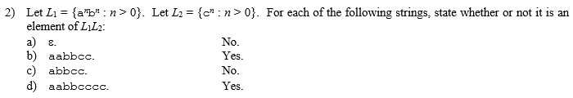
- Can a language (set of strings over an alphabet) ever be uncountably infinite?
- What are the possibilities for the cardinality of the set of all languages over a given alphabet ?
Answer: ___________________ and ___________

- What is the relationship between {0}*{1}* and {01}*? (circle one)
= ⊂ ⊃

Good problems to think about, but not to turn in (not yet, some may be assigned later):
Exercises 2.3, 2.5a, 2.7abde, 2.8

