Name:____________________________________ Section (circle one): 01 (9:00) 02 (9:55) 03 (10:45)

This quiz, which covers some of the prerequisite material, is due at the beginning of the first day of class. Please either print it and complete it by hand, or complete it electronically and then print it. Background reading: pages 745-790 from Appendix A of the textbook; almost all of this material should be familiar. Some of Elaine Rich's notation may be different than you have seen before; you need to understand and use her notation. Please staple!
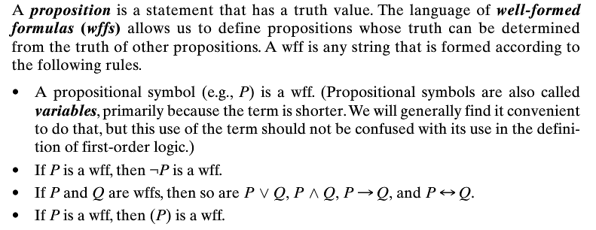
- Show how to derive the Boolean wff A ∧ (B ∨ ¬C) from the rules in the definition on page 745 .

- What does it mean for a Boolean (propositional) wff to be :
valid
satisfiable
unsatisfiable

- Do exercise A.1a, page 804. Show the validity of the propositional formula ((A ∧ B) → C) ↔ (¬A ∨ ¬B ∨ C). Give a justification (in words) for each step in your proof.

- Do exercise A.2, on page 804.
a
List the elements of each of the following sets:
  - P({apple, pear, banana}).
  - P({a, b}) - P({a, c}).
  - P(∅).
  - {a, b} × {1, 2, 3} × ∅.
  - {x ∈ ℕ: (x ≤ 7 ∧ x ≥ 7}.
  - {x ∈ ℕ: ∃y ∈ ℕ (y < 10 ∧ (y + 2 = x))} (where ℕ is the set of nonnegative integers).
  - {x ∈ ℕ: ∃y ∈ ℕ (∃z ∈ ℕ ((x = y + z) ∧ (y < 5) ∧ (z < 4)))}.
b
c
d
e
f
g
- (Nothing to write here) Be sure to notice the inference rules of Boolean logic on pages 747-748.
- (Nothing to write here) Pay special attention for the definitions and notation of First-order logic (pages 748-751), including the following terms: term, predicate, function, wff (look carefully at all of the cases), quantifier, free, bound, sentence, ground instance, interpretation, model, valid, satisfiable, unsatisfiable, implies (entails), theorem, proof, sound, complete, theory, contradiction, consistent, inconsistent.
- What does Gödel's Completeness Theorem state (see bottom of p 751 through top of 753)?
What does Gödel's Incompleteness Theorem state (or look these up somewhere else)?
- (Nothing for you to write here) Terminology about Sets that you should know and understand: characteristic function, enumeration, decides, cardinality, countably infinite, uncountably infinite, subset, proper subset, union, intersection, difference, complement (relative to what?), disjoint sets, and partition.
- Do exercise A.5b
Let P be the set of positive integers. Let L = {A, B, …, Z} (i.e., the set of upper case characters in the English alphabet). Let T be the set of strings of one or more upper case English characters. Consider the following definitions of predicates over those sets:
- For x ∈ L, V(x) is True iff x is a vowel. (The vowels are A, E, I, O, and U.)
- For x ∈ L and n ∈ P, S(x, n) is True iff x can be written in n strokes.
- For x ∈ L and s ∈ T, O(x, s) is True iff x occurs in the string s.
- For x, y ∈ L, B(x, y) is True iff x occurs before y in the English alphabet.
- For x, y ∈ L, E(x, y) is True iff x = y.
Using these predicates, write each of the following statements as a sentence in first-order logic:
  - A is the only upper case English character that is a vowel and that can be written in three strokes but does not occur in the string STUPID.
  - There is an upper case English character strictly between K and R that can be written in one stroke.

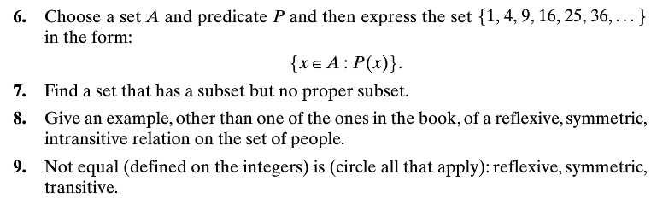
- Do exercise A.6
- Do exercise A.7
- Do exercise A.9
- (Nothing for you to write here)Terminology about relations: Cartesian product, n-ary relation, binary relation, inverse, composition, encoding of a relation as a directed graph, reflexive, symmetric, transitive, antisymmetric, equivalence relation, equivalence classes, partial order, minimal element, least element, greatest element, total order, infinite descending chain, well-founded, well-ordered.
- (Nothing for you to write here) Terminology about functions: domain, range, argument, image, unary function, binary-function, prefix notation, infix notation, composition, total function, partial function, one-to-one, onto, bijection, inverse, homomorphism, isomorphism, fixed point. Se the summary of properties of functions on sets, pages 775-6.
- (Nothing for you to write here) Terminology about closures. Closure, transitive closure, "closed under …". Pay special attention to Example A.11 and the computetransitiveclosure function. You do not have to write answers to A.14 and A.15, but be sure you can do them.
- A.17. Let ℕ be the set of nonnegative integers. For each of the following sentences in first-order logic, state whether the sentence is valid, is not valid but is satisfiable, or is unsatisfiable. Assume the standard interpretation for < and >. Assume that f could be any function on the integers. Prove your answer.
  - ∀x ∈ ℕ (∃y ∈ ℕ (y < x)).
  - ∀x ∈ ℕ (∃y ∈ ℕ (y > x)).
  - ∀x ∈ ℕ (∃y ∈ ℕ f(x) = y).
- A 18. Let ℕ be the set of nonnegative integers. Let A be the set of nonnegative integers x such that x ≡₃ 0. Show that |ℕ| = |A|.

- Do exercise A.17
a)
b)
c)
- Do exercise A.18
- (Nothing for you to write here) Carefully read sections A.6.1 through A.6.8. All of these proof techniques will be used in class or in the course exercises. Hopefully you have seen all of them before, so they will be review, but I still suggest that you review them very carefully.

- Do exercise A.21b (You should also be able to do 21d
and 21e, but you are not required to turn these in).
Be sure to clearly indicate your base case, induction
assumption, and how you use the induction assumption
in proving the "true for n implies true for n+1" step.
- Use induction to prove each of the following claims:
  - ∀n>0 (n! ≥ 2^{n-1}).
Recall that 0! = 1 and
∀n > 0 (n! = n(n - 1)(n - 2) … 1).

- (Nothing for you to write here) Proofs by induction are very common in this course, and you should be fairly comfortable with them before you begin the course. If you are not there, you should go back to definitions and examples from MA 275. Or look up other induction explanations and examples using Google. Be sure to read Examples A.18 and A.19, which probably apply induction in areas that are different than you have seen before. Exercise A.22 will most likely be a Homework problem or in-class exercise at some point.

