474 HW 16 problems (highlighted problems are the ones to turn in)

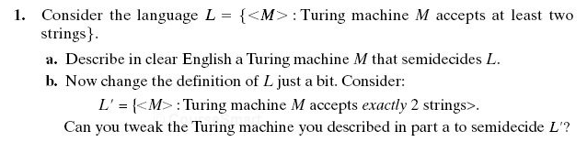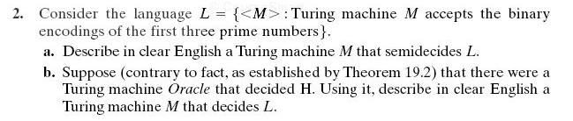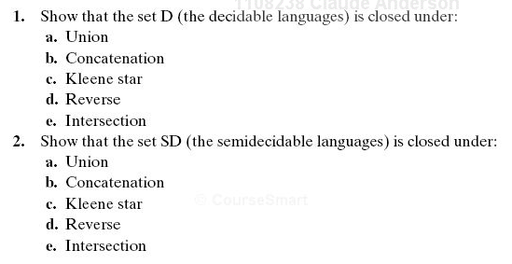
19.1
(#1) 6

19.2
(#2) 12

20.1
(#3)
20.2
(#4)

20.3
(#5) 9
20.4
(#6) 6
20.5
(#7)
20.6
(#8)
20.7
(#9) 6
20.8
(#10) 9

20.13
(#11) 9
