474 HW 15 problems (highlighted problems are the ones to turn in)
The main assignment sheet has several Q and A from previous term’s Piazza forums
17.11
(#1) 6-3
17.12
(#2) 6-6-6-6

17.13
(#3) 3
18.1a
(#4) 9

18.1b
(#5) 9

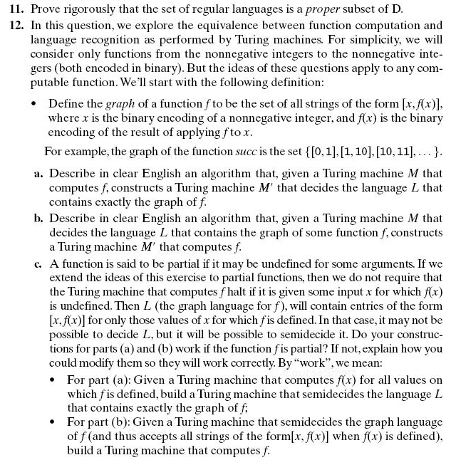
Note on 17.12a:
L = { [<x>, <f(x)>], x∈ℕ}, where <x> means "the binary encoding of x" and <f(x)> means "the binary encoding of f(x)"
17.12b,c: Do these constructions for a general function-computing TM, not specifically for the successor function.
(c) You might find the concept of "dovetailing" helpful for this problem. If you have not seen that technique before, this reference will probably help:

http://lambda-the-ultimate.org/node/322

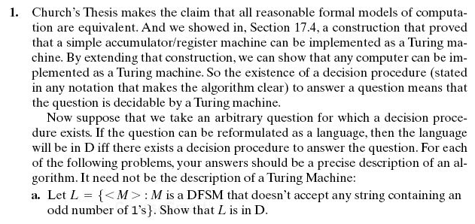
Problem #6 A TM M has tape alphabet { , a, b} (this is the order used in the encoding <M>).
<M> = (q00,a00,q00,a00, →), (q00,a10,q01,a10,→), (q00,a01,y10,a10, ←), (q01,a01,q00,a10,→), (q01,a10,n11,a01, ←)
- (6) Provide a transition diagram or a transition table for the TM M.
- (3) For each of the following outcomes of running M, provide a short string of a's and b's that is
accepted by M,
rejected by M,
neither.

