MA/CSSE 474 HW 14 problems (highlighted problems are the ones to turn in)
Be sure to read the numerous questions and answers in the main assignment document
13.13
(#1)
13.13d
(#2) 6
13.14
(#3) 6,9
14.1a
(#4) 6
14.1c
(#5) 9
14.1d
(#6)
14.1e
(#7)
17.1a
(#8) 6
17.1b
(#9)

17.3a
(#10) 9

17.3b-d
(#11)

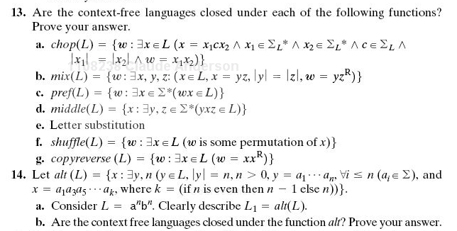
13.14 Examples:
If L is the language denoted by r.e. (ab)*, then alt(L) is denoted by r.e. a*.
If L is the language denoted by r.e. (abcdefg)*, then alt(L) is denoted by r.e. (aceg)* .
If L is the language denoted by r.e. a or the language denoted by r.e. a*, then alt(L) is L.

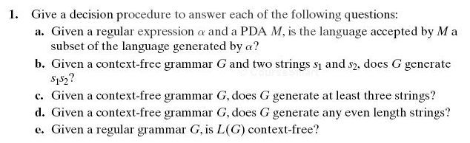
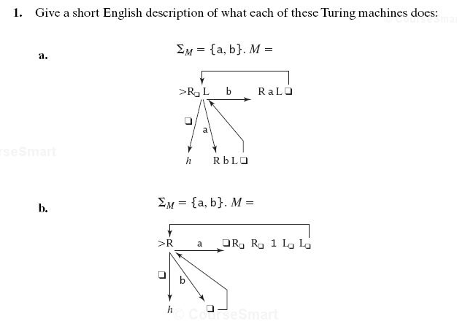
17.1a Don't just describe in English the individual steps the machine makes. Your answer should be a global one: in particular, describe how the final tape content is different from the original tape content.

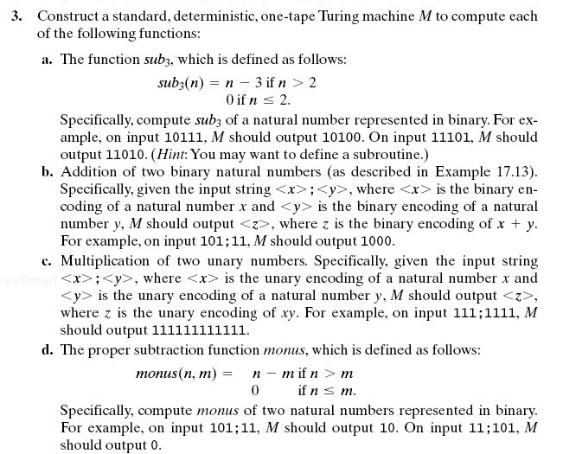

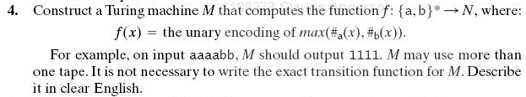
17.4
(#12) 9

17.6
(#13) 3

