474 HW 13 problems (highlighted problems are the ones to turn in)

13.1a
(#1) 6
13.1b
(#2)
13.1c
(#3) 12
13.1d
(#4) 6
13.1f
(#5) 9
13.1g
(#6)
13.1h
(#7)
13.1i
(#8) 9
13.1k
(#9)
13.1l
(#10) 9
13.1p
(#11)
13.1q
(#12)
13.1w
(#13) 9

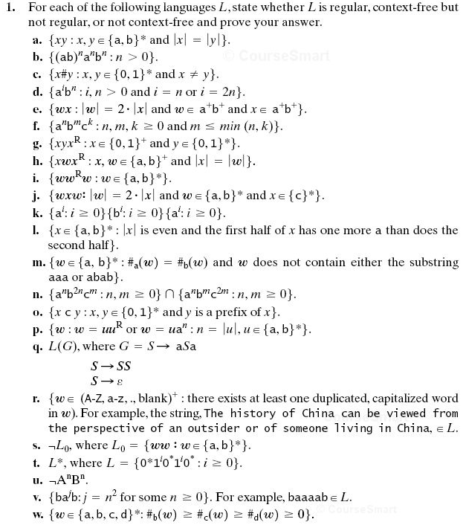
Recall: When we use the pumping theorem to show a language is not context-free, we do not get to choose the k, we choose the w whose length is at least k. We do not get to choose how w is broken up into uvxyz (although the breakup has to meet the length constraints of the theorem), but we do get to choose how to pump the v and y (I.e. we can choose the q in uv^{q}xy^{q}z).
13.1c: When I assigned this before, I thought there was value in starting with the intuitive assumption that this language is not context-free, and only after trying many approaches to showing this, begin to think that maybe it is context-free after all. But in a survey from a previous term, some students told me that they spent more than 150 minutes on this problem, mainly because of spinning their wheels trying to use the Pumping Theorem. Thus I am telling you that this language is indeed context-free.

13.3
(#14) 9

13.4
(#15)

13.8
(#16)

13.9
(#17) 6

13.12
(#18)
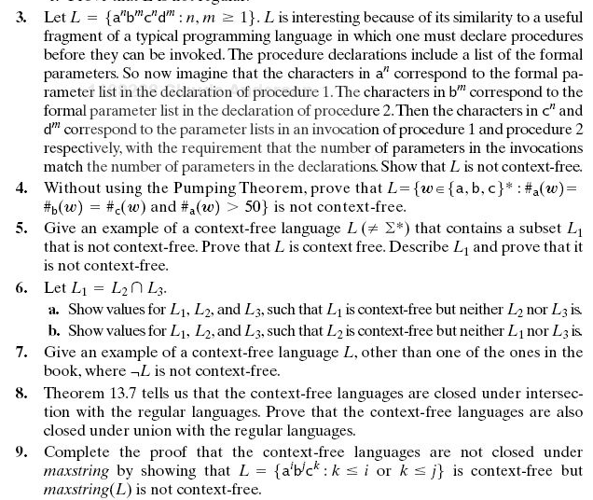
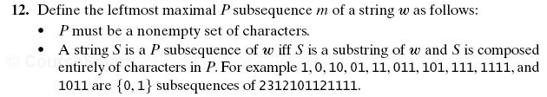
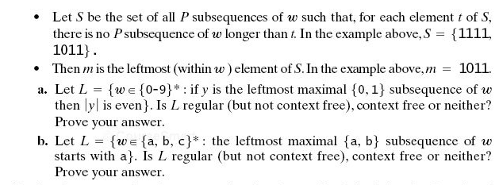
Note on 13.12. What the author meant to ask and what she actually asked are quite different. Both parts should have said: "Is L context-Free (but not regular), regular, or neither? Prove your answer.

