474 HW 3 problems (highlighted problems are the ones to turn in)
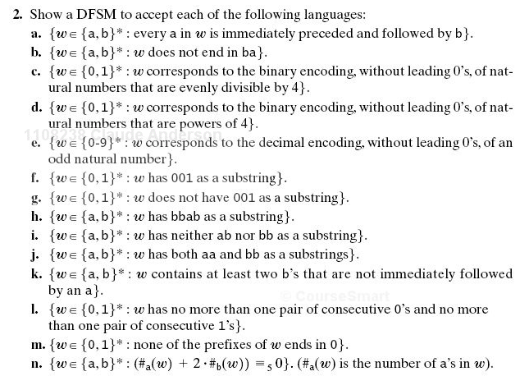
5.2

5.2j

5.2l
5.3

5.4
Problem 5 (On the assignment sheet, not from textbook. DFSM for "divisible by 3")

5.5

If you need simpler practice proiblems (and you probably do!), do some other parts of 5.2 first.

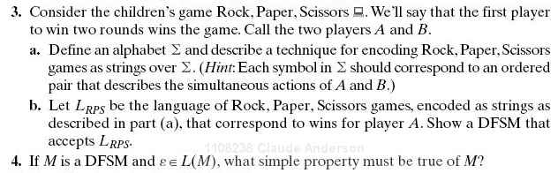

The answer is simple and straightforward, so don't look for anything complicated or tricky.
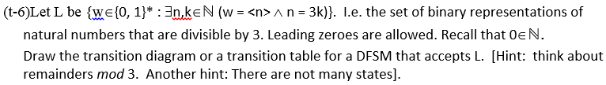
5.

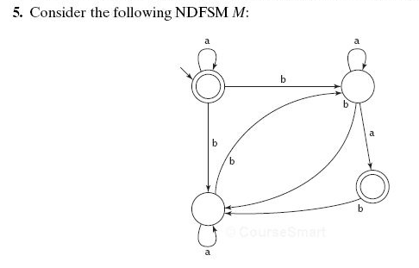

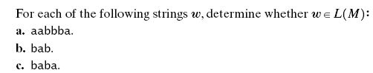

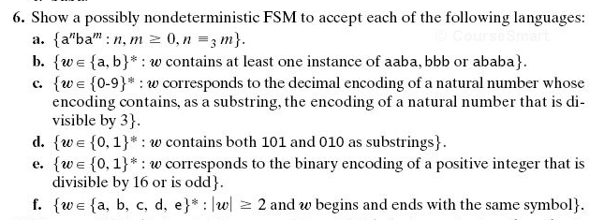
5.6a

5.6c

5.7

5.6(c)
Note that this one is decimal, while problem 1 is binary. Also notice the “contains a substring” part.

