MA/CSSE 474 Day 39 Summary
- L₁ is mapping reducible to L₂ (L₁ ≤_{M} L₂) iff there exists some computable function f such that:
∀x∈Σ* (x ∈ L₁ ↔ f(x) ∈ L₂).
  - To decide whether x is in L₁, we transform it using f, and ask whether f(x) is in L₂.
  - All of the "undecidability" reductions we have done so far are mapping reductions.
  - Sometimes a mapping reduction is not sufficient.
    - We need to use Oracle as a subroutine and then do other computations after Oracle returns.
  - Example: {<M> : M accepts no even length strings}
    - Do the "standard reduction" from H
      - R(<M,w>) → <M#>, where M# erases tape, writes w, runs M on w, accepts.
      - Oracle(R(<M,w>)) is "backwards"; <M,w>∈H ⇒ Oracle rejects <M#>; <M,w>∉H ⇒ Oracle accepts.
      - So we use ¬Oracle(R(<M,w>))
- Rice's Theorem: Let P be any non-trivial property of the SD languages (true for some languages, false for others). Then {<M>: P(L(M)) = True} is not in D.
  - This applies to many languages we have examined, but you should also know how to use reduction.
  - {<M> : L(M) is regular} is not in D. Can show this by Rice's Theorem, or directly (reduction form H).
  - Ditto {<M> : L(M) is context-free}

- {<M> : M accepts no even length strings} Details on slides.
  - Notes on reduction from H
  - Notes on reduction from H with not

- Example: L₂ = {<M, q> : M reaches state q on some input}
  - Reduction diagram: Reduce H_{ANY} to L₂.
  - R takes a TM description <M> as input and returns <M#, h>, where M# is defined by:
  - C is correct: M# reaches it halting state h iff
    - If <M>∈ H_{ANY} , then
    - If <M>∉ H_{ANY} , then
- There is a computable function, obtainSelf. When any TM M calls it as a subroutine, it writes <M> on M's tape.
  - This is a result of the Recursion Theorem, which is in Chapter 25.
  - Quines are related to obtainSelf.
- Details matter:
  - L₁ = {<M>: M has an even number of states}.
  - L₂ = {<M>: |<M>| is even}.
  - L₃ = {<M>: |L(M)| is even}.
  - L₄ = {<M>: M accepts all even length strings}.
- Non-SD languages. Usually involve "double infinity"
  - ¬H = {<M, w> : TM M does not halt on w}.
  - {<M> : L(M) = Σ*}.
  - {<M> : TM M halts on nothing}.
  - Different ways to show non-SD:
    - Contradiction
    - L is the complement of an SD/D Language.
    - Reduction from a known non-SD language.
- If ¬L is in SD, and at least one of L or ¬L is not in D, then L is not in SD.
  - Example that we have seen before: ¬H is in not in SD, since ¬(¬H) = H is in SD and not in D)
- Example: A_{anbn} = {<M> : L(M) = A^{n}B^{n}}
  - Rice's Theorem says "not in D". We want to show it's also not in SD. Reduce ¬H to A_{anbn}
  - Reduction 1: Reduction 2: Reduction 3:
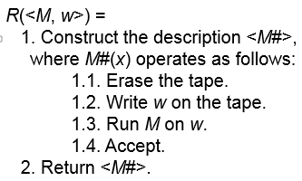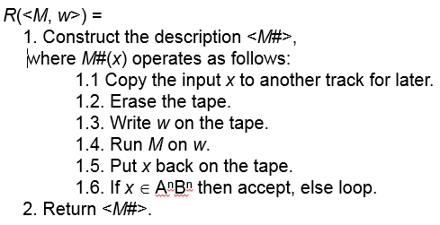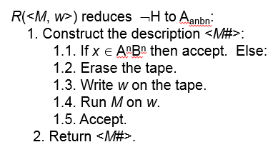

- H_{ALL} = {<M> : TM halts on Σ*}

