MA/CSSE 474 Day 38 Announcements and Summary
- HW15 Feb 18 (nothing to turn in). HW16 Feb 21 (nothing to turn in). Available soon.
- Final Exam Wednesday Feb 26, 8:00 AM. (A-M: G315, O-Y: G317)
  - Covers the entire term, but heavier emphasis on Turing Machines and decidability.
  - You may bring four sheets of paper, plus the handout on TM macros.
Main ideas from today (some undecidability and non-SD proofs)
- Example: L₂ = {<M, q> : M reaches q on some input}
  - Reduction diagram: Reduce H_{ANY} to L₂.
  - R takes a TM description <M> as input and returns <M#, h>, where M# is defined by:
  - C is correct: M# reaches it halting state h iff
    - If <M>∈ H_{ANY} , then
    - If <M>∉ H_{ANY} , then
- There is a computable function, obtainSelf. When any TM M calls it as a subroutine, it writes <M> on M's tape.
  - This is a result of the Recursion Theorem, which is in Chapter 25.
  - Quines are related to obtainSelf.
- Non-SD languages. Usually involve "double infinity"
  - ¬H = {<M, w> : TM M does not halt on w}.
  - {<M> : L(M) = Σ*}.
  - {<M> : TM M halts on nothing}.
  - Different ways to show non-SD:
    - Contradiction
    - L is the complement of an SD/D Language.
    - Reduction from a known non-SD language.
- TM_{MIN} = {<M>: Turing machine M is minimal}

- If ¬L is in SD, and at least one of L or ¬L is not in D, then L is not in SD.
  - Example that we have seen before: ¬H is in not in SD, since ¬(¬H) = H is in SD and not in D)
- Example: A_{anbn} = {<M> : L(M) = A^{n}B^{n}}
  - Rice's Theorem says "not in D". We want to show it's also not in SD. Reduce ¬H to A_{anbn}
  - Reduction 1: Reduction 2: Reduction 3:
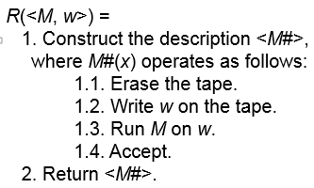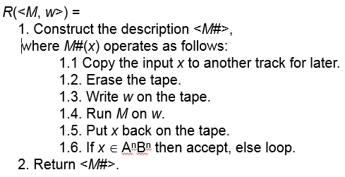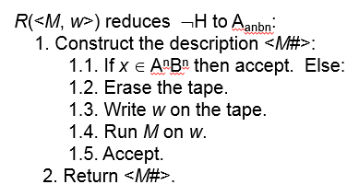

- H_{ALL} = {<M> : TM halts on Σ*}

