MA/CSSE 474 Day 36 Summary
- Summary of results from last session:
  - The language H = {<M, w> : TM M halts on input string w} is in SD but not in D.
  - If H were in D, then SD would equal D
  - Every CF language is in D.
  - D is closed under complement
  - SD is not closed under complement.
  - A language L is in D iff both L and its complement are in SD.
  - The language ¬H = {<M, w> : TM M does not halt on input string w} is not in SD.
- Dovetailing: Run an infinite number of computations "in parallel". S[i, j] represents step j of computation i.
  - S[1, 1]
  - S[2, 1] S[1, 2]
  - S[3, 1] S[2, 2] S[1, 3]
  - S[4, 1] S[3, 2] S[2, 3] S[1, 4 ]
  - For every i and j, S[i, j] will eventually happen.
- A language is Turing-enumerable iff there is a Turing machine that enumerates it.
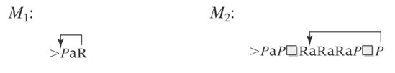
  - A language is SD iff it is Turing-enumerable (TE).
    - TE→SD. Given M that enumerates L, construct M' that semidecides L.
      - Save w. Use M to enumerate L. As each string is enumerated, compare to w. If they match, accept.
    - SD→TE. Given M that semidecides L, construct M' that enumerates L.
      - Enumerate all w ∈ Σ* lexicographically. As each is enumerated, use M to check it.
      - The problem with this approach?
      - Solution:
- M lexicographically enumerates L iff M enumerates the elements of L in lexicographic order.
- L is lexicographically Turing-enumerable iff there is a Turing machine that lexicographically enumerates it.
- A language is in D iff it is lexicographically Turing-enumerable.
  - D→LTE. Given M that decides L, construct M' that lexicographically enumerates L
    - M' lexicographically generates the strings in Σ* and tests each using M (M halts and accepts or rejects each).
    - It outputs those that are accepted by M.
  - LTE→D. Given M that lexicographically enumerates L, construct M' that decides L.
    - Save w. Use M to start enumerating L. As each string is enumerated, compare to w. If they match, accept.
    - If M ever generates a string that comes after w in lexicographic order, reject.
- Problem P₁ is reducible to problem P₂ (written P₁ ≤ P₂) if there is a Turing-computable function f that finds, for an arbitrary instance I of P₁, an instance f(I) of P₂, and
In some sense, ≤ means "is no harder than" or "is at least as decidable as"
  - f is defined such that for every instance I of P₁,
  - I is a yes-instance of P₁ if and only if f(I) is a yes-instance of P₂.
  - So P₁ ≤ P₂ means "if we have a TM that decides P₂, then there is a TM that decides P₁.
- Special case: Language L₁ (over alphabet Σ₁) is reducible to language L₂ (over alphabet Σ₂) and we write L₁ ≤ L₂ if
there is a Turing-computable function f : Σ₁* → Σ₂* such that ∀x ∈ Σ₁*, x ∈ L₁ if and only if f(x) ∈ L₂
  - If P₁ is reducible to P₂, then
    - If P₂ is decidable, so is P₁.
    - If P₁ is not decidable, neither is P₂.
  - The second part is the one that we will use most.
- Another way to say it:
  - A reduction R from language L₁ to language L₂ is one or more Turing machines such that:
  - If there exists a Turing machine Oracle that decides (or semidecides) L₂,
  - then the TMs in R can be composed with Oracle to build a deciding (or semideciding) TM for L₁.
- Using Reduction for Undecidability
  - (R is a reduction from L₁ to L₂) ∧ (L₂ is in D) → (L₁ is in D)
  - Contrapositive: If (L₁ is in D) is false, then at least one of the two antecedents of that implication must be false. So: If (R is a reduction from L₁ to L₂) is true and (L1 is in D) is false, then (L₂ is in D) must be false.
  - Application: If L2 is a language that is known to not be in D, and we can find a reduction from L2 to L1, then L1 is also not in D.
- A framework for using reduction to show undecidability. To show language L₂ undecidable:
  - Choose a language L₁ that is already known not to be in D, and show that L₁ can be reduced to L₂.
  - Define the reduction R and show that it can be implemented by a TM.
  - Describe the composition C of R with Oracle (the purported TM that decides L₁).
  - Show that C does correctly decide L₁ iff Oracle exists. We do this by showing that C is correct. I.e.,
    - If x ∈ L₁, then C(x) accepts, and
    - If x ∉ L₁, then C(x) rejects.
- Example: H_{ε} = {<M> : TM M halts on ε}. Show that it is not in D by showing H ≤ H_{ε}.
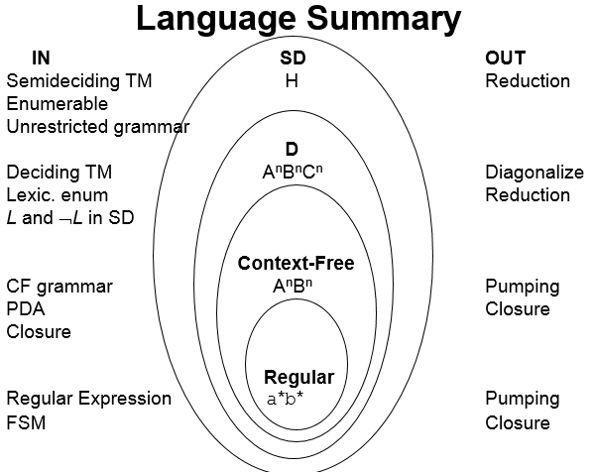
  - H_{ε} is in SD.
  - H_{ε} is not in D.

